University of Central Florida
College of Engineering and Computer Science



Fall 2020
Senior Design I Paper

The Automatic Pill Dispenser

Group 18:
Steven Hudson - CpE
Dakota Riediger Downing - CpE
Eduardo Noguera - CpE
Nestor Vallejos - CpE

Table of Contents
1. Executive Summary ……………………………………………………………...…… 1
2. Project Description ……………………………………………………………...…….. 2
2.1 Project Background ………………………………………………… ……… 2
2.1.1 Motivation and Goals ……………………………………………….…… 3
2.1.2 Objectives ………………………………………………………....…….. 4
2.2 Requirement Specifications …………………………………………..……... 7
2.2.1 Overall Specifications …………………………………………….……... 7
2.2.2 Pill Tray ………...………………………………………………..……… 8
2.2.3 Pill Dispenser ……………………………………………………....……. 8
2.2.4 Database System ……………………………………………………..….. 9
2.2.5 Notification System …………………………………………...………... 9
2.2.6 Wireless System ……………………………………………….………... 10
2.3 Marketing and Engineering Requirements …………………………...……... 11
2.4 Overview of Block Diagram ………………………………………………... 12
3. Research related to Project Definition and Part Selection ……………………….…... 13
3.1 Existing Similar Projects and Products …………………………………..…. 13
3.1.1 Hero Medication Dispenser, Manage, and Pill Organizer ………….….... 13
3.1.2 E-Pill MedTime XL Automatic Pill Dispenser………….………….….... 14
3.1.3 Live Fine Bluetooth Pill Dispenser……………………...………….….... 15
3.1.4 RXPense Automatic Pill Dispenser……………………..………….….... 16
3.2 Relevant Technologies ……………………………………………....………. 18
3.2.1 Different Languages used for Implementation …………………………. 18
3.2.1.1 C Language …………………………………………………………. 18
3.2.1.2 Python ……………………………………………………………..... 18
3.2.2 The Different Stack Implementations …………………………………... 19
3.2.2.1 LAMP Stack ………………………………………………………… 19
3.2.2.2 MERN Stack ………………………………………………………... 19
3.2.3 The Different Servers ………………………………………………….... 20
3.2.3.1 Google Cloud Platform ……………………………………………... 21
3.2.3.2 Amazon Web Services (AWS) …………………………………….... 22
3.2.3.3 Microsoft Azure …………………………………………………….. 23
3.2.4 The Different Boards …………………………………………………... 24
3.2.4.1 Raspberry Pi ……………………………………………………….... 24
3.2.4.2 Arduino ……………………………………………………………... 25
3.2.4.3 MSP430 …………………………………………………………….. 26
3.2.4.4 ATmega32 8-bit AVR Microcontroller …………………………….. 27
3.2.5 The Different Mobile Application Implementations …………………... 32
3.2.5.1 React Native ……………………………………………………….... 32
3.2.5.2 Flutter ……………………………………………………………….. 33
3.2.5.3 Kotlin ………………………………………………………………... 33
3.2.5.4 XCode ……………………………………………………………….. 34
3.2.5.5 Android Studio ………………………………………………………. 34
3.2.5.6 Visual Studio Code ……………………………………………….... 34
3.2.5.7 Visual Studio IDE …………………………………………………... 35
3.2.6 The Different Motor Selections ………………………………………... 35
3.2.6.1 DC Motor …………………………………………………………… 35
3.2.6.2 Step Motor ………………………………………………………….. 36
3.2.6.3 Servo Motor ……………………………………………………….... 36
3.2.7 The Different Motor Drivers ……………………………………………37
3.2.7.1 TB6612FNG Motor Driver………………………………………….37
3.2.7.2 L293DNE Motor Driver …………………………………………….37
3.3 Strategic Components and Part Selections …………………..…………...... 37
3.3.1 Single Board Computer………………………………………………… 39
3.3.2 Display - 5.0" 40-pin TFT Display - 800x480…………………………. 40
3.3.3 HDMI Decoder………………………………………………………… 42
3.3.4 Extension Cable………………………………………………………... 43
3.3.5 Stepper Motor Hat………………………………………………………43
3.3.6 Servo Motor Hat……………………………………………………….. 44
3.3.7 PCA9685 16 Channel 12-bit PWM Controller………………………....45
3.3.8 TB6612FNG Driver IC for Dual DC Motor…………………………....46
3.3.9 LM2596 Simple Switcher………………………………………………47
3.3.10 LM3940 Low-Dropout Regulator…………………………………….47
3.3.11 ATmega32 8-bit AVR Microcontroller……………………………….48
3.3.12 Stepper Motor………………………………………………………...48
3.3.13 Servo Motors…………………………………………………………49
3.3.14 Speaker……………………………………………………………….49
3.3.15 Breadboard and Male-Male Jumper Wires…………………………..50
3.3.16 Medicine Cup………………………………………………………...50
3.4 Possible Architectures and Related Diagrams …………………...……….... 50
3.5 Parts Selection Summary …………………………………………….…….. 55
4. Related Standards and Realistic Design Constraints
4.1 Related Standards …………………………………………………………... 57
4.1.1 Servo Motor standards IEEE 3001.11…………………………………... 58
4.1.2 Design impact of Servo Motors ………………………..………………. 59
4.1.3 Python Standard ………………………………………………………... 59
4.1.4 Design impact of Python ………………………..…………………….... 60
4.2 Realistic Design Constraints ……………………………………………….. 60
4.2.1 Economic and Time Constraints ……………………………….………. 61
4.2.2 Environmental, Social, and Political constraints ……………….…….... 61
4.2.3 Ethical, Health, and Safety constraints ……………………………….... 62
4.2.4 Manufacturability and Sustainability constraints …………………….... 63
5. Project Hardware and Software Design Details
5.1 Initial Design Architecture and Related Diagrams.…………...……………..63
5.2 Hardware Design Approach…………………………..…………...…………64
5.3 Software Design Approach……………………………………..………....... 65
5.4 Software Subsystem…….………………………………………...…….........68
5.5 Electronics Subsystem…………………………………………...………......68
5.6 Power Subsystem…..…...………………………………………...……….....68
5.7 Hardware design choices…… …………………………………...……….... 68
5.8 Software design choices…………………………………………...………... 75
5.9 Software Design ……………………………………………………………. 79
5.10 Summary of Design and Overall Schematics ……………………….……. 85
6. Project Prototype Construction and Coding
6.1 Integrated Schematics ……………………………………………………… 86
6.2 PCB Vendor and Assembly ………………………………………………… 96
6.3 Final Coding Plan …………………………………………………………..102
7. Project Prototype Testing Plan
7.1 Hardware Testing…………………….......……………….….………........... 107
7.2 Software Testing ……………………...……………………...…………….. 113
7.3 Prototype Testing ……………………………...……………..…………….. 116
8. Administrative Content
8.1 Milestone Discussion …………………………………………...………….. 118
8.2 Budget and Finance Discussion …………………………………....………. 121
Appendices
9. Appendices ………………………………………………………………………….. 122
9.1 Bibliography ……………………………………………………………..... 122

List Of Tables
Table 1: Marketing and Engineering Requirements…………………………………….. 11
Table 2: Parts List ............................................................................................................. 38
Table 3: BCM2711 Details…………………………………………………………….... 40
Table 4: Max Rating…………………………………………………………………….. 41
Table 5: Parts Summary………………………………………………………………….55
Table 6: Requirements Analysis..………………………………………………………..103
Table 7: Development Process………………………………………………………...…106
Table 8: Project Milestones………………………………………………………………120
Table 9: Projected Price List……………………………………………………………..121

List Of Figures
Figure 1: Overall view of prototype pill dispenser build…………………………………6
Figure 2: Block Flow Diagram…………………………………………………………..12
Figure 3: Hero Medication Dispenser…………………………………………………....13
Figure 4: E-Pill Medtime XL Automatic Pill Dispenser………………………………....14
Figure 5: Live Fine Bluetooth Pill Dispenser…………………………………………….15
Figure 6: RxPense Medical Dispenser…………………………………………………...16
Figure 7: Google Cloud Server Representation…………………………………………..22
Figure 8: Architecture of Information Flow with AWS…………………………………..23
Figure 9: 40 Pin DIP Version of the ATmega32………………………………………….28
Figure 10: 44 Pad TQFP/MLF Version of ATmega32…………………………………...28
Figure 11: Schematic for ATmega32 Blinking LED....…………………………………..30
Figure 12: ATmega32 Block Diagram…………..……………………………………….31
Figure 13: Raspberry Pi 4………………………………….……………………………..39
Figure 14: TFT Display……...…………………………………………………………...40
Figure 15: HDMI Decoder and Decoder Hook Up….…………………………………...42
Figure 16: 40-Pin Extension Cable..……………………………………………………..42
Figure 17: Stepper Motor Hat……………………………………………………………43
Figure 18: Servo Motor Hat…………………………………..…………….……………44
Figure 19: PCA9685…………..………………………………………………………….45
Figure 20: TB6612FNG…………....……………………………………………....…….45
Figure 21:TB6612FNG Internal.………………………………………………………....46
Figure 22: LM2596 Voltage Regulator.…………………………………………………..46
Figure 23: LM3940 Voltage Regulator…………………………………………………...47
Figure 24: ATmega32 8-bit AVR MCU………………………………………………..…47
Figure 25: Stepper Motor………………………………………………..………………..48
Figure 26: Servo Motor………………………………………………..………………….48
Figure 27: Speaker………………………………………………..………………………49
Figure 28: Breadboard and Male-Male Jumper Wires……………………………………49
Figure 29: Medicine Cup………………………………………………..………………..50
Figure 30: Architecture Diagram (No PCB)……………………………………………...51
Figure 31: Architecture Diagram (PCB)………………………………………………….53
Figure 32: Architecture Diagram………………………………………………..………..54
Figure 33: Pill Container………………………………………………..………………..64
Figure 34: Block Diagram for Automatic Pill Dispenser…………………………………66
Figure 35: Hardware Flowchart………………………………………………..………....67
Figure 36: Power Supply………………………………………………..………………..69
Figure 37: AC/DC Power Adapter………………………………………………..………69
Figure 38: LCD Module Display………………………………………………..………..70
Figure 39: Stepper Motor x2………………………………………………..……………71
Figure 40: 5V Stepper Motors and ULN2003 Driver Test Module Board………………71
Figure 41: 5 Set 28BYJ-48 ULN2003 5V Stepper Motor……………………………….72
Figure 42: 3" Speaker………………………………………………..…………………..73
Figure 43: Mono Enclosed Speaker………………………………………………..……73
Figure 44: Pill Dispenser/Container………………………………………………..……74
Figure 45: Adafruit Perma-Proto Half-sized Breadboard PCB………………………….74
Figure 46: Ultrasonic Sensor Sonar Distance……………………………………………75
Figure 47: Arduino Uno REV3………………………………………………..………...76
Figure 48: Arduino Mega 2560………………………………………………..………...76
Figure 49: ARCELI 5pcs DC 3.3-5V………………………………………………..…..77
Figure 50: Arduino Motor Shield REV3………………………………………………...78
Figure 51: Qunqi 2pack L298N Motor Drive Controller Board………………………...78
Figure 52: Mobile Application UI Layout………………………………………………82
Figure 53: User Experience Flow………………………………………………..………83
Figure 54: Software Summary………………………………………………..…………85
Figure 55: 12V DC to 5V DC Regulator………………………………………………..89
Figure 56: 5V DC to 3.3V DC Regulator………………………………………………..90
Figure 57: 12V DC input………………………………………………..……………….90
Figure 58: PCB Schematic………………………………………………..……………..91
Figure 59: ATmega32 Schematic………………………………………………..……….93
Figure 60: PCA9685 Schematic………………………………………………..………..94
Figure 61: TB6612FNG Schematic………………………………………………..…….95
Figure 62: PCB Board………………………………………………..………………….96
Figure 63: LCD System Test………………………………………………..…………...109
Figure 64: Motor System Test………………………………………………..………….111
Figure 65: Hardware System Test without PCB (Using HATs)…………………………113
Figure 66: Hardware System Test With PCB……………………………………………114
Figure 67: Software System Test………………………………………………..……….117
Figure 68: Prototype System………………………………………………..…………...119
Figure 69: Bill of Materials (BOM)………………………………………………..……122

1. Executive Summary

Staying on top of everyday tasks and reminders can sometimes be overwhelming and stressful. One of the daily reminders and tasks that many people have to make sure they do everyday is taking their vitamins, supplements, or prescriptions. This is especially crucial and important for the elderly community, as they sometimes can forget what medication is needed for certain days. Keeping track of all vitamins, supplements, or prescriptions daily can pose to be a challenge, but with the current technology available, we can make sure that won't be an issue. We want to not only make sure they are reminded of their medications, but that they also have easy accessibility to all medication at all times.

The automatic pill dispenser is a new and improved way to not only help the elderly community, but for everyone who has the need to take their vitamins, supplements, or prescriptions. However, we are focusing on the elderly community as this product will meet some of the challenges they are faced when having to take their medications. Some challenges the elderly can face with themselves are dementia, arthritis, paralysis, or any other form of illness that can hinder their physical and mental well being. Because of those illnesses it can lead to things like forgetting to take medication, having trouble opening the prescription bottles, or forgetting where their prescription bottles are in the first place. With our project we will look to eliminate these challenges and improve the lives of the users.

The product will aim to be user friendly and also be a one stop shop for all medication or vitamins. Other current automatic pill dispensers can be expensive or not user friendly which can turn some people away. We want to create a system that is affordable than the alternative current products out there. The system will also include user friendly capabilities and easy to use features that will be more attractive to the elderly community. The elderly will benefit from this product as it will be linked to their current smartphone devices to help with those easy to use features. Some of the features on the system will aid and inform the user of when their next scheduled medication is. One of the features will include an always on display to prompt the user of the date, time, and the next upcoming scheduled medication. The display will have easy and simple to read information that is personal to the user depending on how they configured it. The other feature that will help is having the smartphone linked to the automatic pill dispenser. They will work together to ensure that the user has constant access and reminders to their scheduled medications. Their medication will dispense into a tray once the time is reached to be taken.

2. Project Description

Across the world, many people want to make sure they are staying healthy and on top of any medications that are necessary for them to take. For some, it is just to stay on top of their health by taking extra vitamins or supplements. For others, they have medication and prescriptions that are mandatory to take and stay on top of it to not forget about it.
As mentioned before, one of the challenges we look to eliminate with this product is the need to have to remember all your prescriptions and the times you need to take them at.

2.1 Project Background

The automatic pill dispenser will have the capabilities to be connected with your smartphone device and allow you to schedule what and when your medications should be dispensed right from your smartphone. Pings or notifications will be sent to the smartphone device on the scheduled time the user inputs to let them know that their medication is dispensed and ready to be taken. A wireless signal will be sent from the smartphone to the system that will communicate together as to when medications should be dispensed.

The product will also focus on easy accessibility of all vitamins, supplements, or prescriptions as we will eliminate the need to have to open each container daily. The product will have containers available for each day where the medication can be poured into. With this, you only have to open the container once and not worry about opening it again as everything will be in one location, being dispensed automatically. Upon pouring the medication into the containers, your smartphone device will keep track of what is in each container for its given day. This not only helps with the container issue mentioned earlier, but also helps with misplacing or forgetting where your medication is. We look to make the automatic pill dispenser an all in one machine to keep all your medication in one place, without having the need to scramble looking for your medication in different places.

The product will have a display on the front to help display what medications are currently inside and what is currently being dispensed if any. The medication will dispense into a small tray that will be easily accessible for the customer to take. We look to make the machine very user friendly, and will start with the display showing everything very clearly and legibly. Access to refilling the machine with the user's medication will also be very convenient. With an easy to access lid, there will be a circle container containing the days of the week. It will rotate to the given day we are and dispense in accordance to what was scheduled from the users smartphone.

2.1.1 Motivation and Goals

In the United State of America alone, we have more than 131 million people who are on prescription drugs. A lot of people with chronic conditions also depend on prescriptions, many of whom are adults. Many of their prescriptions are expensive and have to be filled annually or sometimes monthly. The use of prescription drugs is higher within the older age group as they are prone to need medication. This does not include those who take vitamins, supplements, or other medications for one's own self health improvement. However, we wanted to put our focus and attention on the elderly with this product. As mentioned before, they are the ones who use medications and prescriptions more than any other age group.

Since they are on medications and prescriptions, we can say that they have some form of illness, disability, or need to take prescription drugs. We took this into count and thought about some challenges these pose for the elderly. Some challenges can be forgetting when to take your medication, forgetting where you put your medication, or having trouble accessing the containers. We looked into this and decided to make an automatic pill dispenser to address these issues. To be able to assist the elderly in making their lives easier and happier by taking care of one of the big things that they take daily or weekly.

Another incentive was to come together and demonstrate all the knowledge and experience we have acquired through the University of Central Florida, internships, and personal projects. We want to apply our skills and education into making a viable working product that can be used in the real world with a customer base. Also, to make an impact within the elderly community that we are putting our focus on. We also have the opportunity to work with a group and experience what being part of a team of engineers will be like. In the real world, a lot of projects are done in a team based setting, and this is valuable experience we are getting prior to graduation.

Some of the goals we look to accomplish is to be able to engineer a viable and user friendly automatic pill dispenser machine that will simplify the lives of the elderly. We want to make sure the stress of worrying to take your medication is eliminated with an easy to use machine that is personalized just for you. In addition, make sure you are spending less time worrying, looking, or forgetting about your medications and have more time to yourself to be able to do the things you enjoy. We know how stressful it can be, thus this product will look to reduce the stress and put the focus back on you, the user.

Another goal we have is to learn new skills and technologies. There is a lot that goes into making a product with so many components, features, and software from scratch. Everyone will be exposed to something new, but it is an opportunity to learn and grow that will be used outside of school in future careers. Everyone will try to accomplish this goal by making sure they finish this product with a new skill set under their belt.

2.1.2 Objectives

In the design of our project, our main objective is to create an automatic pill dispenser. Its main purpose will be to store vitamins, supplements, or prescription drugs one may need to take daily or weekly. Although we are focusing on the elderly crowd, the product is useful for anyone with these needs. The stored medication will then be able to be dispensed at any given time the user suggests into a tray where the user can pick it up to take. There will be many other components of the product, thus the objectives are broken down as such.

Design Implementation - We want to make sure our product is attractive and competitive to other similar products, thus our focus is on making sure it is simple and user friendly. Along with this, we want to make our product compact enough that it can be placed anywhere convenient to the user. Starting with the automatic pill dispenser itself, we want to make it square shaped with a circular inside that will rotate in accordance to the day of the week. This will be done by having constant communication, through a bluetooth device, with a smartphone that will update the machine on what day of the week it is on. Although our goal is to make the device simple and user friendly, the user will have access to it constantly through their smartphone to make any changes or updates to their medications, vitamins, or supplements. We will have a pill tray at the bottom of the product that will hold the medication there for the user to take. Notifications and pings will be sent out to the user's smartphone to alert them that their medication is ready to be taken. This will be done by a software application that will be made specifically for this machine. The user will have the ability to customize the app to their liking and preferences in accordance to what medication they take. The main user interface will be through this application. However, another goal is to have a screen on the front of the machine that will display easy to read information that is important to the user on a screen. We will have the last medication that was dispensed, future medication to be dispensed, as well as what each day's medication is with their names. This will allow the user to know the exact names of what medications are in each day. The current date and time will also be displayed on the screen to keep the user aware of where they are in that week.

Cost Efficiency - Our goal here is to make our product as affordable as possible. We want to try to stay competitive by lowering our costs, but keeping the user friendly and simplicity of the machine. When we are choosing the parts for the machine, we will take the prices into careful consideration, but our specifications and features come first. Luckily, we already have one of our major components at hand, so this saves us a purchase straight off the bat. We will not charge money for our application like some other competitors do. It will be free of charge with the purchase of the machine.
Power Efficiency - To keep the cost of power consumption low when using the product, the power efficiency should be kept at a minimum. The machine will be powered on by being connected to an outlet on the wall. Due to this, the power needs to always be on to pick up transmissions from the smartphone device on when to dispense medication. The dispense tray that holds the medication will be powered by some rotors that will be configured to use low power in attempts to keep the power efficiency low. The other parts of the system like the screen on the front of the system will have to always be on. We will keep the power consumption low by reducing the brightness, but keeping focus on the legibility of the information on screen. The smartphone device will be powered by the user in relation to what kind of device they have.

Wireless Communication - Constant communication between the user's smartphone device and machine will need to be established. Since the machine needs to be notified of when to dispense medication from the smartphone, a bluetooth device connection will have to be established between the two. Also, we will need to have some sort of internet connection to the machine to notify the user of any changes in the system.

Database System - The use of a database system in this machine is important to help the user keep track of what and when their medications were taken. The information will be stored all in the user's smartphone device. There will be a database system on the application showing the history of what and when all medications were dispensed. Along with this, it will also keep track of when refills happened so the user knows when they are low. Other important information to save in the database, would be the quantities of the medications in each container. This will allow the user to know if they are getting low and to plan ahead to get their refill.

Notification System - A very important feature that we want to accomplish of the automatic pill dispenser is allowing the user to keep track of what their medications are currently inside the machine and when to take their medications. A notification system will be set up between the machine and the user's smartphone device. The user will set up their times and days on when they want their medication to be dispensed. It will act kind of like an alarm clock system. The user will receive text-like notifications on their phone that will notify them that their medication has been dispensed and ready to be taken. If the user does not have their smartphone device on them, the screen on the machine can also be read to show that their medication has been dispensed at a certain time and ready to be taken.

Pill Tray - Another goal we want to make sure we have met with this product is the pill tray where all medication dispensed will go to. The tray will be looked to be placed directly under the dispenser, where the user has enough space to see and take their medication from the tray. The tray will remain static, as the only thing turning will be the container that holds all medication. The pill tray will have another container near the pill container that the user can leave a cup of water in to be ready to take with their medication.

Pill Dispenser - The goal we want to accomplish with the pill dispenser is to make sure the user has seven slots for the seven days of the weeks. We will look to make it circular and break it up into fourteen slots where the pills can be filled into. There will be an opening in the top of the machine to get access to the pill dispenser for easy refilling or exchanging current medication. The pill dispenser will then be rotated in accordance to the day of the week by some rotors. It will set still on that day until the next day arrives.

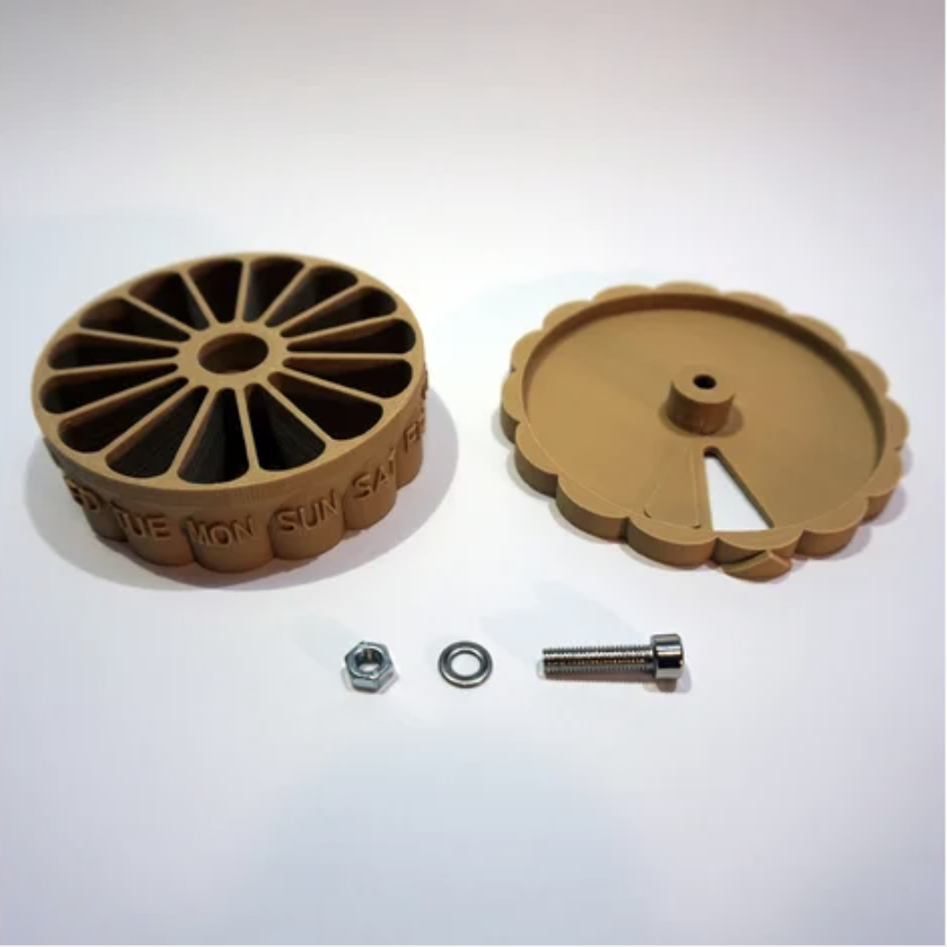
Figure 1: Overall view of prototype pill dispenser build

Screen Display - We want to accomplish setting up a screen display on the front of the machine. The display will have to be user friendly and all information displayed must be easily legible. By making it user friendly and simple to use and read, this will allow us to stay competitive and have more people want to use our product. The information on display will have the date and time across the top. Information about the last medication dispensed with its name and time will be in the center, along with the next upcoming dispense going right under it. The medication previous to the most recent one dispensed will also be displayed along with information next to them like its dates and times of when it was taken.

Main Printed Circuit Board - We want to have enough printed circuit boards (PCB) for this product so all moving parts and power capabilities are met. The rotors and dispensing mechanism is something that will need to be maintained accurately and correctly. The management between the display screen, power, and wireless capabilities will also need to be controlled and assured that power is going to all of them accurately.

3D Printed Parts - The design of the system will have some 3D printed parts to better accommodate the design and have all parts fit perfectly. The outside of the system will be a square that will be 3D printed and inside will have the circular container inside that will rotate to dispense the pills. The pill container that was mentioned earlier will look to be 3D printed as well, and have the hole that the pills come out of be the right size for the pills to come out. A slider will also be there that will slide back and forth to release pills and close them off. The tray to hold the pills being dispensed and the water beside will look to be 3D printed as well, to accommodate both features correctly. The cost of these parts will not add too much to our overall budget, as we have a 3D printing machine at hand already.

2.2 Requirement Specifications

For the pill dispenser to work successfully and fill the need that we want it to fill, it must function without bugs and properly dispense medication at the time specified by the user through the mobile app. Not only this, but it must also alert the user that the medication is ready to be taken.

2.2.1 Overall Specifications

The product shall conform to the following specifications to ensure accuracy, feasibility, and other core traits about its functionality. The specifications shown break down the system into a few major parts that will help us see what specifications are needed for each part. "The device" is referring to the automatic pill dispenser machine.

- The device will be compact and portable to ensure it can be moved around for convenience.
- The device will be no bigger than 1.5 x 1.5 x 1.5 feet (L x W x H).
- The device will be lightweight weighing no more than 8 lbs.
- The device will allow for pills to be inserted by the user into the pill dispenser tray
- The device will use servo rotors to control the rotation of pills throughout the week.
- A raspberry pi will be used in the device.
- The device will be composed of a square outside, circular rotating inside, a pill dispenser tray to put the pills in, a Wi-Fi system, a printed circuit board, a tray to hold the pills and water, wireless communication to the smartphone device, LCD display screen.
- The LCD display screen will be large enough for the user to read the information on it and be user friendly.
- The LCD display will be positioned on the device in a position where it will provide ease of use to the user.
- The device will be powered by an everyday household outlet.
- The device will consume no more than 20 V of power.
- The device will have Wi-Fi capabilities so that it can talk to the server.
- The mobile application and LCD display screen shall use a similar interface for ease of use.
- The servo motors that spins the pill dispenser and device itself will be wired so that they don't interfere with each other.
- The device should cost no more than $400 total.
- The power supplied to the device should be as minimal as possible.
- The power supplied to the device will be adjusted as needed to prevent overheating.
- The device will have 3D printed parts as needed to ensure all parts of the machine fit together.
- The LCD display screen will be no bigger than 5 inches across for displaying information to the user.

2.2.2 Pill Tray

The pill tray will be responsible for holding the pills that will be dispensed, as well as a spot for a medicine cup of water to be taken with the medicine.

- The tray will be 3D printed to ensure it fits with the size of the device.
- The tray will have a container for the pills to fall into, as well as a cup holder for a medicine cup of water.
- The tray will be attached to the bottom of the device.
- The tray will be easily accessible to the user by allowing ample space for the user to reach in.

2.2.3 Pill Dispenser

The pill dispenser will be inside of the machine and will serve to hold and dispense the medication out to the user. The specifications for how the pill dispenser will work are written down below.

- The pill dispenser will be circular shaped no longer than 6 inches across in diameter.
- The pill dispenser will have fourteen slots for pills, each one representing a day of the week for morning and night.
- The pill dispenser will be controlled by a servo motor that will allow it to be rotated as the time and days of the week go by.
- The pill dispenser will be easily accessible by the user for refills or exchanges from the top part of the device.
- The pill dispenser will be powered by the same power that is being used throughout the device.
- The pill dispenser will be attached to the device.
- The pill dispenser will be 3D printed

2.2.4 Database System

There will be a database system to hold all the information the user has inputted about their medications. All specifications on how and where the database system will be setup is specified below.

- The database system will be stored on a cloud server.
- The device will have access to the server at all times through Wi-Fi capabilities, as long as it is powered on.
- The device will extract information from the database system such as, last medications used, current medication being used, and future medication to be dispensed.
- The device will organize this information in a neatly and simple fashion for the user to read from the LCD display screen.
- The database system will take information from the user's smartphone to be configured and stored with MongoDB.

2.2.5 Notification System

The notifications system will be responsible for notifying the user of when their next medication is ready to be taken. They will also be notified about other instances that will have specifications for that below.

- The notifications will be configured by the user and will be sent out accordingly.
- The user will receive notifications when their medication is ready to be taken.
- The user will receive notifications when their medication is running low and a refill is needed soon.
- The notification system will notify the user of the names of the medications that have just been dispensed and when they run low.
- The LCD display screen will be aligned with the notifications system to display information as the user receives notifications.
- The notifications will show up as banners on the user's smartphone device until they confirmed they have taken their medication.

2.2.6 Wireless System

The wireless system will be used to communicate to the server's database from both the device and the user's smartphone device. It will allow the user's smartphone device to send their information to the server and the device to receive that information and be properly updated.

- The device will connect to a Wi-Fi connection to receive information from the database server.
- The device will use the power from the system to supply power to the wireless communications system.
- The user's mobile device will have access to the database server to send and receive information.
- The device will only receive information from the database server, and correctly display it on the LCD display screen.
- The device will be set up to a Wi-Fi connection by the Raspberry Pi's Wi-Fi capabilities.
- The device and the user's smartphone device will interact indirectly by the database server.
- The wireless system will integrate to the main printed circuit board (PCB).
- The device will be constantly connected to a Wi-Fi connection to ensure it is always updated through the database server.
- The user's configurations from the mobile application will be sent to the database server and the device will use that information to configure itself properly so medication is being dispensed at the user's times that they scheduled.

2.3 Marketing and Engineering Requirements

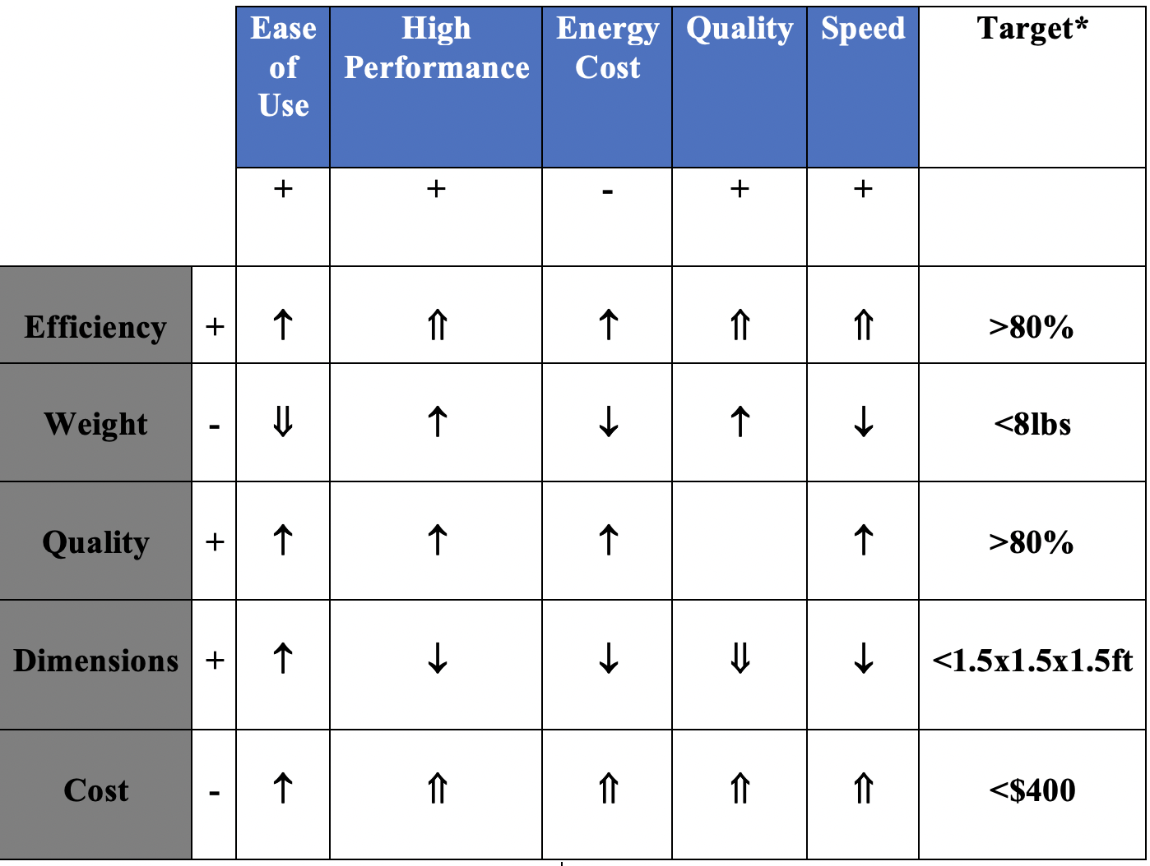
Engineering -  Marketing - 
Table 1: Marketing and Engineering Requirements

↑ - Positive Correlation

↓ - Negative Correlation

⇑ - Strong Positive Correlation

⇓ - Strong Negative Correlation

2.4 Overview of Block Diagram

An overview of the tasks and flow of how the product will work is shown below broken down by color coordination. Each member will have a part of the product to do as an assigned task to ensure the project gets done in a timely manner, and everyone has evenly distributed work.

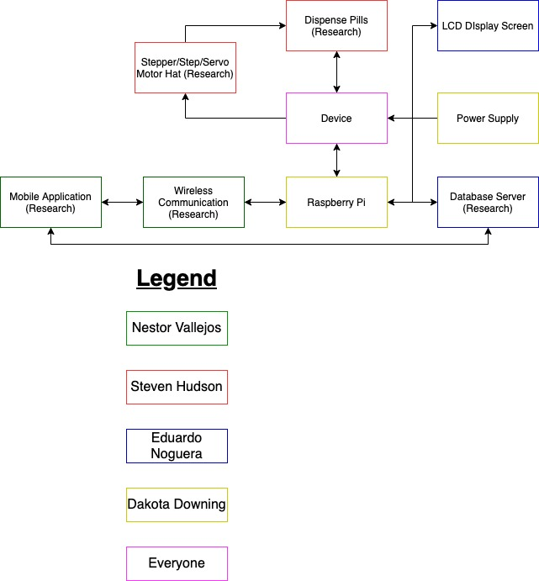
Figure 2: Block Flow Diagram

3. Research related to Project Definition and Part Selection

An automatic pill machine is not an unheard of device in today's smart and always connected world. There are plenty of automatic pill dispensers out there but some of them seem to fall short due to expense or monthly subscriptions. Before moving forward with certain design choices, research was a huge part of what we needed to do in order to get an idea of what we wanted and what parts we needed.

3.1 Existing Similar Projects and Products

In today's world, there are many different designs and products for virtually almost anything. You can find a product or project to meet your needs in the click of a button. What is important in this is innovation. It plays a key role and it is important to differentiate yourself from other similar products to remain competitive. Expanding on other similar designs and trying to improve it is important not only for marketing, but for the engineering aspect. There are other similar products and designs for an automatic pill dispenser, but with different designs and approaches to them.

3.1.1 Hero Medication Dispenser, Manage, and Pill Organizer

There are many products that are automatic pill dispensers. Upon looking at some, we were able to compare and contrast some similar products and projects.

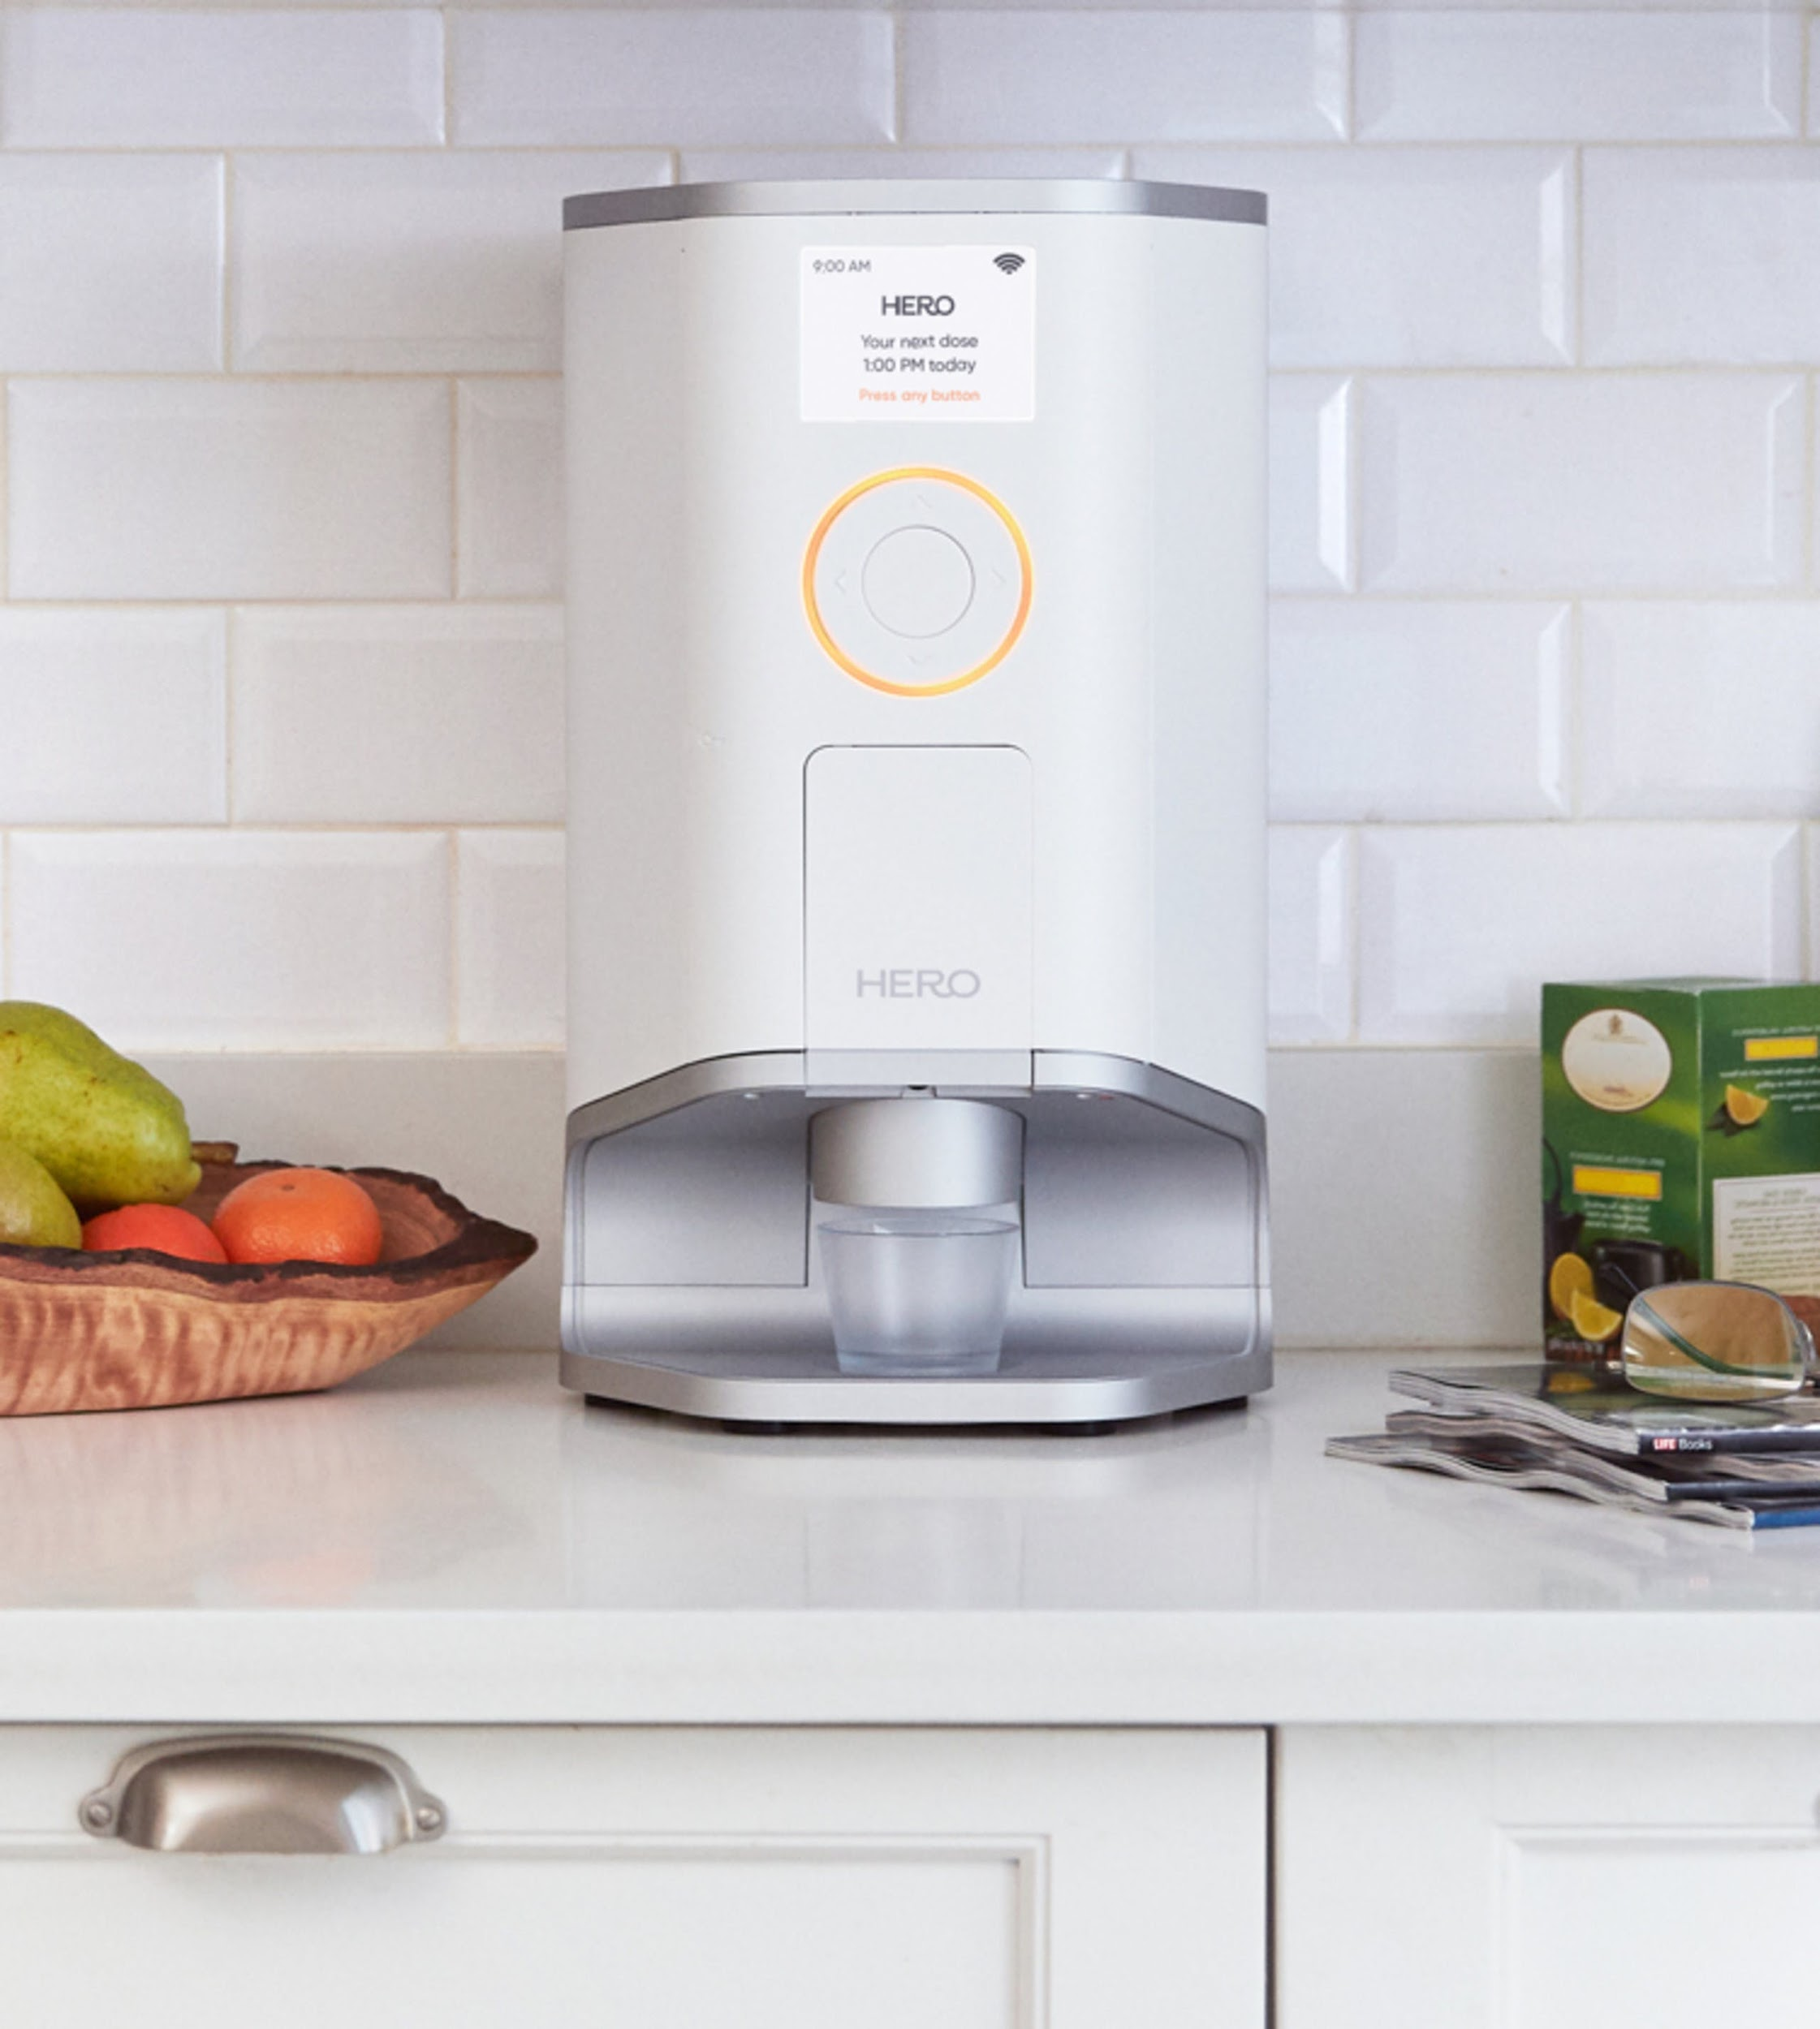
Figure 3: Hero Medication Dispenser

Figure 3 shows an automatic pill dispenser that incorporates automatic dispensing of medication at the user's customized times. The system has audio and visual reminders to let the user know when their medication is ready to be taken. It also allows the user to input a PIN password that will keep the users medication safe. From the figure we can see that it is portable and compact enough for the user to easily move it around to where they need it to be. It allows for enough medication to be filled for a month with more than ten different medications. The system does require a $29.99 monthly subscription with a $99 initiation fee. This is something that can hold it back, as many users take medication for years or sometimes their whole life and the money can quickly add up to be expensive. It also has a mobile application for the user's smartphone device to allow for smartphone notifications for the user to be aware of at all times. Another feature of this particular product is its option to have your medication delivered directly to your door. This allows the user to help keep from running out of prescriptions, over-the-counter medications, and supplements and includes free delivery. It has many features and capabilities, but does not seem very simple or user friendly which is something our product will focus on.

3.1.2 E-Pill MedTime XL Automatic Pill Dispenser

There is another alternative product found that is similar to what we want to build for our current project. With a smaller and circular design, this automatic pill dispenser shows to be a viable alternative to our project.

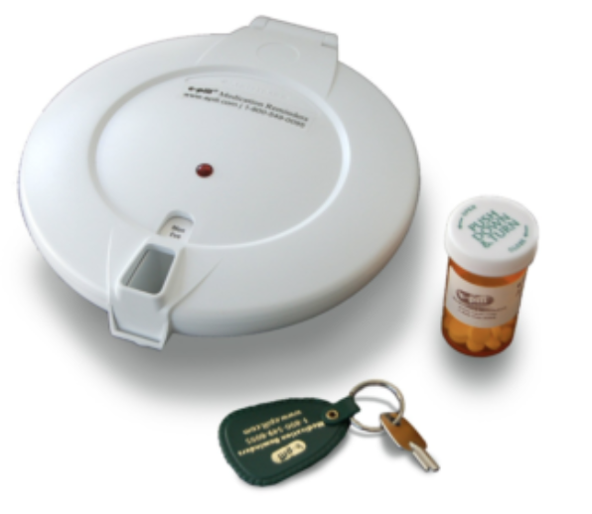
Figure 4: E-Pill Medtime XL Automatic Pill Dispenser

The E-Pill Medtime XL Automatic Pill Dispenser is another product that has automatic pill dispenser features. It is a rotating disk with unlimited number of dispenses (up to 28 a day) as it has 28 slots inside to fit medication in. It is locked by keys, so refilling it with medication requires you to have the keys and unlock it to access the inside. It also has reminders such as an alarm to alert the user when it is time to take their medication. However, it is not connected to a smartphone but rather the noise comes from the machine itself and once notified, you have to turn it upside down to dispense into your hand or cup. It is convenient as it can hold up to 15 aspirin sized tablets per dose, so you are able to store plenty of medication with the system. It also uses 4 AA batteries that last up to 12 months and the machine will let you know when the system is getting low.

Some downsides with this implementation of an automatic pill dispenser would be the fact that you need keys to open the device. Our product is meant to simplify the lives of people and not have to worry about remembering things. The fact that you need a key to open the device to refill your medication is a worry, as if you lose your key then you don't have access to the device anymore. You lose access to your medication and will have to find another way to open it which is very inconvenient. Another feature that doesn't seem so convenient would be that you have to flip the machine upside down to get your medication to your hand or cup. With our product, we look to have that feature be done on its own to a cup, rather than you having to lift a finger to get your medication. Although no monthly fees are required with this product, the price of it stands at around $389.95 - $495.00, which is very pricey. Although some nice features, like its small size and compatibility, it still lacks in ease of use and simplicity.

3.1.3 Live Fine Bluetooth Pill Dispenser

Similar in design to the last product, this one too provides a great alternative and similar product design to our project at hand. Below are its key features and capabilities described to show how it is similar in design.

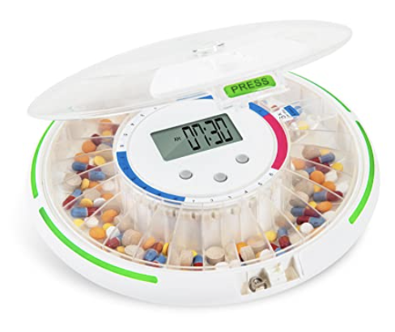
Figure 5: Live Fine Bluetooth Pill Dispenser

The Live Fine Bluetooth Pill Dispenser is similar to the last product but now this one has bluetooth capabilities. It has an LCD screen to allow the user to program manually or connect to their smartphone device so they plan out their dosages. It has a ring design that rotates and allows the user to have pills dispense up to 6 times a day with 28 compartments to hold their pills and medication. The system has visual and audio alerts to let the user know when their medication has been dispensed. One unique feature is that it has a mini magnifying glass over the medications which will give you a closer look at corresponding dosage information.

Similar to the E-Pill Medtime XL Automatic Pill Dispenser, it falls behind on being simple by also having a key to open the medication compartment. If you lose the keys, you lose access to your medication and refills. It's one more thing for the user to worry about on top of their reminders for medication. You also have to grab the product and flip it upside down to get the medication that was dispensed. However, the system does have a competitive price starting at $90.

3.1.4 RxPense Automatic Pill Dispenser

One of the last similar product designs for an automatic pill dispenser was the RxPense Medical Dispenser. Below is discussed of its many features and capabilities along with the pros and cons of having this particular product.

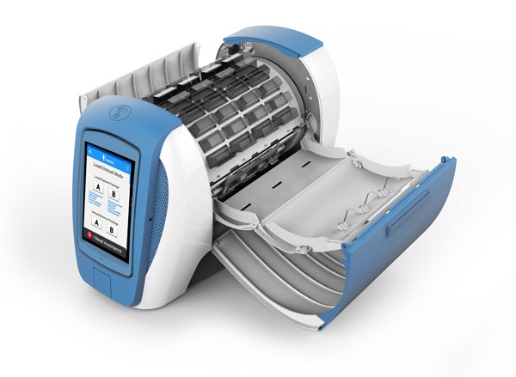
Figure 6: RxPense Medical Dispenser

The RxPense is secure, smart, and connected to the user automatic pill dispenser that assists seniors with medication management and a remote monitoring system. They want to cater to seniors specifically in residences and long-term care facilities, rehab centers, and chronic care patients. This will not only help with medication management, but also with health monitoring and remote management from their home or wherever they are located at. RxPense will ensure the right pills are dispensed at the right time to the right person with security features that make sure the pills are being dispensed to the patient or some authorized person like their doctor or caretaker. This product has many great features that are great and can be taken advantage to provide a unique experience to the user.

Some of the features that the RxPense automatic pill dispenser has that is similar to your project's design is the ability to dispense medication, send reminders, and be compact. The RxPense will hold up to 15 medications per dose for up to 2 weeks. Once the scheduled medication has been dispensed and ready to take, the RxPense will alert the user via voice, alarms, music, or other forms of notification methods. It also has a similar feature to the design we want to implement in our project which is a cloud based server to store and access data. This is the only automatic pill dispenser listed here that has this feature.

The RxPense has some very unique features on top of the ones we want to have in our project. Although the user will be notified by means of alerts, alarms, or notifications on the system, it has also a unique feature to configure the type of alerts. This means that the user can have some form of music playing for when their medication is ready. It also allows the user to customize the alert to be the voice of a doctor or loved one as a pre recorded voice message. With the security built in the product, it will verify the user by means of voice verification to ensure the medication is being given to the right patient. It also has alert notifications by text to their smartphone device or visual alerts by setting lights to off at their specified time. If a patient were to miss their medication, the system has a way to store that medication and alert the caregiver of their missed dosage. The LCD screen on the system has many features and capabilities to show to the patient with touch screen capabilities. The patient also has the ability to communicate from the product to their doctor or caretaker directly without the need of their smartphone device.

Currently, the RxPense system is not available for individual purchase and would require some caregiver or pharmacist to acquire the product. This makes this a little bit inconvenient as it limits the amount of people it can be reached to. Although the features and capabilities are great, it can prove to be a little bit complex which takes away from the simplicity design we look to implement in our product. The price to maintain the RxPense automatic pill dispenser looks to be at around $150 a month, which can also prove to be a hefty investment in something that our product can also do with a better price.

3.2 Relevant Technologies

The following sections will be relevant technologies that we could have used for the design and implementation of our product. The sections will describe the product and its use, and describe why we chose to use the technology or not.

3.2.1 Different Languages used for Implementation

There are multiple languages you can use to implement instructions for the electrical components in your system. There is Python, C, Assembly, and Verilog. We decided to pick between the two more simplistic languages out of the four. The two more simplistic languages are C and Python. These are easier to code in due to the way they implement the syntax and logic. Assembly and Verilog could be easier to use for implementation, but to get the point of implementation it would be hard to understand the syntax needed to perform specific instructions.

3.2.1.1 C Language

The C language is the base language for coding. It is used for hardware systems and software based systems. This language would be beneficial to sending instructions to our components to make the electrical components work. For example, the C language can be used to code instructions onto a MSP430 to perform certain tasks or make electrical components attached to it perform tasks. The C language would be a good choice for implementing our vision for this design because it is an easier language to code in, but it would be complex to use due to the specific actions we are wanting to create. We will use C for programming the ATmega32 microcontroller, but for all other purposes we will be using the other descriptive language for hardware systems, which is Python.

3.2.1.2 Python

Python is also a newly developed language for coding both hardware and software systems. Python is just the same as C, the coding styles and standards are different, but all in all you use Python for the same use as C. Most developers prefer Python though in comparison to C because of the ease of implementation. Python is a little more difficult to code than C for people with no experience with Python, but once some experience is gained in the understanding of how Python works and it’s syntax, it becomes very easy to use and manipulate to implement what you want to do. This is why we plan on using Python to code up our board to issue instructions to our electrical components.

3.2.2 The Different Stack Implementations

For our mobile application, they are two different stack implementations. There are LAMP stacks, and there are MERN stacks. The difference between LAMP and MERN stacks is their purpose, and capabilities. Below will be a more in depth idea of the difference between LAMP and MERN, and which one we decided to choose as a team.

3.2.2.1 LAMP Stack

A LAMP stack is an application development that is a Linux Subsystem with an Apache web server that's coded with PHP or Python, and uses MySQL as a database. LAMP stacks are used for implementing applications where you just want to manage the user's interaction. For example, a contact manager is usually a LAMP stack, the reason being that a LAMP stack is harder to implement when trying to develop more complex applications. It’s harder to implement a LAMP stack due to having to communicate to the database MySQL to rely on PHP backend, and some JavaScript frontend.

MySQL is the database for the LAMP stack. MySQL works with an operating system to make a database within a computer’s storage system. It also manages users and their relationship to other users. MySQL through queries allows users to access the database and either retrieve information or give information to add to their accounts. It stores user information within tables and uses Entity Relationship Diagrams to find the information specifically associated with that user. This system is straight forward.

For beginners and even experts will have trouble implementing this stack because of the different languages used to develop it. Luckily for us, we can implement a MERN stack which is easy to use and implement for multiple applications, and for translation from web to mobile.

3.2.2.2 MERN Stack

A MERN stack is just like a LAMP stack but it’s implemented with MongoDB with help of ExpressJS as a mediator from the frontend, which is React, to the backend server environment known as NodeJS. As stated before, a MERN stack is better used for implementing complex applications. It’s used for more complex implementations for many reasons. One, a MERN stack consists of a singular language for both the frontend and backend and only very little of HTML for styling purposes. A big reason for using MERN over LAMP is the idea that the language JavaScript is a web based development language, and with a MERN stack can directly communicate the frontend needs with the backend. For example, a LAMP stacks server has to reach out to the PHP, Python, or whatever communicates with the backend, get the information, and then the backend returns the information to the PHP, then finally the PHP communicates to the server on what’s in the database. With MERN, the frontend JavaScript can directly communicate with the database and gather the information needed per user.

Its database is MongoDB that stores users and their information as JSON packages within its database tables. This data is extremely flexible because it allows multiple variations of documents to be structured the way you seem fit. MongoDB also stores data that is partially complete. For example, one of our users can create an account with our mobile application and with our mobile application we will insist the user to enter in the schedule for when they have to take their medications; however if the user decides to not implement this portion of our application, then they will still be able to use the main purpose of the application, which is to dispense their medication from our machine.
MongoDB is flexible, has the ability to be dynamically changed or altered, and is easy to use. Thus, we think using MongoDB is a better choice over using a LAMP stack and MySQL.

Another reason for using MERN over LAMP is the idea of having everything in one language. Most of us on the team, we are not well versed with any application based coding language, so having everything in one language makes it easier for the team. We would only have to learn one language apart from the three we would need to learn for implementing a LAMP stack. JavaScript is complicated, but will be easier to learn and easier to manage given the time constraint, to learn and perfect 3 different languages in order to use a LAMP stack would be too time consuming and not practical.

MERN stack is the best choice for the application we plan on doing due to time constraints, complexity, and the needs of our design. We plan on having users be able to keep track of their medications via their own profiles. Also, we are planning on having the users be able to set times and/or reminders on when they need to take their medication. A button will also be implemented with the application to release the medication into the tray.

3.2.3 The Different Servers

One of the important features that we want to implement to the product is to allow the user to easily upload and the product to download information over various platforms and have the user notified of any changes. For this, we want to have both the product and the user's smartphone device connected to a single server for easy communication throughout each other. A server would be a solution to this problem, as it would allow for both the product to connect to the server wirelessly and the user's smartphone device as well. However, having to have both connected to a physical server would not be the most convenient, as it would require constant power through the server and that can be cost efficient. Therefore, we will look into implementing our product to a cloud server.

With a cloud server we will have access to a powerful virtual infrastructure that will perform application and information processing storage in a cloud computing environment. We eliminate one problem using cloud servers, where we don't have to worry about a large physical computer having to stay on at all times to host our product. This helps reduce the cost effectiveness by only paying for what we need and reduce expenses from maintaining server hardware. With cloud services you also get the benefit of scalability, which will allow us to scale computing and storage resources to meet our changing needs.

For our product, we want to use cloud services to allow for communication between the user's smartphone device and the product. The cloud server will also store all information from the user into a database that the product has access to and will allow it to download it and display it on its LCD display screen. Below will be discussed between two of the most popular and efficient cloud services that are possible to use for our product implementation.

3.2.3.1 Google Cloud Platform

One of the cloud services that is out there available for our product is Google's Cloud Platform. The Google Cloud Platform is a public cloud-based machine whose services are available to customers by a way of service components. This means we are able to use just what we need from the platform, rather than everything they have to offer. Whereas with a physical server where we pay for the machine and maintenance, with Google Cloud Platform, we only pay for the services being used. Google's cloud computing services run on the same infrastructures that Google uses for its end-user products like Google search, Youtube, Gmail, and file storage. This shows reliability in the services as even Google themselves use it for one of their biggest softwares and products.

With Google Cloud Services, we would be able to take advantage of its computing resources for deploying and operating applications on the web. The Google Cloud Platform will also allow us a platform to build and run software, and use the web to connect the users of that software. This is exactly what we want with our software application and product. To allow everything to be connected to one server, and allow communication between them with the software.

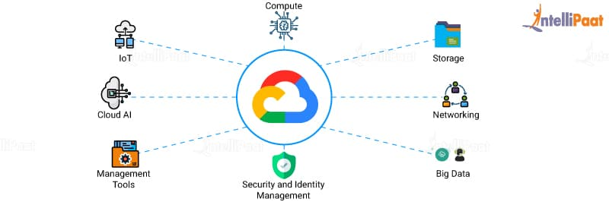
Figure 7: Google Cloud Server Representation

Figure 6 gives us a visual representation on how everything reports back to the Google Cloud Platform and is all connected to the same server. We also have security and identity capabilities that Google themselves use for their private global network to protect your data. We will also be using Google's Cloud Storage for our database. Google stores all their data in object storage, which allows us to store any amount of data and have fast retrieval. Another advantage of object storage is that we are able to represent that data to the user in whatever manner is most useful. This will prove to be useful when we are displaying the information to the product's LCD display screen.

Another factor to look into when picking which cloud service to use is their cost to run our applications. Every service we choose to use consumes resources of cloud computing such as processing power, memory, data storage, and connectivity. Although it is a little bit complex to calculate how much exactly it would cost, since you pay for the resources that you use. An application like for this project should not be very costly, as it is small and would not require much processing power or storage.

3.2.3.2 Amazon Web Services (AWS)

Amazon Web Services (AWS) is another cloud computing platform that is available to be used for our product. They offer services like database storage, content delivery, computing power, and much more. Similar to Google's Cloud Platform, Amazon Web Services allow us to use their IT resources over the internet with pay-as-you go pricing. This is a benefit as it replaces up-front capital infrastructure expenses with Amazon's low variable costs to suit our use.

Amazon Web Services has hundreds of products to use, but one we will be focusing on is their Cloud Computing. We would be able to use the cloud servers for data backup, virtual desktops, software development and testing, and customer facing applications. We would be able to provide personalized information displays to our customers. With cloud computing we would be able to reduce costs, be more agile, instantly scale, and deploy globally in minutes.

We would also have instant access to a broad range of technologies such as computer storage and databases, all deployable in minutes. Other technologies that are available through cloud computing are machine learning and intelligence that will help us customize the experience to our users. Since Amazon Web Services is available worldwide, we would be able to deploy our application anywhere in just a matter of minutes. This allows our product to be worldwide all through the services of one server in Amazon cloud computing.

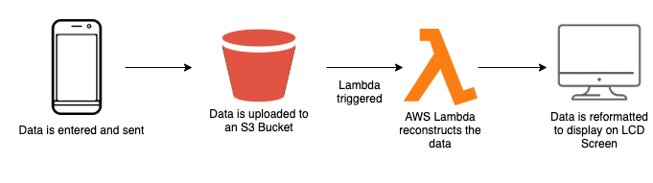
Figure 8: Architecture of information flow with AWS

In figure 7, we have an architecture of how data from the user will be sent to the product using Amazon's Web Services. When the user inputs and sends their information, it will be sent to an S3 bucket. This is an object storage device that offers industry-leading scalability, data availability, security, and performance. Object storage is very suitable when using it with cloud services. Another web service in AWS Lambda will then be triggered to work on the information that has been received from the object storage. It is a serverless computing platform that allows us to run code for any type of application or backend service with zero administration. Lambda will make sure it has everything required to run and will scale it with high availability. Once this is done, we will be able to call it from any web, mobile, or product application, which in our case will be the automatic pill dispenser.

3.2.3.3 Microsoft Azure

Microsoft Azure is another very popular cloud services platform that competes with the Google Cloud Platform and Amazon Web Services. It allows for users to build, run, and manage applications across multiple clouds. With Microsoft Azure we will have access to 200 products and cloud services to help with making sure our application runs as efficiently and is simple for us and the users.

A common service that will be needed from all cloud platforms would be a database to store the users information. Azure has its own in Microsoft Azure SQL Database, which is a relational database. This is a managed cloud based database that runs on a cloud computing platform, provided as a service. It is flexible as it allows quick availability to our database, scalable, and backup of the information. Due to this being serverless compute and hyperscale storage, we are able to focus on building our application without the worry of storage size or resource management. This is due to the optimality of serverless compute and hyperscale storage which automatically scales resources on demand. One thing unique to Microsoft Azure's SQL Database is its built in AI and high availability which maintains peak performance and durability with an Service-level agreement (SLA) of up to 99.995%.

The cost of keeping our servers up is always something that needs to be looked at so we reduce cost effectiveness. With Microsoft Azure, we are able to take advantage of their web services for free for the first 12 months. On top of that we get a $200 credit to explore Microsoft Azure for 30 days. Even after the first year of free services, we will still have access to 25+ web services. This will help us use their services and do testing to see if it is the most optimal and efficient without worrying about the costs for the first year. During the first year, it would also give us time to grow our market and audience and perfect any features with their web services.

3.2.4 The Different Boards

There are multiple boards that we could use to implement a microcontroller. The options we considered are Raspberry Pi, Arduino, and the MSP430. Most of the boards considered are all boards that we as a group are familiar with and have used for projects or assignments. The MSP430 is a board we had to use during Engineering Computation Analysis. We used it to perform simple actions such as lighting sequences, and to work with push buttons. The Arduino board is used for (insert example and its optional use).
The Raspberry Pi is used as a microcontroller to control lots of electrical components and their operations based on the coded instructions that are uploaded. Let’s go into detail their specific operations and how they would be used for our design.

3.2.4.1 Raspberry Pi

A Raspberry Pi is a small computer board with multiple components on it. Depending on the model, the Raspberry Pi consists of a CPU, RAM, network support such as ethernet, and supports peripherals such as keyboard and mouse. The specific model we are going to use for our design can also support a Touch Screen, which we will use to have a user interface displayed.

The CPU on the model that we are using, which is the Raspberry Pi 4, has a range from 700 MHz to 1.5GHz. The memory range that it is capable of holding is 256 MiB to 8GiB for the model we are using. For network implementation, we plan on attempting to implement a wireless connection, so that our board can communicate with our mobile application because the mobile application is going to send instructions to the Raspberry Pi for it to commence on the rest of the components on the design in order for the mechanism to operate.

Pros to the Raspberry Pi:
- USB 3 Port support
- Ability to output 4k resolution at 60Hz
- Almost the same capability as a regular desktop computer
- Ability to hold a large amount of memory with being so small
- Reduced footprint
Cons to the Raspberry Pi:
- Gets overheated very easily
- Key software doesn’t work at launch
All of these qualities lead us to selecting this component for our design because we believe it would give us an easier time to implement it and have it correspond with our design specifications.

3.2.4.2 Arduino

The Arduino board is an open source easy to use hardware and software electronic. The board takes in inputs that are instructions to do things, such as a light sensor, pushing a button on the board, or even a tweet on twitter, and then performs outputs based on the instructions the microcontroller on the board decodes. Some outputs can be to turn on an LED, turning on a monitor, or even publishing a tweet on twitter.

The CPU clock speed for the model we thought about using is 16MHz. The maximum amount of memory that this board could hold is 32KiB of flash memory and 2KiB of SRAM. With this board, we saw an opportunity as a gateway between getting the instructions for the parts of our design and then sending them to a decoder to translate the instructions into actions; however, we found that this would increase the footprint of our design, which is not what we want. We want a small footprint and simplistic design, thus using the Raspberry Pi would provide that since it does both of those actions all at once.

Pros to the Arduino:
- Ready to use - there are multiple components that are ready to use without updates
- Example codes are available online, so if you need help figuring out what you want it to do, you can find it online.
- Effortless built in functionality
- A community that can help with debugging.
Cons to the Arduino:
- Cost
- The structure because it doesn’t support big builds
- Easy use, its it hard to implement and use these boards if you don’t know what you are doing and depending on the size of the design
- Using this board will cause an increase in footprint in our design

3.2.4.3 MSP430

The MSP430 is a microcontroller that can be used as an embedded system. The board can read instructions and produce and output based on those instructions; however with the knowledge we have, the board would have limited applicability. For example, the extent of our knowledge is instructing the board to be a timer, interrupt, and a boolean circuit. By this, we mean it can send outputs of 1’s or 0’s.

The board’s CPU clock rate is 25MHz. The amount of memory it can hold is 512KB of flash memory and 66KB of RAM. A good thing about this microcontroller is the power required for it to use its functionality. The power required is 1µA for it to operate which is the least powered controller out of the group.

Pros to the MSP430:
- Does not need a lot of power to operate
Cons to the MSP430:
- Limited functionality
- Low memory
- CPU clock rate is low so huge processes might take a up time

It can be used for the functionality that we desire; however, the time consumption and amount of money we would need to do to implement this into our design is not in mind. Implementing the MSP430 is a time constraint because in order for us to get it to perform the tasks at hand we would need to do a multitude of research due to our inexperience with the microcontroller and its applications. Implementing this into our design would also make us go over budget due needing extra equipment to allow the implication of this board into the design.

3.2.4.4 ATmega32 8-bit AVR Microcontroller

The ATmega32 8-bit AVR microcontroller is another type of microcontroller that is based on the advanced Reduced Instruction Set Computer (RISC) architecture. This is an unique architecture to the ATmega32 microcontroller as this acts like a computer with a small but highly optimized set of instructions. This differs from other microcontroller architectures as others may be a more specialized set, such as in a complex instruction set computer (CISC). Using the RISC architecture we have an advantage as each instruction only needs one clock cycle to execute, compared to its predecessor CISC architecture. To be more exact, the ATmega32 AVR microcontroller can execute 1 million instructions per second if the cycle frequency is 1MHz.

There are also many key features in the ATmega32 microcontroller that can be utilized to get the most of it. Below are some bulletin points of the features.

- We have access to 32 x 8 general working purpose registers.
- 32K bytes available for system flash program memory.
- 2K bytes of internal SRAM.
- 1K bytes EEPROM
- Access to 4 PWM channels
- 32 available programmable I/O pins
- There are 8 channels, 10 bit ADC
- An master/slave SPI serial interface
- An available programmable USART serial
- An option to have external and internal interrupt sources
- Six available sleep modes that include being idle, power save mode, power down, ADC noise reducer, standby and extended standby.
- A watchdog timer that is programmable with a separate on-chip oscillator.
- 40 pin DIP, 44 pad QFN/MLF, and a 44 lead QTFP version are options for this type of microcontroller.
- The power consumption at 1MHz is at 3V and 25 degrees celcius

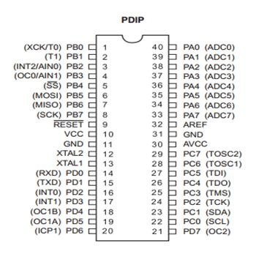
Figure 9: 40 Pin DIP version of the ATmega32

The 40 pin DIP version of the ATmega32 is shown above in Figure 8, that has its 32 registers directly connected to the arithmetic logic unit (ALU). This is unique to this version as it allows for two independent registers to be used in one instruction that is executed in one clock cycle.

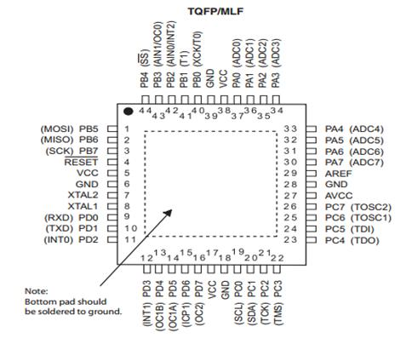
Figure 10: 44 pad TQFP/MLF Version of the ATmega32

In figure 9, it is another version of the ATmega32 8-bit microcontroller which has more pins and in its system has a self programmable flash on a monolithic chip. With this feature, we can have more flexibility and be more cost effective which helps with the overall price of the final project to be constructed.

Some of the pins that are listed above play a crucial role when designing it to our product which can be described as shown below.

- GND: Pin for ground.
- VCC: Pin for a digital voltage supply.
- Reset: Pin for resetting input.
- Port A: (PA7-PA0): Pins that serve as the analog inputs to the A/D converter.
- Port B: (PB7-PB0): Pins for an 8-bit bidirectional input/output port that has internal pull-up resistors for each bit.
- Port C: (PC7-PC0): Pints that are also for an 8-bit bidirectional input/output port that has internal pull-up resistors for each bit.
- Port D: (PD7-PD0): Pints that are also for an 8-bit bidirectional input/output port that has internal pull-up resistors for each bit.
- XTAL1: Provides input to the inverting oscillator amplifier and input to the internal clock operating circuit.
- XTAL2: Directs the input as output from the inverting oscillator amplifier.
- AVCC: Pin that provides a supply of voltage for Port A and the A/D converter.
- AREF: The analog reference pin to the A/D converter.

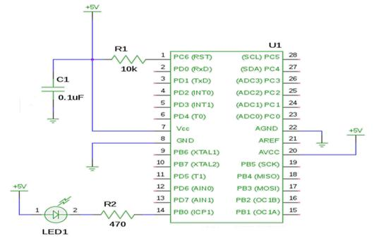
Figure 11: Schematic for ATmega32 blinking LED

Above is an schematic example for the ATmega32 being used to program a blinking LED with utilization of its pins. There is connection being formed to the pins with resistors, capacitors, and voltage all being connected to the microcontroller.

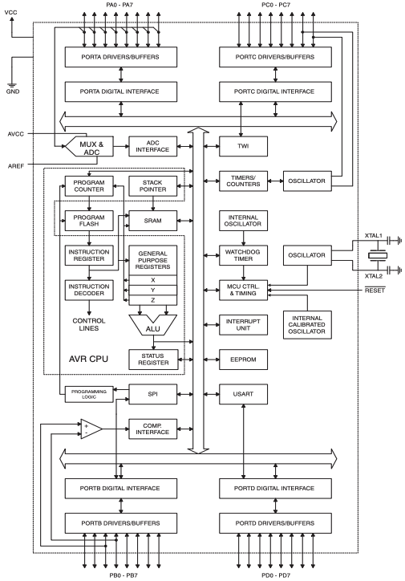
Figure 12: Block Diagram

Figure 11 shows a block diagram for all the pins that were discussed earlier in the bulletin points. It is shown how the pins interact with each other inside the ATmega32 microcontroller and the routes it takes to ensure everything works in correspondence. We can get consistent speeds up to ten times faster than other CISC architecture micontrollers. We also have many tools with programming and system development of the microcontroller that include C compilers and programming with C, program debugger/simulators, in-circuit emulators, evaluation kits, and macro assemblers.

3.2.5 The Different Mobile Application Implementations

An important part of the project is allowing the user to use their smartphone device to not only get notifications of their medications, but to also set up what and when to get their medications. Their smartphone device acts as the remote controller to the product, so we need to make sure the user interface of the mobile application is as simple and efficient to use as possible. There are many different applications out there to use to accomplish this feat, so we will look into some of them and analyze what would best fit for our project. The goal when looking into the technologies of making an mobile application is to make sure it is easy and efficient for us, so we are able to maintain and debug it as the product is being used.

3.2.5.1 React Native

React native is an open source mobile application framework that is used to develop mobile applications for Android and iOS. By allowing developers to use React's framework and along with native platform capabilities, we are able to write natively rendering mobile applications for iOS and Android. Using react native would be useful in our instance since it is written in Javascript but rendered with native code. Since we have experience in Javascript and React as well, switching to react native would not be too much of a problem.

React native would follow a similar coding pattern to react, where we will write many React components that will all come together. React components are small pieces of code that describe how portions of the app will look given some input. However, instead of having elements such as <div> we would use <View>. With this, we are able to compile our code into real, native UI elements. React native also allows for our application to maintain high performance without sacrificing capabilities due to it working separately from the UI thread. Using React native helps with not only the mobile user's experience but with the developer's experience as well.

From a developer's standpoint, there is an advantage to using React native in comparison to other mobile application implementations. Due to React native just being React from the web, you have access to creating a native application but with the feel and look of a web using familiar tools. It is very easy to use, as it is just Javascript with some additional tools and frameworks. Since React native is very similar to React, there is a big community that share knowledge and code reusability. This is very useful as developing with React native is a big emphasis on using components and putting them together to create an mobile application.

3.2.5.2 Flutter

Flutter is an open source user interface software development kit that is created by Google that is primarily written in C++ and also uses dart. The flutter engine implements flutter libraries that include animations, graphics, file and network input and output, plugin architecture, and a tool to check dart runtime. It also provides low level rendering support using Google’s graphics library. Dart is the language that Flutter uses to develop its applications.

Dart is a client optimized programming language used for apps on multiple platforms and is developed by Google. Dart can be used to create mobile, web, and desktop applications. To be more specific, dart is written as an object orientated, class based, garbage collected language with C looking syntax. In my opinion it’s kinda like java in the way it works; however, the syntax is entirely different. Dart can compile either native code or Javascript.

This would be useful for creating our mobile application because it is made for that specifically; however with none of our members really having experience with flutter, we decided that flutter is probably not the best application builder. It could come into consideration if our first choice gives us issues with implementing our design for our mobile application.

3.2.5.3 Kotlin

Kotlin is the native android application development language. Kotlin is the language to use when developing an app in Android Studio.

While using Kotlin for our mobile app development was a viable choice, it would limit us to only having the app available for android. Then if we wanted to develop the app for iOS, we would have had to rewrite a lot of the code in Swift. This significantly increases our development time on the mobile app, which is something we do not want on a deadline. Another issue with using Kotlin is our team experience in the area. While we all have experience using JavaScript, Kotlin is a specialized language that we haven’t gotten much experience in yet. This would mean a lot of extra research time to correctly develop the mobile application.

There was an upside to using Kotlin though. Native languages generally run a lot faster and smoother. Solutions like React Native have been known to have some issues and slow downs in certain areas. These do not exist when using a native language.

3.2.5.4 XCode

XCode is an integrated development environment for macOS that contains software development tools that were created by Apple. XCode includes most of Apple’s development documentations with a built-in interface builder, and the application is used to create user interfaces. XCode can support multiple source code programming languages such as C++, Java, Python, Apple Script, and Swift.

Swift is a programming language used by XCode that is also developed by Apple. Swifts structure is to be a general purpose compiled language that is a redevelopment of Objective-C. Swift is able to work with Apple’s Cocoa and Cocoa Touch frameworks and was basically made to refresh the old Objective-C that was already being used for Apple products and modernize it for easier development in the future.

Since XCode and Swift are for macOS development and are a product of Apple, we unfortunately can not use this framework and the language swift. We can not use it because we want our mobile application design to be on all platforms, so that any one of our users can have access to the product, which means that users with both Apple, Google, and other Androids can have access to our mobile application.

3.2.5.5 Android Studio

Android Studio is the official integrated development for Google’s OS. It heavily supports making Android specific wear applications. This implementation supports all programming languages for app development and it is more well known for using Kotlin. It has a built in Android simulator to test applications on a virtual machine. It even has support on giving templates of common components to applications.

Though this option is viable, we as a group are still unable to use it due to the fact it is platform specific and we really want our mobile application to be versatile and be on multiple platforms, so that every user has access to it.

3.2.5.6 Visual Studio Code

Visual Studio Code is a text editor created by Microsoft for writing code. Visual Studio code makes a great code writing solution because it supports marketplace extensions which allows language support for almost any programming language. This means auto-suggestion and completion along with text formatting can be supported for almost any language. Along with this Visual Studio Code supports an in application terminal for program compiling and execution. Visual Studio code also has an extension for GitHub which integrates GitHub into the application for easy code pushes and pulls. Visual Studio Code is just a text editor, not an IDE.

3.2.5.7 Visual Studio IDE

Microsoft's main development tool is Visual Studio. Visual Studio is a fully integrated development environment built specifically for development teams to work on web and mobile applications. Visual Studio offers a built in GUI for version control through either their own platform, Azure DevOps, or GitHub. This means there is a full GUI for making commits, pushing code, fetching code, and pulling code. This makes it extremely easy to start a project with a team and keep all the code updated on everyone's local machine.
Visual Studio is one of the largest IDE’s in the development space right now and is the IDE of choice for this project as it supports Node.js applications.

3.2.6 The Different Motor Selections

To implement our design, there are multiple configurations we could attempt to perform the same action. There are also multiple motors we can use and apply to the other components to get the same outcome. For example, we could use a DC motor to operate the turning mechanic of our device because when a DC motor is powered on it rotates, so if we were to attach a component of our device, which both of them require to be rotated to perform their task, then we would get a desirable outcome. This idea also applies to the Step motor and Servo motor. Obviously though with them being able to perform the same duties, they have their own order of operation and below will describe the difference between their operations, and whether or not we chose them.

3.2.6.1 DC Motor

A DC Motor is a motor that runs off of electrical current, which when inputted, the motor converts the current to mechanical energy. An upside to the DC motor would be its footprint within our design, rather than increasing our footprint by using two separate motors for the two operations that will be occurring within our design, it would decrease the footprint of the overall design. Also, this motor is applicable because it can rotate; however, we do not plan on to use it.

We do not want to implement the DC motor into our design because it would be hard to manage and make testing tedious and the time consumption is not of our best interest. The tedious testing would be from figuring out to monitor and test the current being supplied to the DC motor, and then attempting to regulate it with other components to get the right input for the motor. Since this would require a numerous amount of testing, the time consumption caused by all of the testing would be not beneficial to us since we have limited time to implement our design and test it. Thus, we decided to not go with the DC motor moving forward.

3.2.6.2 Step Motor

A Step Motor is a DC Motor that is an electromagnetic device that converts digital impulses into mechanical rotations. For example, the Step motor will break its rotations down in steps, so that you don’t need to time, or provide an external signal to know when to stop in rotation, so for a motor such as the base DC motor you would need to either time the rotations so that you don’t over rotate, or use a peripheral that allows notifies the motor when to stop such as a visual sensor.

More advantages of using a Step motor are it’s simple, it’s cost efficient, and it still has good torque at slower rotations. The Step motor being cost efficient is an advantage because the design we plan on implementing is on a strict budget. The Step motor being simple allows for the design to follow specifications, and allows us to easily implement it in the design. Lastly, we plan on running the motors as fast as needed, which in our case is going to be slow or at medium speed depending on what we fully decide, thus it having great torque at lower speeds means that it will perform its task to the full extent. With all of these advantages, it also means that the Step motor would be reliable to implement in our design; therefore, we decided as a collective that it would be best suited for the days of the week design portion.

3.2.6.3 Servo Motor

A Servo Motor is a rotary actuator which allows the user to have precise control of angular or linear position, velocity, and accuracy. The way it operates is that it has a motor that is partnered with a sensor that gives positional feedback to the motor. For our design, the way in which this motor operates is beneficial to our design by being able to turn or open the flap with precision, which will allow the medication to be dispensed cleanly without any issues.

Just like the Step motor, the Servo motor has advantages such as simplicity, cost efficiency, and is able to perform tasks with precision. Its simplicity of use allows us to implement it into the design without trouble. The Servo motor being cost efficient means that it won’t break the budget if we decide to use multiple of them, which we did. Lastly, the Servo motors precision is an Extra bonus to our design because the more precise we can be with the actions that our product needs to perform, the less problems we will run into. Thus, the Servo motor is a great addition to our design and we plan to implement two of them into the design.

3.2.7 The Different Motor Drivers

This project uses the TB6612FNG motor driver by Toshiba to drive the stepper motors, however there are other options out there for driving stepper motors. For example, a popular motor driver that has been used various times for this application is the L293DNE by Texas Instruments.

3.2.7.1 TB6612FNG Motor Driver

The TB6612FNG has a 1.2 A per channel current capability and can draw up to 3A. Inside is a dual channel H-Bridge controller that uses MOSFETs to drive the motors with good execution. You can control the chip via four different modes, clockwise rotation, counterclockwise rotation, short brake, and stop. The H-bridges use the A and B pins for the motor control output and the PWMA and PWMB pins are used to control the motors speed. The TB6612FNG driver works from 91% to 95% efficiency and has a small voltage drop of 0.05 to 0.12V DC. It also has a low current standby mode.

3.2.7.2 L293DNE Motor Driver

The L293DNE is an alternative motor driver to the TB6612FNG. THe L293DNE only functions with 40% to 70% efficiency, has a voltage drop of 1.4V DC and has no standby mode. It is also a large device and requires a thermal management system like a heatsink. The perks of using the L293DNE is that you can drive a motor that requires a larger voltage. Since our device uses 12V steppers, the TB6612FNG was the obvious choice. Its smaller and is a more efficient choice for our needs.

3.3 Strategic Components and Part Selections

This project requires a significant amount of hardware and software to produce a viable and properly functional device. When dealing with something as serious as health and something as volatile as medication, ensuring the proper parts are used and tested for proper functionality is a top priority. When designing this device we decided to move forward with its core being a raspberry pi 4. This device will serve as the brain of the pill machine offering control over servo motors for dispensing pills, as well as allowing the use of an LCD display for displaying important scheduling and pill information. Outside of the core we have an array of containers and servo motors for holding and dispensing pills. These servo motors will control the movement of the pill container and the dispensing of the pills. With the parts listed below and a decent amount of programming, we will be able to create a functioning automatic pill dispenser.

Part Name
Raspberry Pi 4 2GB Model Board
5.0" 40-pin TFT Display - 800x480 with Touchscreen
TFP401 HDMI/DVI Decoder to 40-Pin TTL Breakout - With Touch
40-pin FPC Extension Board + 200mm Cable
Adafruit DC & Stepper Motor HAT for Raspberry Pi
Adafruit 16-Channel PWM / Servo HAT for Raspberry Pi
Adafruit Perma-Proto Half-sized Breadboard PCB
2x Micro servo
1x Mini Stepper Motor - 200 Steps - 20x30mm NEMA-8 Size
3D Printed Chassis Parts and Gears
Grafco 3241 Graduated Medicine Cup, 2 oz
Power Supply
PCA9685 16 channel 12-Bit PWM chip
TB6612FNG Driver
LM2596T Voltage Regulator
LM3940IMP Voltage Regulator
AOD417 Semiconductor
Table 2: Parts List

3.3.1 Single Board Computer

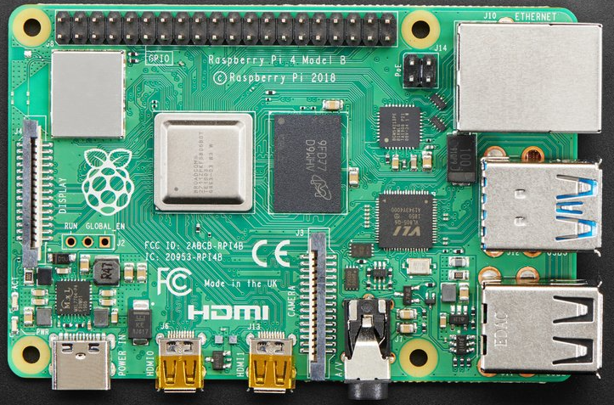
Figure 13: Raspberry Pi 4

As young engineers who haven’t done many of these projects, when choosing the brain of this project we had one thing in mind, flexibility. Flexibility is important for on the fly changes that may have to be done in order to make something work the way we want it to. For this reason and many more, we decided to pick the Raspberry Pi 4 2GB as our computational powerhouse. We decided against a microcontroller for this project because many of us were inexperienced with them and with so many operations going on in the pill machine itself, we decided it may be best to have one device as the brain that can handle a bunch of tasks.

The Raspberry Pi is highly regarded in the hobbyist community and with that come plenty of internet resources for learning. Along with this the Pi is very customizable and open. This means if we need to incorporate an arduino later down the line or some other microcontroller, we could without much of a hassle. This also means we have lots of options for external boards and devices that we may need to extend features and fit the pill machines operation.

Some may feel this board is overkill for the project, and it may very well be. However with limited experience in our corner and a tight deadline, it is better to have overkill than to come up short due to a lack of communication or knowledge.\

The model of board we decide to move forward with is the 2GB RAM model. To be more specific, this board includes;
  - 2GB LPDDR4-3200 SDRAM
  - Broadcom BCM2711, Quad core Cortex-A72 (ARM v8) 64-bit SoC @ 1.5GHz
  - 40 pin GPIO header
    - Our motor HATs will sit on top of these headers to add a more PWM support
  - 5V DC via USB-C connector or 5V DC via GPIO header
This single computer board comes in at a cost of $35 with a small physical footprint and is powered by a 5V source. It is easily programmable, can easily extend to displays, and has built in wifi which will come in handy when receiving signals from a wireless application. The microcontroller and RAM combination on this board gives us more than enough power to output to the display, intake wireless signals from a web server, and regulate a schedule for the motors in order to drop the pills.

The microcontroller on this board is a Broadcom BCM2711. This processor was designed for the Pi 4. It contains 4 cores, runs at 1.5 GHZ, and was built on the ARM Cortex-A72 microarchitecture which implements the ARMv8-A 64-bit instruction set designed by ARM. Details on this MCU are listed in the table below.

Feature | BCM2711
Operating Voltage | 1.2V
Clock Frequency | 125MHz
Memory | 32 KB data + 48 KB instruction L1 cache per core. 1MB L2 cache.
Bit Count | 64-bit
Thermal Design Power | 4W TDP
Temperature Range | -40 – 85°C
Table 3: BCM2711 Details
Ultimately, this board gives us all the tools we need as we move forward with building the pill dispenser and writing software to accompany the features that the dispenser will have. Not only that, but the Pi gives the flexibility to build on those if we have enough time to do so.

3.3.2 Display - 5.0" 40-pin TFT Display - 800x480

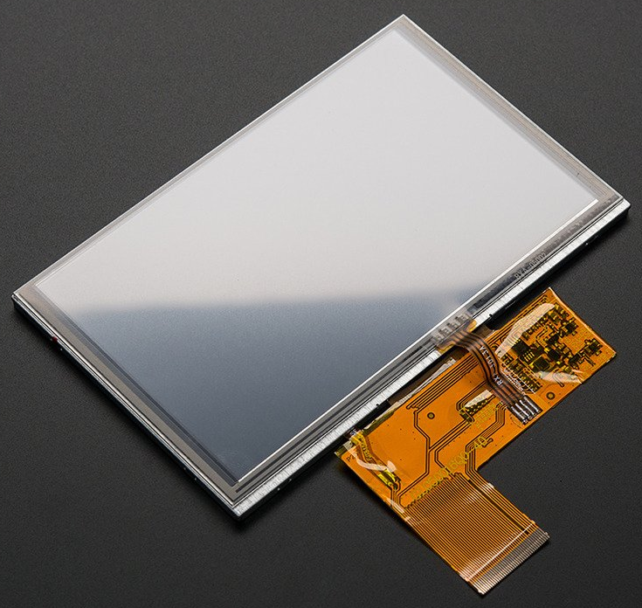
Figure 14: TFT Display

The role of the display is to show the next scheduled pills. This display will show when the next set of pills are scheduled for, how many pills, and what kind of pills you are going to take. Along with this, when the pills are taken, the display will show a message that the pills were taken successfully and a message was sent to a caretaker. For this display we decided to go with a 5.0" 40-pin TFT Display - 800x480 with Touchscreen. The touch screen offers flexibility and allows us to include features that we may want to build out in the future. The touchscreen works with the HDMI decoder to allow us to easily hook up to the Raspberry Pi and begin displaying a pill schedule.

Coming in at a cost of $40, this display gives us a large area of 5" of touchscreen at a small price. This is ideal since our pill dispenser is aimed primarily towards the elderly who take medication. A bigger display allows us to display larger text for those with worsening eyesight. This display refreshes constantly at 60Hz and is a "raw pixel-dot-clock" display meaning it does not have an SPI/parallel type controller or any kind of RAM. It’s resolution is marked at 800 pixels by 480 pixels which is more than enough for displaying text and is connected to an external board via the 40 pin ribbon connector attached to it. It is a color TFT-LCD screen with a white LED backlight. A TFT LCD is a “Thin-film-transistor liquid-crystal display”. Essentially it is an LCD that uses thin film transistor technology to improve image quality. The max rating for this board is shown in the table below.

 | Symbol | Min | Typ | Max | Unit
Logic Power Supply | DVDD | 3.0 | 3.3 | 3.6 | V
Driver Power Supply | AVDD | 11 | 12 | 13 | V
Input High Voltage | V_{IH} | 0.7DVDD |  | DVDD | V
Input Low Voltage | V_{IL} | 0 |  | 0.3DVDD | V
Operating Temperature | T_{OPR} | -20 |  | +7 | ℃
Storage Temperature | T_{STG} | -30 |  | +8 | ℃
Table 4: Max Rating

3.3.3 - HDMI Decoder

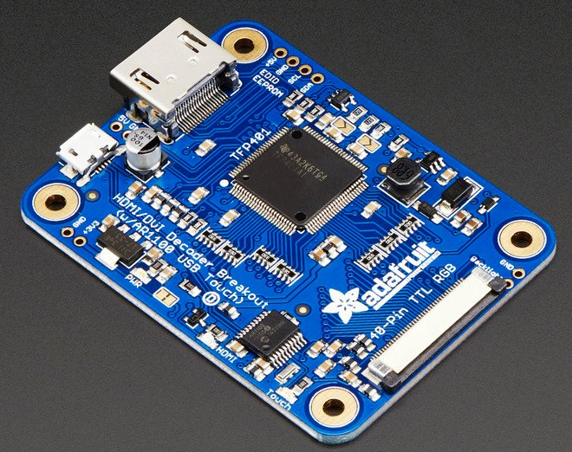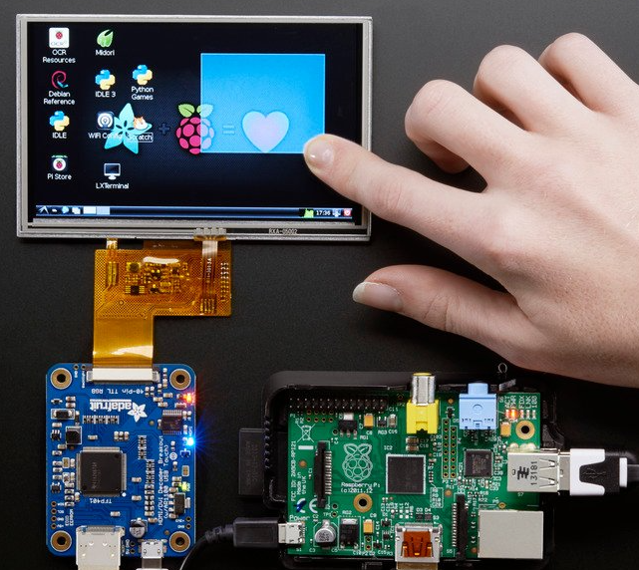
Figure 15: HDMI Decoder and Decoder Hooked up

In order to hook up the display to the Raspberry Pi we need a display driver. This TFP401 HDMI/DVI Decoder to 40-Pin TTL Breakout - With Touch board serves as the driver for our TTL display. The board is powered by a 5V DC input in the form of a microUSB. With this board we can simply use an HDMI cable and connect the Pi to the driver in order to output to the display anything that is on the Pi. It is connected to the display through the 40 pin connector on the board. This board comes in at a cost $30, which makes our display setup a total cost of about $80 ($10 for cables). There are cheaper options out there than a display and driver separate setup. However, these options tend to sit on top of the Pi and take up the GPIO pins that we need for motor control. With this setup we are able to keep the GPIO pins free, and keep the Pi any distance away from the display. The board utilizes the TFP401 decoder from Texas Instrument and uses the DVI protocol to decode and output through the HDMI connector. The board can take unencrypted video and output the raw 24-bit color pixel data. It will decode any resolution from 25-165MHz pixel clock up to 1080p. With the 5” 800x480 display we are using, with the backlight on, this board will draw 500mA in total. It also has a small physical footprint, making it a good low power choice for our automatic pill dispenser.

3.3.4 - Extension Cable

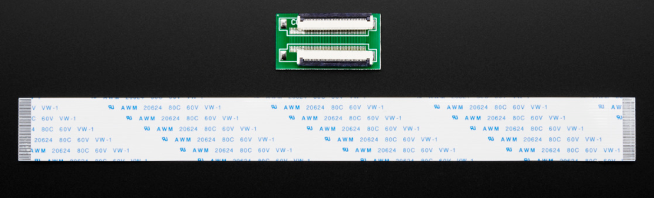
Figure 16: 40-Pin Extension Cable

We included a 40-pin FPC Extension Board + 200mm Cable in the project as a way of distancing the display from the main electronics. This gives us the freedom to mount the main electronics wherever we want in the pill dispenser. This way we are not retained to keeping our Pi right next to the display or the decoder. Coming in at $4.50 it is a nice thing to have as we move forward with the project and design.

3.3.5 - Stepper Motor Hat

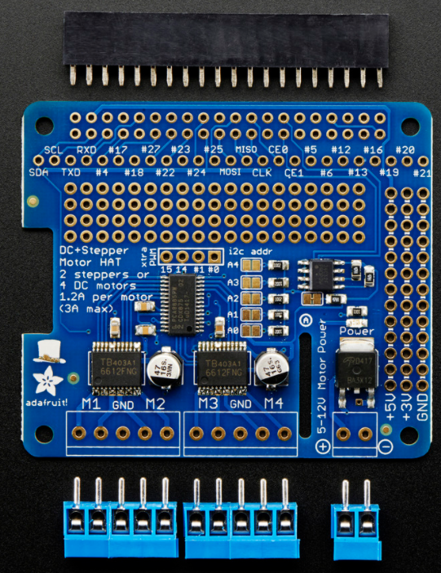
Figure 17: Stepper Motor Hat

The Raspberry Pi is great at a lot of things, but one thing it is not great at is PWM control, something that is a necessity when it comes to motor control. The Pi 4 has only one PWM and it is shared with the audio, so to make up for that we have decided to move forward with this stepper motor “hat”. The Adafruit DC & Stepper Motor HAT for Raspberry Pi is called a hat because it sits right on top of the Pi 4 and it provides a PWM driver for driving motors. Not only this, but it leaves the GPIO available in order to stack other “HATs” on top of it. In our case, we will be stacking a servo motor driver board on top of this one to offer full support for servo, DC, and stepper motors.

This board can drive two stepper motors, or four DC motors at 1.2 amps per motor, with a 3 amp max. The board has a PCA9685 PWM driver which is a 16 channel, 12-bit PWM driver. The board is powered using a 12volts, 5A DC power source, so it cannot simply run off of the current the Pi is receiving. The motors are controlled by four TB6612 MOSFET drivers with 1.2A per channel. The board even offers polarity protection at the power pins. To communicate with the Raspberry Pi, the hat uses I2C. Once enabled on the Pi, can use a Python library to communicate with the motors. We can write Python code to tell the motors how to run and when to run. We plan on using only one stepper motor to turn the pill container to the next day, but it is nice to have the option to drive two motors in case we need it.

This board will be used strictly for testing and development purposes while we finalize our PCB design. This board will help us ensure our design outside of the PCB will work.

3.3.6 - Servo Motor Hat

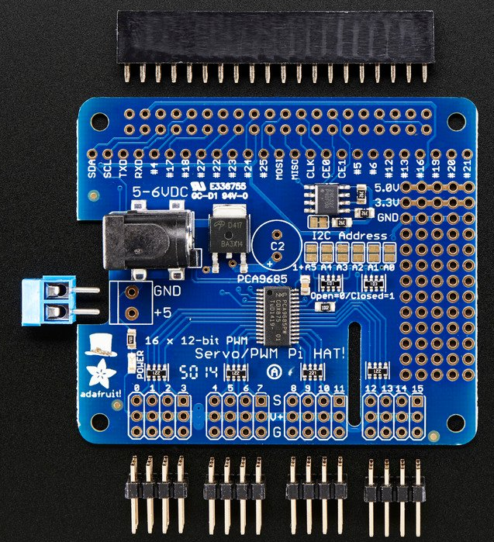
Figure 18: Servo Motor Hat

This Servo Motor Hat was chosen as a way for us to control the two servo motors that will be used to dispense the pills. This board is very similar to the board above except this one is used to control servo motors, not stepper or DC motors. This board will sit on top of the stepper motor hat. These HATs will sit on top of each other in order to give us the capability to control both the stepper motor and the two servo motors.
This board is capable of controlling up to 16 servo motors, which is a bit overkill for our project, but this board will add a PWM driver, which the Pi does not have. This also gives us the option to use more servo motors if we need to, or if we end up adding another pill container and need more servos.

Each servo connects to the board via one of the 16 3-pin connectors located on the board.
The board uses the same PCA9685 PWM driver as the stepper board above, which is a 16 channel, 12-bit PWM driver. The board is powered using a 5-6volts 2A DC power source, and cannot simply run off of the current the Pi is receiving.

To communicate with the Raspberry Pi, the hat uses I2C. Once enabled on the Pi, we can use a Python library to communicate with the servo motors. We can write Python code to tell the motors how to run and when to run. We plan on using only two servo motors to open a sort of “trap door” that will drop the pills out of the machine and into the cup. However, if we go with using two pill cups inside the machine instead of one we will need four servo motors.

This board will be used strictly for testing and development purposes while we finalize our PCB design. This board will help us ensure our design outside of the PCB will work.

3.3.7 - PCA9685 16 Channel 12-Bit PWM Controller

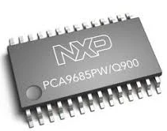
Figure 19: PCA9685

The PCA9685 is an I2C bus controlled 16-channel controller. Intended initially for LED and LCD backlighting, it serves as a great PWM controller for the servo motors and also aids in driving the stepper motors. This PWM controller will be the main controller in our PCB and will connect and receive data directly from the MCU (Atmega32) through the SDA and SCL pins. Our development HAT boards use this controller as a means to drive the servos and the steppers making them a great option for us to incorporate into our PCB design. The PCA9685 has 16 PWM drivers each with 4096 steps (12-bit). Since we only need at most 2 servo motors and 2 stepper motors, this leaves us with 8 extra PWM pins that we can keep for any necessary additional connections or testing.

The PCA9685 also has a noise filter on the SDA/SCL inputs. Since we will be transferring data from the Atmega32 to PCA9685 via the SDA/SCL inputs, this is an incredible benefit to us that makes this controller a great choice for our application. This controller runs on a supply voltage of 2.3V to 5.5V, we will be supplying it with an operating voltage of 3.3V in our PCB design.
Each output can be set to its individual PWM controller value allowing us to write our own program for handling the motor control when the time comes to make the motors move. It has a programmable prescaler to allow us to adjust the PWM pulse widths of multiple devices. This will help in the case of us using both servo motors and stepper motors off of the same controller.

3.3.8 - TB6612FNG Driver IC for Dual DC Motor

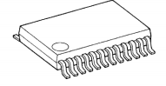
Figure 20: TB6612FNG

The TB6612FNG is a driver integrated circuit for DC motors. We will be using it to drive our stepper motor. This device contains two H-bridges each with their own corresponding control logic. This allows the driver to drive up to 2 motors. Each control logic piece takes in inputs from an external source. In our case, it will take in PWM signals from the PCA9685. We can see this logic and H-bridge breakdown in the figure below.
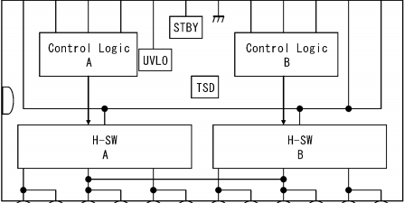
Figure 21: TB6612FNG Internal

This driver features four modes for motor movement, clockwise, counter-clockwise, short brake, and stop mode. The board runs off of a supply voltage of 15V, we will be supplying it with 12V .

3.3.9 - LM2596 Simple Switcher

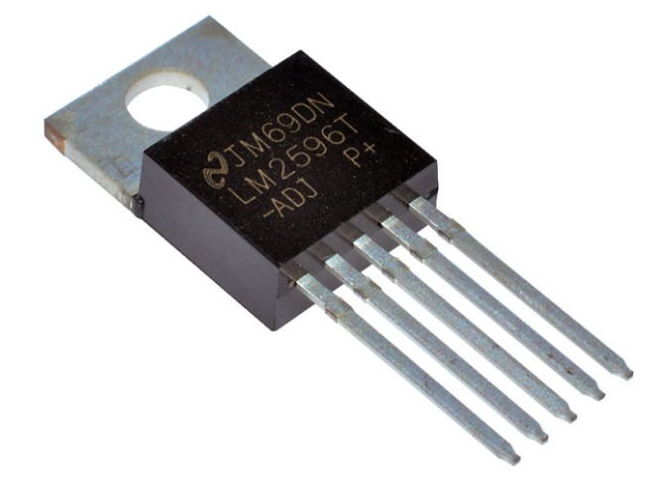
Figure 22: LM2596 Voltage Regulator

There are various parts involved in this project that all run off of different voltages and amperages. This calls for some voltage regulation on our PCB. FOr that exact reason we have selected the LM2596 for some voltage regulation. This device can take in a voltage range of up to 40V and output a range of 1.2V to 37V and is capable of driving a 3A load with great load regulation. It is highly efficient, has a low power standby mode, and offers thermal shutdown with current-limit protection.

Our purpose for this device in our PCB is to intake a 12V DC (the max voltage our board needs) and step it down to a 5V output. This will give us the voltage we need to run our servo motors.
It consists of a VIN, Output, Ground, Feedback, and On/Off pins. A 5-pin system. VIN is the input supply, Output the output, and Ground is the ground. The on/off pin allows the switching regulator circuit to be shut down by logic signals, however we do not need this pin so we will simply ground it. Finally the Feedback pin senses the regulated out voltage in order to know whether the loop is complete.

3.3.10 - LM3940 Low-Dropout Regulator

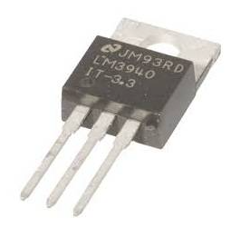
Figure 23: LM3940 Voltage Regulator

We also need to step our voltage down to 3.3V. For this we have chosen the LM3940 voltage regulator. This device will take in our 5V input supply and output 3.3V for us to power the PCA9685. This device is a simple regulator that takes in 4.5V to 5V and outputs 3.3V. It is short-circuit protected and has built-in protection against high temperatures.
This device only consists of 3-pins, IN, OUT, and GND. Ground is common and both IN and OUT should be connected to a capacitor.

3.3.11- ATmega32 8-bit AVR Microcontroller

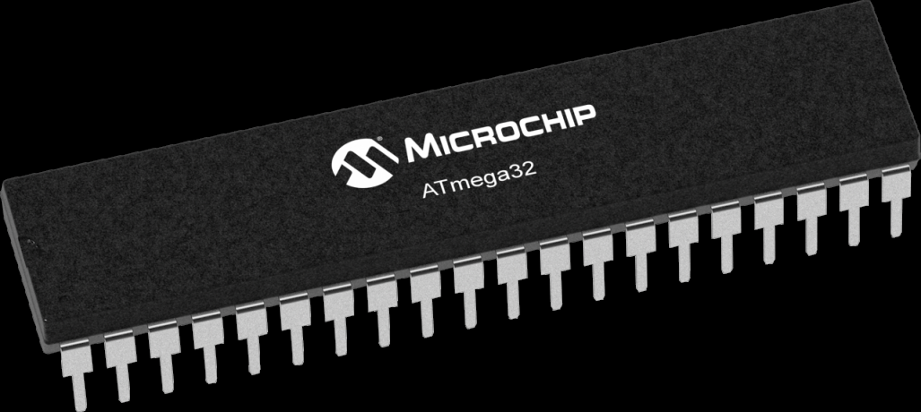
Figure 24: ATmega32 8-bit AVR MCU

The ATmega32 is a widely used microcontroller that we plan to incorporate into our PCB. This microcontroller will serve as a message man between our Raspberry Pi and the motors. The Raspberry Pi will receive data from our database pertaining to when the pills are scheduled to be dropped. The Pi will then parse that data into something more logically usable and send it to the ATmega32 via a yet to be determined communication protocol. The ATmega32 will then interpret that data and communicate it to the PCA9685 via I2C using the SCL and SDA pins on the ATmega and PCA9685.

The ATmega32 is an ultra low-power CMOS 8-bit microcontroller that is based on the RISC architecture. It is capable of close to 1 MIPS per MHz. This MCU runs on a supply voltage of 5V and that is what we will be supplying it with.

3.3.12 - Stepper Motor

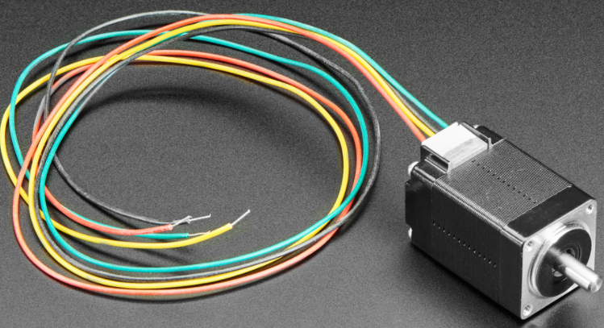
Figure 25: Stepper Motor

The stepper motor will be responsible for turning the pill container to the next day. They will attach to the stepper motor hat board. A generic stepper motor seemed like a bit too large than what we were looking for so we went with this mini stepper motor. Specifically, the “Mini Stepper Motor - 200 Steps - 20x30mm NEMA-8 Size”. This motor is a bipolar stepper with a rated voltage of 3.9volts at 600mA max current.

3.3.13 - Servo Motors

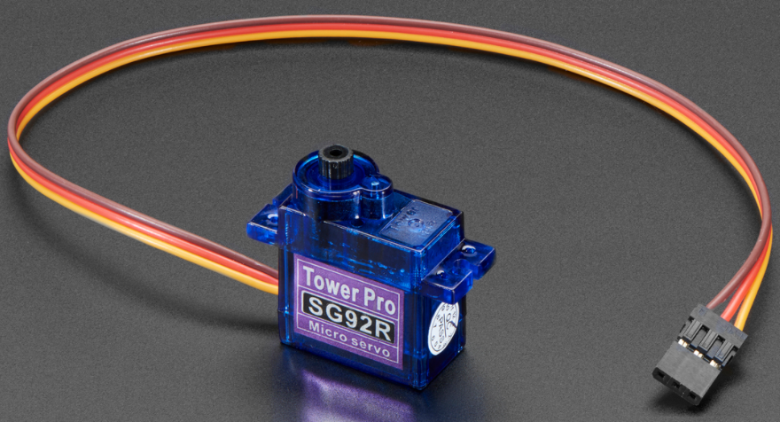
Figure 26: Servo Motor

The servo motor will be responsible for opening the “trap door” style area where the pills for the upcoming cycle are held. This will drop the pills into a medicine container for the users to take. These little servos are called “Micro servos” and we will incorporate two to four of them in the project. These servos will plug into the servo motor hat board. These servos can rotate approximately 180 degrees (90 in each direction). They run at 4.8V nominal (3V to 6V DC), have a speed of 0.1 sec/60 degree (at 4.8V) and a torque of 2.5 kg-cm.

3.3.14 - Speaker

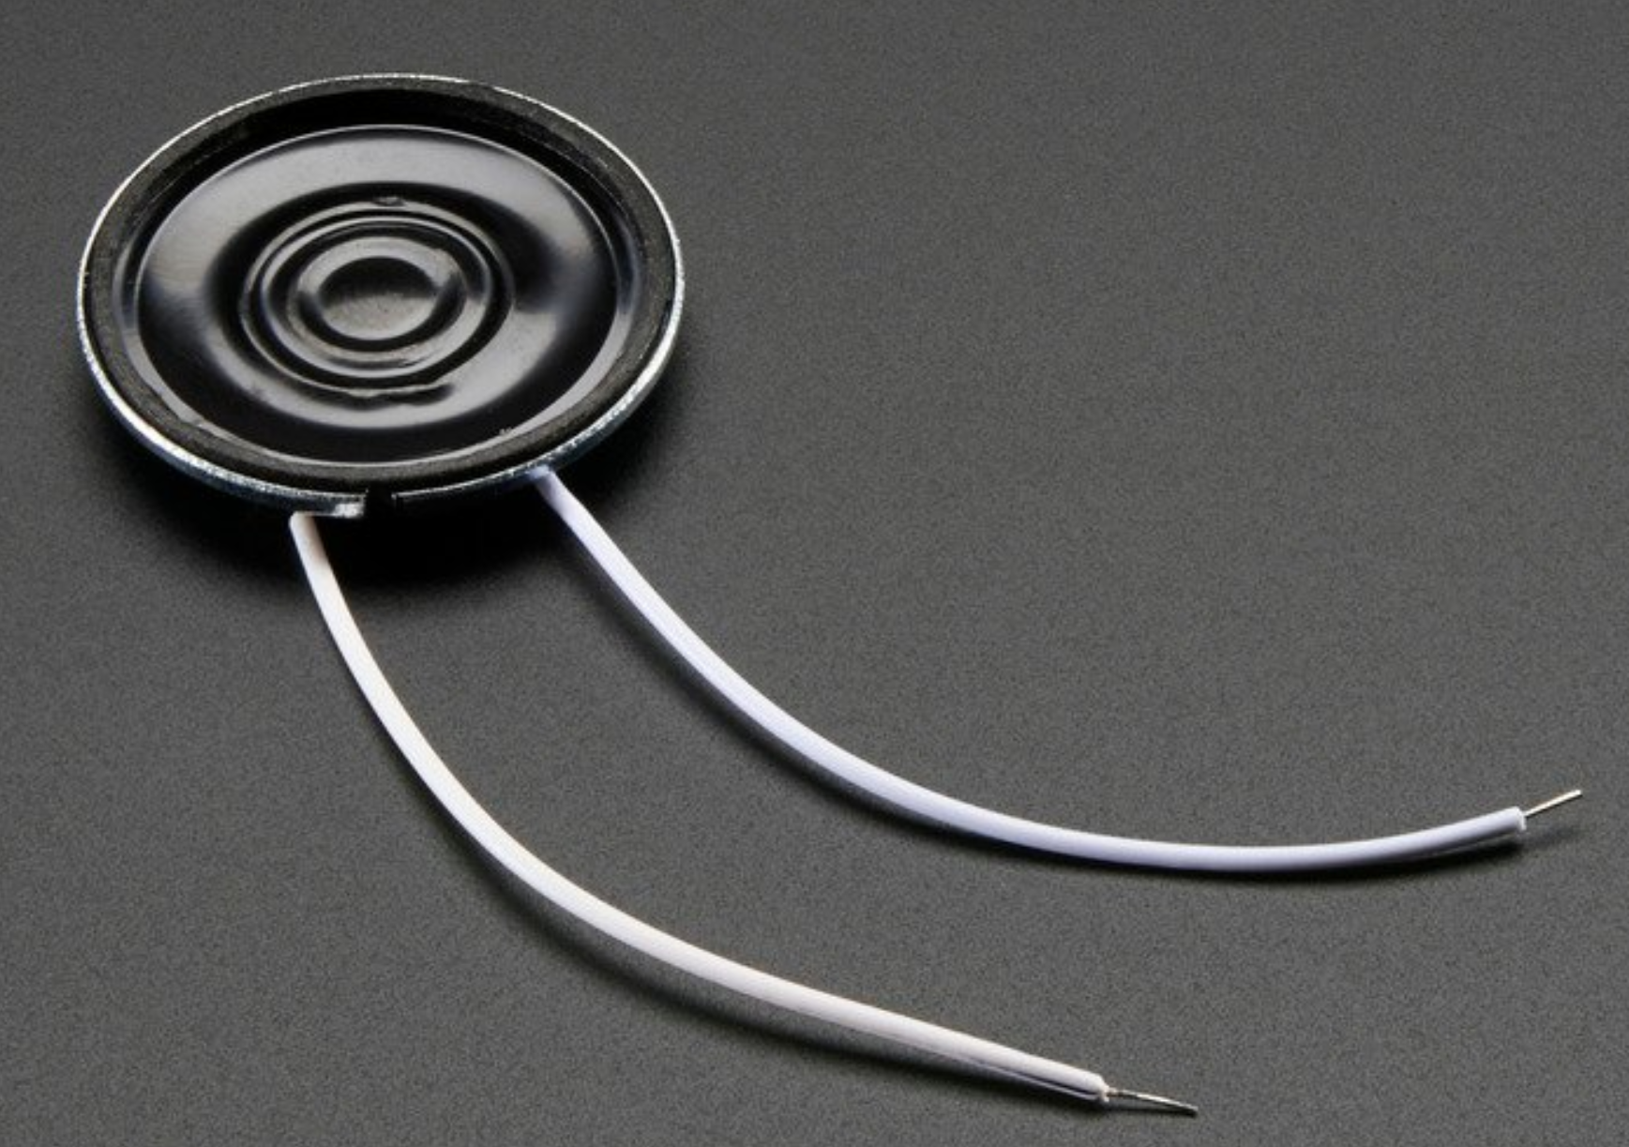
Figure 27: Speaker

This “Mini Metal Speaker w/ Wires - 8 ohm 0.5W” will be used to notify the user that the pills have dropped and it is time to take the pills. This is a small speaker for the Raspberry Pi that will sound an alarm triggered through the Python script when the time comes for the pills to be taken.

3.3.15 - Breadboard and Jumpers

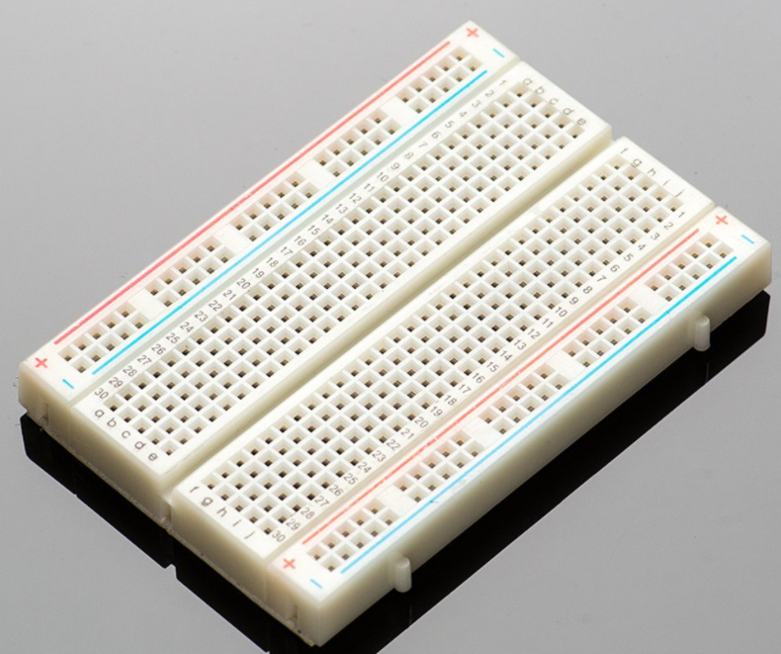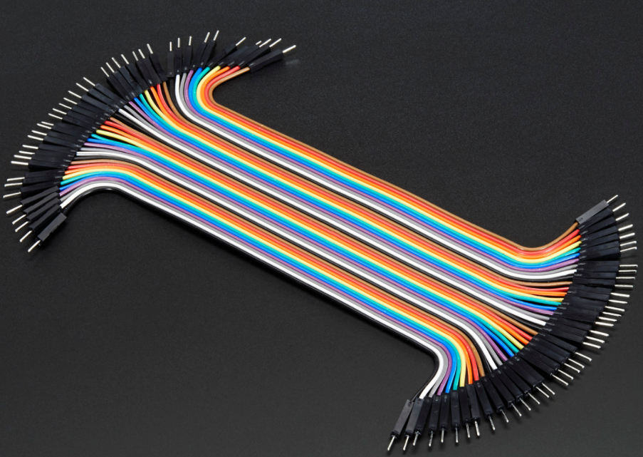
Figure 28: Breadboard and Male-Male Jumper Wires

This breadboard and the jumper wires are for debugging. We do not plan to have them in the final product, however it is good to have a breadboard and some cables for debugging and in case we do need to end up using it in the pill machine.

3.3.16 - Medicine Cup

The product must have a place to have the medication to be dispensed on. Below is our option on that type of requirement for the project.

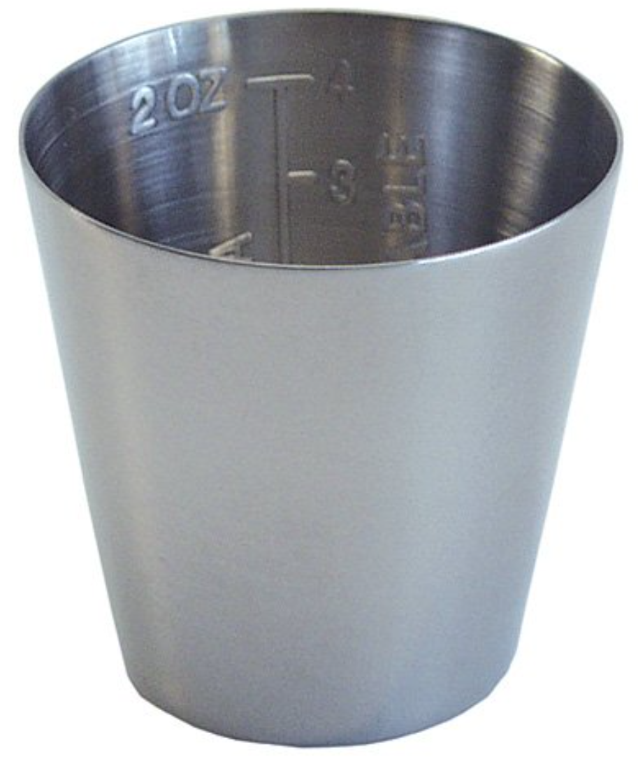
Figure 29: Medicine Cup

This medicine cup is to catch the pills that fall from the pill machine. It is a metal cup for reusability as opposed to a plastic cup that would degrade pretty quickly. More specifically this the “Grafco 3241 Graduated Medicine Cup, 2 oz. Capacity, 2" x 1-3/4"”

3.4 - Possible Architectures and Related Diagrams

When designing the pill machine system we wanted to ensure we had a way to verify our PCB was functioning properly and we wanted a method where we could test our designed PCB separately from the rest of the system. After discussing different ways to achieve the same goals we came up with two separate designs, one with our developed PCB and one where we focus on making the device work purely on helpful development boards that were manufactured for our specific motor controls.

Our designs focus specifically on the user sorting their medication in accordance with what they will input in the app. They will put their medication in the removable pill container and then they will put that container back into the machine. This container will sit on top of the stepper motor.

The first diagram where we depend on the motor controller boards and not our own PCB looks as follows.

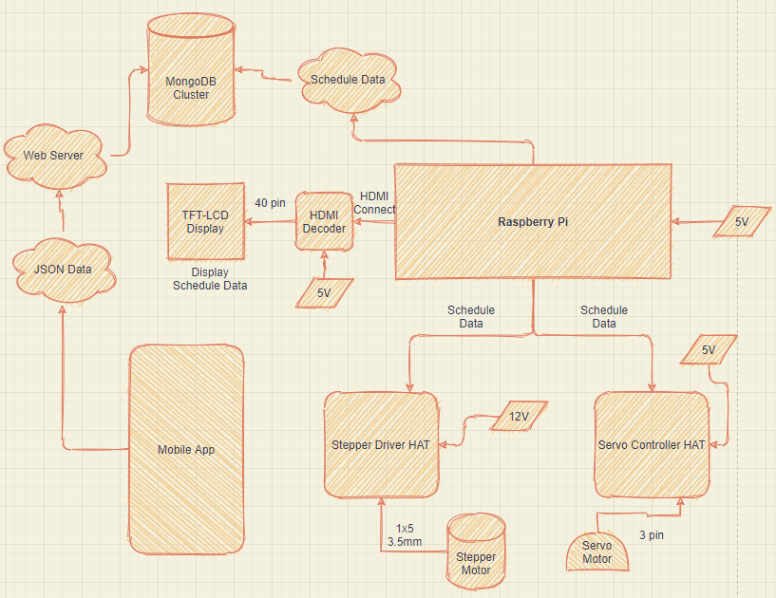
Figure 30: Architecture Diagram (No PCB)

The figure above shows a diagram of the design's components and how they are connected. To give a brief description of how the components will interact with one another, our design begins with the user’s mobile application. The mobile application will have the user of the product sign in, and then enter a schedule of when medication is taken to dispense the medication. Once the user enters this info on the app, it will send a signal to the Raspberry Pi to start the instructions to the following connected components. The instructions depending on the components will consist of actions, or a generated user interface. The instructions with the generated user interface will be sent through the HDMI to the HDMI Decoder which will then send the image to the TFT Display. The TFT Display will have an image for the user to see and interact with the instructions with actions to take will be sent to their respected components which are either the step motor or the servo motors. These actions will be translated by the respected Hat’s then sent to the components to perform their mechanics. The actions will be the step motor, to rotate the pill containers and if the servo motors, it will open the locking mechanism that is holding the medication within the container.

However once we dove more into research and development we came up with our second design which incorporated our own made PCB, complete with an ATmega32 microcontroller and motor drivers to move and control the motors. With this new schematic, the design becomes more reliable and stable because of the separation between giving out instructions to actually having the components doing the tasks. So now the functionality of the overall design remains the same; however, now when the Raspberry Pi receives instructions they will be sent from the Pi into the ATmega32. The ATmega32 will then decode the instructions and turn the data into signals of 1’s and 0’s. These signals inform the stepper motor driver and the servo motor complete the actions based on the signal. Ideally, 0 means to not perform an action, and 1 means to do the action. These actions will be timed with the microcontroller so the process is smooth and concise to reduce energy waste. The process of the user based interface components of the design such as the Touch Screen Display with the GUI will remain the same. The power to the whole system will be regulated by the PCB. With a combination of resistors and capacitors, the voltage supplied to the system of components goes into the PCB and the PCB provides a down step system to reduce the input voltage of twelve volts from the overall PCB system to 5v and 3v through resistors and capacitors. We made the PCB this way to prevent short circuiting or power surges within the components to prevent malfunction and even component termination.
This design looked as followed in the figure below.

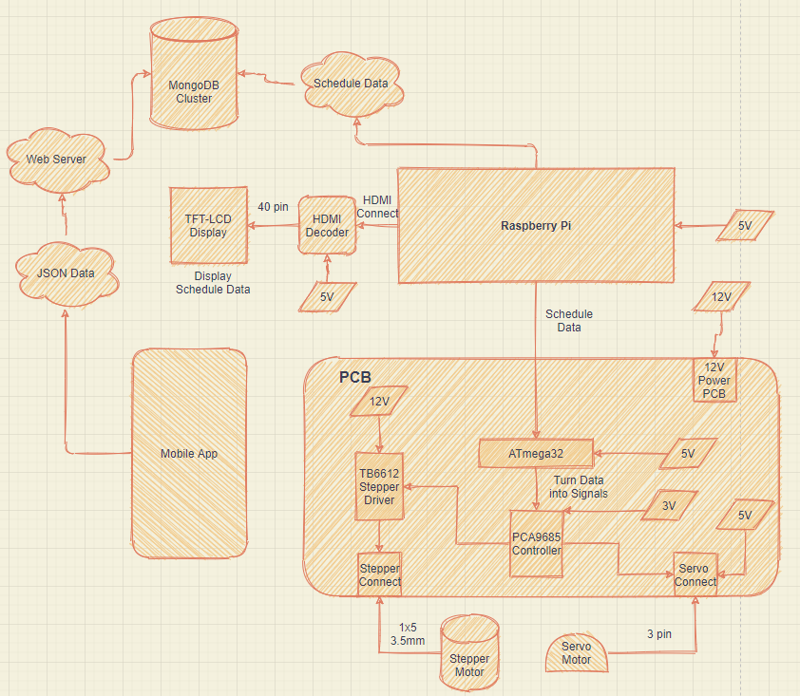
Figure 31: Architecture Diagram (PCB)

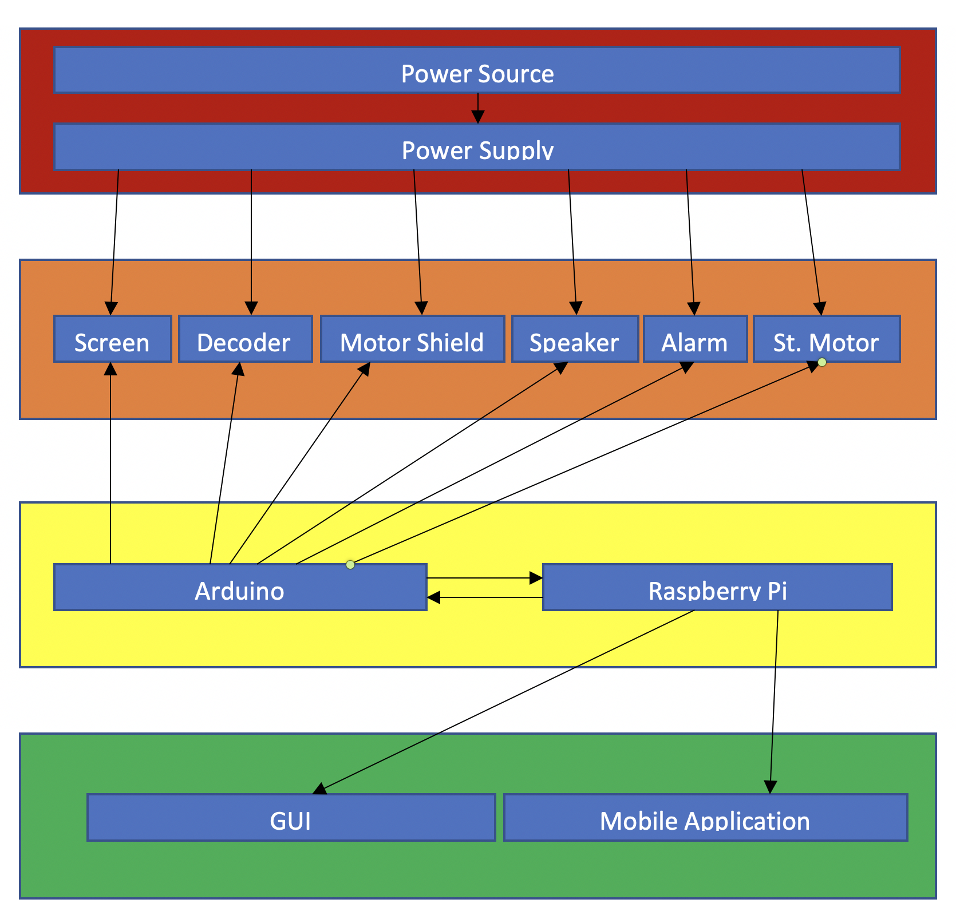
Figure 32: Architecture Diagram

The diagram above represents the other configuration of our design. It starts off with the mobile application communicating to the Raspberry Pi which then communicates instructions to both the Arduino board and the Touch Screen Display. We found the Raspberry Pi to be an effective medium between the mobile application and the rest of the equipment. From there, the Touch Screen will display a generated user interface, for the user to interact with scheduling of the medication. The Arduino will break down the instructions from the Raspberry Pi, and tell the other components what their functions they will be performing. Everything else will follow their instructions. We found this design to be broader rather than concise like the first diagram. A benefit to this possibility is that since it's broader there are easier ways to find where the components are going wrong if the product were to malfunction.

3.5 - Parts Selection Summary

Table 5: Parts Summary

Parts | Model Number | Manufacturer | Cost
Raspberry Pi 4 2GB Model Board | B | Raspberry Pi | $35.00
5.0" 40-pin TFT Display - 800x480 with Touchscreen | * | * | $39.95
TFP401 HDMI/DVI Decoder to 40-Pin TTL Breakout - With Touch | TFP401 | Adafruit | $29.95
40-pin FPC Extension Board + 200mm Cable | * | * | 4.50
Adafruit DC & Stepper Motor HAT for Raspberry Pi | * | Adafruit | $22.50
Adafruit 16-Channel PWM / Servo HAT for Raspberry Pi | * | Adafruit | $17.50
Adafruit Perma-Proto Half-sized Breadboard PCB | * | Adafruit | $5.00
2x Micro servo | SG92R | Tower Pro | $5.95
1x Mini Stepper Motor - 200 Steps - 20x30mm NEMA-8 Size | * | NEMA | $19.95
3D Printed Chassis Parts and Gears | * | * | *
Grafco 3241 Graduated Medicine Cup, 2 oz | 3241 | Graham-Field | $7.00
1x Ultrasonic Sensor | HC-SR04 | * | $3.95
Power Supply | * | * | *
PCA9685 16 Channel 12-Bit PWM Controller
TB6612FNG Driver IC

LM2596 Simple Switcher
LM3940 Low-Dropout Regulator

ATmega32 8-bit AVR Microcontroller

4. Related Standards and Realistic Design Constraints
This section will discuss the standards and constraints that will apply with creating our Automatic Pill Dispenser.
4.1 Related Standards
Standards are required before designing a product to know the technical specifications to meet certain standards for optimal user application. “Standards are published documents that establish specifications and procedures designed to ensure the reliability of materials, products, methods, and/or services people use every day.” (IEEE.org, 2011) We will be needing standards for our design to ensure the safety of the users of our product, and for the safety of anyone or anything related to the user that could potentially have access and use our product.
There are multiple different standards that we can use as a base for our design and project such as the IEEE Standards Association, the NSSN which is a National Resource for Global Standards, ANSI, etc. The ANSI, American National Standards Institute, “is a private non-profit organization that oversees the development of voluntary consensus standards for products, services, processes, systems, and personnel in the United States.” (ANSI) A brief history of ANSI is that this organization formed in 1918, which was also known as the AESC. AESC was a joint effort of the five main engineering societies such as the IEEE, ASME, ASCE, AIME, and ASTM. Once they formed the AESC, they came to an approved consensus standard to live by. The ANSI themselves do not develop standards, but this organization acts as an administration to the development and use of the standards. “ANSI accreditation signifies that the procedures used by standards developing organizations meet the Institute’s requirements for openness, balance, consensus, and due process.” (ANSI) We will use this organization as a reference to what standards we should incorporate into our design. Since this product will be mainly in America, we will be using the ANSI as an aid to the standards we set forth for the design of the Automatic Pill Dispenser.
For the electrical portion, we will be referencing the IEEE SA standards for the electrical portion. The IEEESA is an organization that develops standards for anything that uses power and energy. The standards they develop are monitored by ANSI. We will be using the IEEE SA standards to determine the standards for most of our components such as servo motors, breadboards, TFT display, etc.

4.1.1 Servo Motor standards IEEE 3001.11
There are many standards for Servo Motors given by the IEEE 3001.11. One of those many standards is overload protection. Overload protection is the idea of protecting the equipment from overheating due to the current becoming greater than the maximum running current that the motor can support. In relation to this condition, the IEEE requires that “motors of less that 600V” (IEEE) be protected from overloading. To ensure that this standard is met we need to dedicate a steady current, or run the motor at a specific speed so that it does not pull more current that would possibly be greater than the maximum running current the motor can support. The standard needs to be met to provide safety for both the equipment and the user. It will provide safety for the equipment by not having a chance for a part to malfunction, which would allow the machine to continue its process without risk of harming the user. These standards also provide safety for the user because if a part were to malfunction it would cause the product to be down for maintenance or out of use, and if the user prior to this put their medication into our machine, then their medication that they would need to take would be stuck. The user then would be either put into a compromised position with their medical health and this is what these standards are trying to prevent.
Another standard that needs to be followed for the safety of our users is Overcurrent protection. Overcurrent protection is in place to protect the components and the motor itself from short circuiting and/or ground faults. “Overcurrent conditions due to faults can cause damage to motors, controllers, and conductors.” (IEEE) This standard is applied to any motor less than 600V just like the Overload protection standard. “Overcurrent protection can be provided by circuit breakers, motor circuit protectors, or fuses.” (IEEE) To protect our product and our users, we are going to implement the circuit breaker the standard recommends, which is thermal-magnetic circuit breakers. This will support the servo motor from the Overcurrent conditions over time and prevent further damage to its individual components.
4.1.2 Design Impact of Servo Motors
The impact to the design of the Automatic Pill Dispenser due to the Servo Motors is basically the whole product. The Servo Motors will play the main role in the movement of the product. In the product design, the Servo Motors are rotating our dispenser to the separate days of the week and dispensing the pills. The rotation of our machine is important for smoothly transitioning between days and reducing the idea of accidently dispensing a day ahead of schedule. Dispensing a day ahead of schedule will put the user in danger of either overdosing or simply the possibility of someone else or something else taking the users medications, which would lead to medical health issues. Incorporating the Servo Motor in this fashion guarantees this prevention.
The other way we are incorporating the Servo Motors is using them to dispense the pills. The characteristics of why this is so important is previously described and includes the idea that the first purpose of the Servo Motors is dependent on the next one. If we do not use the Servo Motor to do the dispensing, then there is no purpose of our dispenser. There are different forms of dispensing; however, the easiest to manage and safest form is using a Servo Motor that will open and close a flap that the pills will be resting on.
When including the Servo Motors and applying the standards to them, the Servo Motors purpose and mechanisms will be in full effect and allow our product to succeed in its purpose of dispensing pills for our users. The only impact that the standards will have on our design is the inclusion of parts needed to prevent Overload and Overcurrent, which will be a circuit breaker, to prevent further damage to the components, and a monitoring system that will allow use to monitor the current so that it does not surpass the maximum running current specification.
4.1.3 Python Standard
The standard for python is mostly a styling and space management standard. A style guide highly recommended as a standard is PEP 8. “This document gives coding conventions for the Python code comprising the standard library in the main Python distribution. Please see the companion informational PEP describing style guidelines for the C code in the C implementation of Python.” (python.org) Following a styling standard allows for other developers to read and understand code more easily due to the uniform styling.
The space management standard of python relates to when calling libraries to use specific functionalities that are already built into those libraries. An example of this is most people when calling on libraries will call on all of them so they do not have to write out every individual import; however, this takes up lots of space and memory when compiling, which can reduce run time and space on the component that is holding the code.
4.1.4 Design Impact of Python
We will be using Python for the raspberry pi. Without the raspberry pi, our servo motors will not be able to turn or do their assignments with requests. The servo motors would have to be operated manually in order to turn the mechanism to a specific day of the week at a certain time, and then dispense the medication into the tray. With the servo motors not needing to be hand operated in our design hence the Automatic portion, Python is essential to code the instructions to the raspberry pi is immense for the design of our project because with the instructions on the raspberry pi, it can assign tasks to the servo motors when called on by our mobile application. Overall, Python is crucial for the overall mechanics of our design to function automatically.
4.2 Realistic Design Constraints
The following pages describe the realistic constraints for the following categories below:
- Economic
- Time
- Environmental
- Social
- Political
- Ethical
- Health
- Safety
- Manufacturability
- Sustainability
The implication of these constraints is based on the improvement of society and the quality of life that is provided, which is what leads the design of the product. The constraints affect the specifications as well as the requirements to make the product to meet standards. Constraints are accounted for because in the end they are based on the user’s needs, the resources that are available for the product to be manufactured, and other outside factors. Realistic constraints make the creation of this product more challenging, and time consuming; however, at the end of the day following the constraints provides customer satisfaction, safety, and reliability. Every design needs realistic design constraints to successfully implement a design that is based on what is possible rather than impossible. With the following pages, the individual realistic constraints will be considered separately, then I will combine to show how they all depend on each other to create a complete and successful design.
4.2.1 Economic and Time Constraints
Economic constraints are realistic because based on the economy that the design is being implemented in will determine the budget and part selection applicable to the design. An economic constraint for our group is heightened by the Covid-19 pandemic. The Covid-19 pandemic has made most of us lose our jobs, and other sources of income, which affected the budget immensely. Since we are a group of college students during the Covid-19 pandemic and have no sponsorship, the budget for this design is four hundred dollars. There are advanced electrical components that are beneficial to our design; however due to the budget, many of those components are being substituted with cheaper models. For an example, (insert example here). The economic constraints can unfortunately reduce efficiency and flexibility of our design and make it hard to find substitutable parts that can both mirror and/or match the more advanced technologies capabilities.
While at the same time economic constraints are an issue, time constraints should as well be kept in mind. The process of researching the suitable parts to fit within the design parameters that meet the standards and building the design with these components is a time-consuming process. To combat the time constraint, a schedule needs to be made to ensure that the process of gathering and creating the design stays on track; however, creating a schedule also takes time away from the original process. Due to Covid-19, the process in building the design will be a long process due to the limitation on what tools can be used and meeting up with fellow teammates to aid in the building of the design.­­­ To reduce the issues caused by this constraint, A schedule needs to be created and completed in order to ensure the building of the design to be efficient.
4.2.2 Environmental, Social, and Political Constraints
With the design we are implementing, there are a few political constraints that stems from the usage of our design. A good example would be that we are legally liable for the user’s usage and the functionality of our product. Let us say that our machine malfunctions and dispenses the wrong pills that relate to a different time and date that is current to the user. We, the developers of this product, are liable for the conditions that the user will face with taking the wrong set of pills at the wrong time/day. Thus, the user can legally take us to court. There are ways of avoiding this such as making the user sign an agreement of usage basically making the user acknowledge the usage of our product could be dangerous if a malfunction would occur. Another way to avoid this is to do numerous amounts of proper testing and taking the statistics of the components of the design malfunctioning, then tweaking the design until the percentage of the product faulting becomes very slim.
Due to our design being mainly built with electronics, our product will have environmental constraints because of the possibility of the components within our design becoming outdated and if not attended to with updates then the components will count as waste over time when it is thrown out. These constraints are hard to control due to the technology forever evolving.
The social constraints of our product would have to be that our design does not allow for much portability, so if the user puts their weekly pills into the correct sections, then they will have to be near the machine at all times to take them because the design makes the medication less accessible. This constraint will need to be looked more into for future updates to our original design. Another social constraint could be that our product is not best around a social gathering because if a malfunction were to occur and someone from the gathering were to take the medication it could bring on a serious lawsuit. To prevent the issue of anything other than the user from taking the medication, we plan on making a portable prototype in the future.
4.2.3 Ethical, Health, and Safety Constraints
There are mild health constraints to the design of this product. An example of a health constraint for this product is that the user inserts their medication into our product to take at a specific time of a specific day. Now, if our application where to malfunction or the product itself does not work for when the user needs to take their medication, this then can raise a health concern because our product shouldn’t be trusted with vital medications. To make sure this constraint is not really a constraint numerous tests are being implemented to check for faults. If a fault occurs, then we are going to reprogram our product so that a fault has a severely low percentage of ever happening.
In relation to health, there are safety constraints to this product because it does hold prescription medications, which mistakenly or at uneven doses can lead to bad side affections or make the current health conditions worse. Thus, safety is a priority so that there are no risks to the user, or anyone related to the user, or anything that can have access to our product. To prevent any safety issues, we are using a mobile application that will be registered to the user of the product. They will have to create an account and display the medications that they will be taken on specific days, with specific times. The application will then notify the user of when they must take their pills. The user will then have to press a button to dispense the pills. I believe to make this safer we will need two step verification that will prevent any small children or anyone from misusing our application. Another safety constraint with this is the fact that if the user does not log out of the application and remain logged in, which would make sense for convenience, would still put anything around them at risk of accidently or mistaking triggering the dispensing mechanism. I believe that we will implement a logout period for a safety precaution. This could lead to ethical issues which will be mentioned next.
An ethical constraint would be if we had access to the profiles of our users without letting them know, or having them sign an acknowledgement agreement, which grants us, the developers, permission to view their profiles, which will have the medications they are taking. I believe in order to remain ethical we would also need to sign a confidentiality agreement, so that if any legal business were to be brought against our user or the product we can not legally give out their personal information.
4.2.4 Manufacturability and Sustainability Constraints
The manufacturability constraints of our design are the amount of the components that would be readily available to use to manufacture our product. Another manufacturability constraint would be the manufacturing service readily available to us as the developers. I believe the manufacturing constraint we would need to manage the most would be finding services that are available to us and be willing to develop our product in a timely manner. I do not think that not having a surplus of components for our design to be an issue because the components that we plan on using are manufactured already in abundance, so the components would always be accessible.
Normally along with the manufacturability constraint, the sustainability constraints would be if there is enough material to keep up production once production takes off. Another sustainability constraint will be determining how long our product will last before needing maintenance or needing to replace the whole unit entirely with up to date technology that remains within our economic constraints. The constraint that will affect our design the most is the ability to remain relevant or the idea of not becoming outdated so quickly. The components of our design that can become outdated are a raspberry pi and a display. The reason these can become outdated is because the drivers for the raspberry pi get updated frequently and having outdated material can lead to technical issues which should be avoided for both the health and safety of the user. The display can become outdated by possibly one of its own components becoming worn out and decides to stop working.

5. Project Hardware and Software Design Details

When designing this product, we took a step back and looked at what we were aiming to achieve.
With a clear idea of what we wanted the end goal to be, we set out on research and looked for parts that could fit our needs and tried to fit them in with our areas of experience.

5.1 Initial Design Architecture and Related Diagrams

Hardware Concept Design

Power Supply: The power supply will be responsible for ensuring that all components on the automatic pill dispenser have met their power requirements. For the microcontroller, 5V DC voltage is required to power it and the motor controller requires between 12-15 DC voltage in order for it to function. Also to be considered will be the possibility of having battery backup for the power supply in order to prevent any loss of data from loss of power.

LCD display: The LCD display will be used for the means of being able to visualize all the information regarding what day it is, what pills are located in which slot, and what time are they scheduled to be dispensed. The LCD display that we are considering is the I2C LCD 16x2.

Stepper Motor: The motor that is needed in order for the pill dispenser to work properly is a stepper motor. It moves in discrete steps, which will help when rotating through each individual vitamin pill dispenser in order to be able to deliver the medication with accuracy. The stepper motor that we were looking at to perform this task is the Adafruit Motor Shield.

Speaker: The speaker will be used to be able to sound the alarm when it is time for the user to take their medication. On top of that, it will provide the user with sounds that signal to the user when information is being processed by the microcontroller.

Pill Dispenser/Container: The design of our dispenser will include 7 individual slots where each slot can be labeled through the LCD display with information regarding that slot such as pill type, description, alarm, etc. There will also be sensors that will be used to detect when the pills have been taken from its respective slot and also the sensors will be used to keep track of the time that pills were taken from the dispenser.

Software Concept Design

Microcontroller: A microcontroller will be used in order to execute all the commands given to the pill dispenser by the user. There are many features on the microcontroller that can help in ensuring that all the components of the pill dispenser are in sync and communicating in order to ensure its functionality. One of the microcontrollers that we were considering for this design is the Arduino Uno R3.

Raspberry Pi: A Raspberry Pi will be used as the device that will be responsible for running the software application we plan to integrate with the pill dispenser in order to make it easier for the to process commands between the end user and the hardware components.

Alarm: Its responsibility will be to alert the user when it is time to take a medication both visually through the use of an LED and audibly through sound coming through the device. The alarm will be able to still function in the case of low/no power.

Motor Controller: The motor controller is the device responsible for giving a circuit enough power to start the motor and just enough power to stop the motor. Based on the component we decide to choose for the stepper motor, the motor controller will be responsible for taking microcontroller input values and powering the stepper motor in order for the desired torque to be achieved.

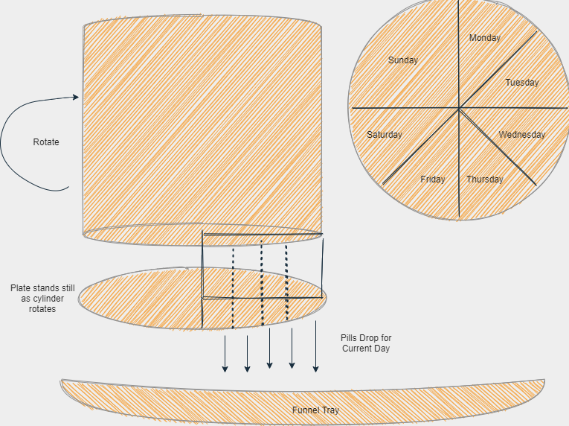
Figure 33: Pill Container

This is a visual representation of the container and its intended implementation towards the functionality of how it will dispense the pills onto the funnel tray.

5.2 Hardware Design Approach

The automatic pill dispenser is expected to have 6 x 8 x 4 inches cubed. We believe that this size is good enough so that users of this pill dispenser can possibly be able to be used on the go as well as not take up too much space in any household. A primary objective that we wanted to achieve was to be able to obtain parts such that our pill dispenser would be easy to assemble, cost-efficient, and have a straightforward concept design. The approach we plan to take is to search for affordable parts over the internet on Amazon and begin to find the most viable way to develop our automatic pill dispenser in order to successfully meet our desired requirement specifications. The design is meant to be created in such a way that it simplifies the user’s ability to interact with it while having it perform at a high level.

The way that it will work is that the user will be prompted with a menu of options in which from each of those options they can choose to add a new medication, edit a medication, or remove a medication. If a user would like to add a new medication, they will be prompted with being asked to input the name of the medication, the time it needs to be taken and what day(s) it should be placed in. Upon completion of this, the microcontroller will process this information and the user will be asked to place the medication in the designated slot. If the user would like to edit a medication, they would be asked to select which medication is the one that they are looking to modify (they will also be allowed to search for the name of the medication to find the one that they are looking for). If the user would like to remove a medication, the user would be asked to select which medication is the one that they are looking to remove. Upon selection, the user would be asked again if they are sure about their selection. The moment that the time has come for the user to take their medication, an alarm will sound to indicate that the time to take a medication has arrived. The user will be prompted if they would like their medication to be dispensed.

The way in which the number of pills are tracked will basically be composed of two rollers. One of the rollers will be rotated using a servomechanism while the other will be allowed to spin freely. Using these rollers, we can actually dispense one pill at a time. This is due to the pill size as well as the available gap between the two rollers. To ensure that all pills will be able to be dispensed, we decided on defining the gap between the rollers to be slightly larger than the average size of a pill, specifically 14mm. Also, being able to use a pliable sponge is something that would be needed in order to also increase the gap between the rollers for a pill to go through the rollers. The idea is that once a single pill goes past sensors that are located alongside the two rollers, the rollers will start to rotate in the opposite direction in order to prevent other pills from being dispensed. The idea is to try and place the sensors around approximately 28-32 mm apart. Further experimentation will determine the optimal choice for the distance between the sensors. The ultimate goal is for the cylinder to rotate correctly based off of the correct day and for the desired pill to be dispensed. We also considered using a vial or a small cup. Ultimately, our budget will consider what we decide to purchase. The size of either is expected to be larger than the average size of a vial which typically ranges between 6 - 30 dram.

5.3 Software Design Approach

There are two types of programming that will be needed in order to ensure that the automatic pill dispenser is fully functional. The first is embedded programming in such a way that our Arduino microcontroller can successfully perform all the tasks at hand such as processing user input, dispensing the pills correctly, programming the timer to set off at the right moment when the pills need to be taken, ensure that the alarm sounds at the right time, ensure that there is sufficient storage to retain all the information of all pills in the dispenser, etc. The second part is full-stack programming specifically a mobile app that will enable people to keep track of their pills while away from the dispenser, receive notifications when it is time to take their medications, allow for users to modify any information regarding their pills, and to also be able to keep track of the location of their pill dispenser. Intended language for embedded programming would be C, and the intended language to use for the development of the app would be Java, and Javascript with the intention of using the MERN stack to create the application. For the embedded programming portion, we will intend to use Serial Peripheral Communication (SPI) to be able to effectively communicate between the Arduino microcontroller and the LCD display. For the embedded programming, we intend to use a series of interrupts to determine exactly how the microcontroller will be able to keep track of time as well as the notifications that will be displayed on the LCD.

Figure 34: Block Diagram for Automatic Pill Dispenser

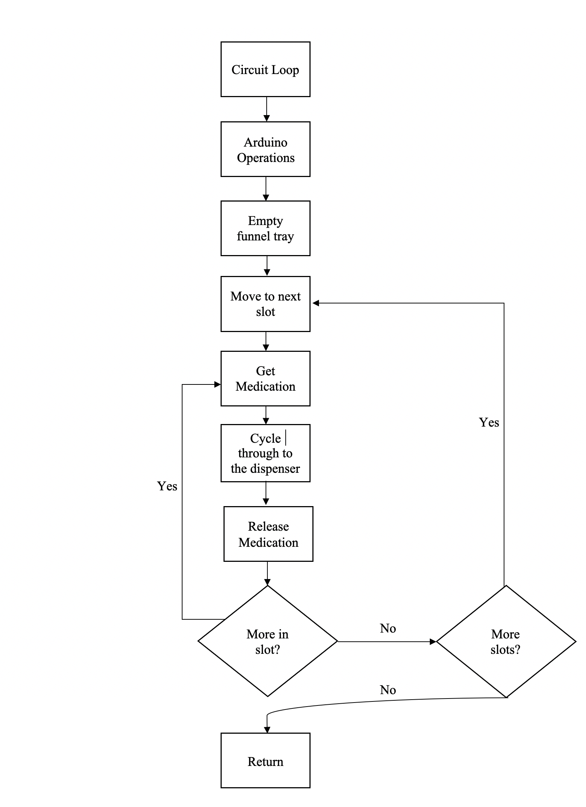

Figure 35: Hardware Flowchart

5.4 Software Subsystem

We plan to utilize python to code our solution onto the Raspberry Pi and from there be able to program the stepper motor, the servo motors, and the TFT screen. The reason python is used on the Raspberry Pi is because it is versatile, extremely powerful, and very simple to utilize. The idea is to edit Python on the Raspberry Pi via SSH by enabling SSH on the Raspberry Pi and obtaining the Raspberry Pi’s IP address to be able to successfully establish a connection from another computer. This is usually accomplished using a terminal or command line.
Python, MERN Stack, Server (Google Cloud)

5.5 Electronics Subsystem

In order to be able to build the automatic pill dispenser we must first begin by using the necessary electrical components to actually connect the hardware components located in the electronics subsystem. A breadboard becomes very handy when it comes to prototyping our circuit to ensure that everything is working properly. Jumper wires will also enable us to prototype the connections on the circuit so that we can connect GPIO pins with components. Raspberry Pi has five different types of pins. GPIO pins are general purpose input/output pins. 3V3 provides a 3.3V power source to components. 5V provides a 5V power source to components. GND provides a ground connection. ADV are special pins dedicated for complex tasks.

5.6 Power Subsystem

The power subsystem consists of our power supply giving power to our server and stepper motors in order to be able to ensure functionality of all the automatic pill dispensing mechanisms.

5.7 Hardware Design Choices

Power Supply:

SunFounder DC 9V/650mA Power Supply Plug Adapter for Arduino R3 Mega 2560/1280 (6 Feet)

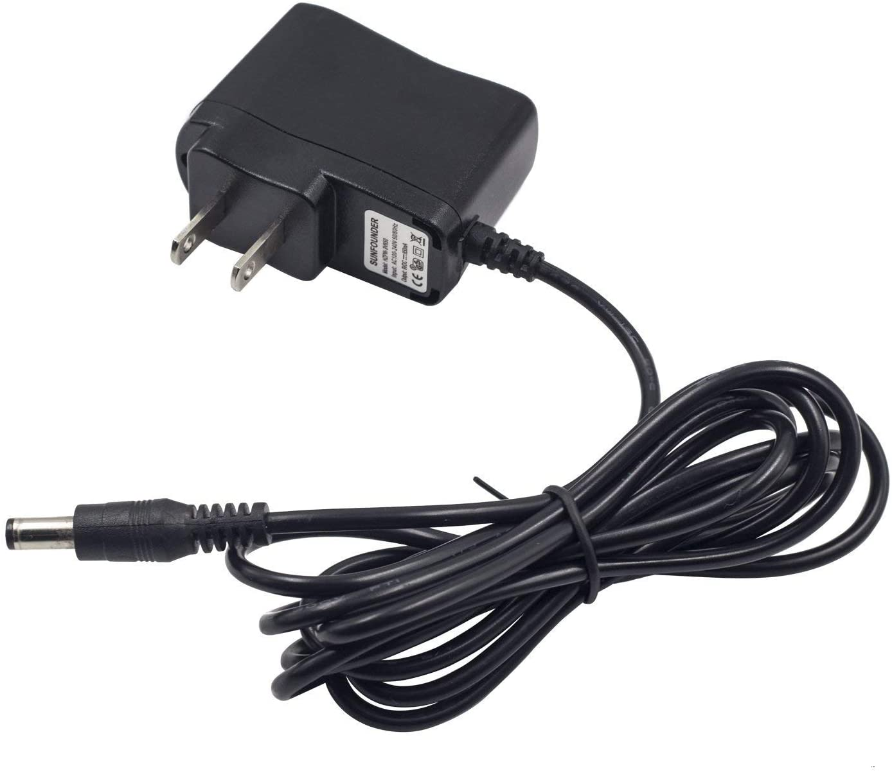
Figure 36: Power Supply

- AC - DC power supply, with Vin = 120-240V AC and Vout = 9V Iout = 650mA.
- Very good with any projects utilizing under 650mA.
- center-positive 5.5 x 2.1mm barrel connector
- Arduino board compatibility MEGA, R3, etc.
- 6 feet cable size

UL Listed 9V AC/DC Power Adapter for Arduino/Schwinn Bike A10 A20 A40 220 430 Elliptical Recumbent Upright Trainer/Crosley Cruiser CR8005A - Center Positive 5.5x2.1mm Power Supply Cord for UNO R3

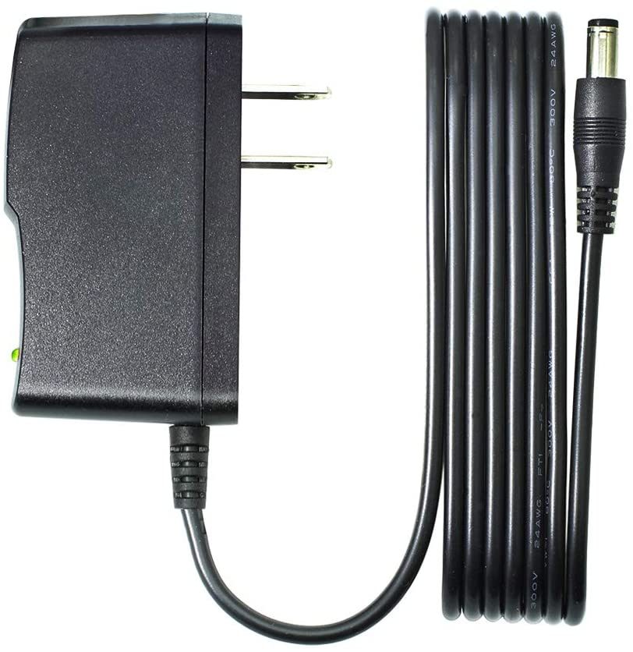
Figure 37: AC/DC Power Adapter

- Center-positive plug (Dimensions: 5.5 x 2.1 mm)
- Vout: 9V
- Iout: 100mA - 1500mA
- Vin: 100~240V
- 6.6ft cable size
- Certified Safe:
- Overloads automatically
- It has a thermal cut-off
- It protects from short circuiting

LCD display:

SunFounder IIC I2C TWI 1602 Serial LCD Module Display for Arduino R3 Mega 2560 16x2

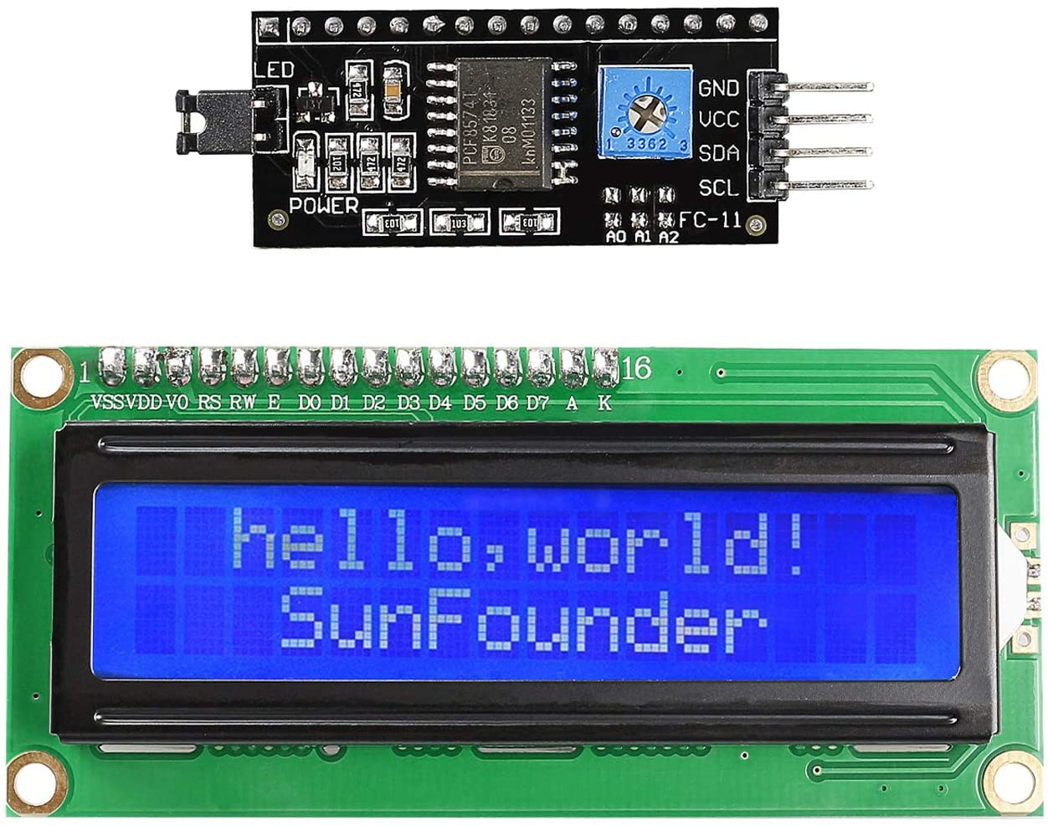
Figure 38: LCD Module Display

- Four I/O ports:VCC, GND, SDA, SCL.
- Includes I2C protocol
- Potentiometer helps to improve any contrast or backlight
- +5V power supply

Stepper Motor:

KOOKYE 2 x 28BYJ-48 DC 5V Stepper Motor + ULN2003 Driver Test Module Board for Arduino
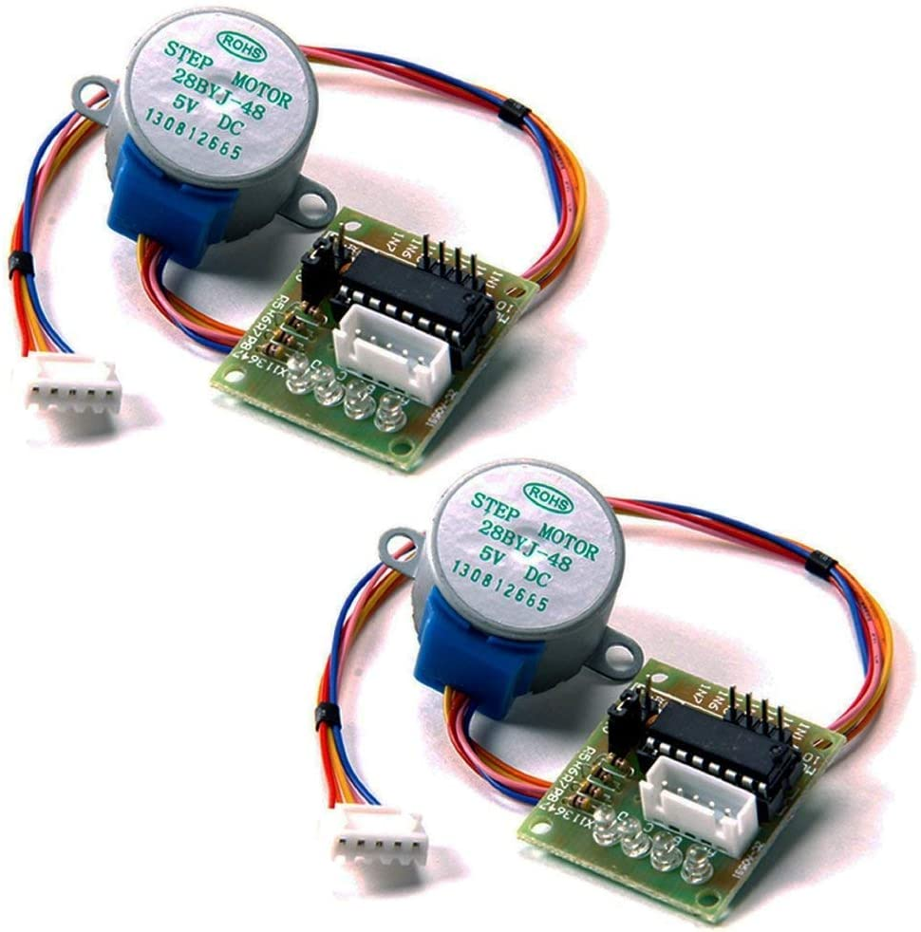
Figure 39: Stepper Motor x2

- Drive Module Board x 2
- Stepper motor x 2

Aoicrie 2Sets 28BYJ-48 DC 5V Stepper Motor + ULN2003 Driver Test Module Board for Arduino
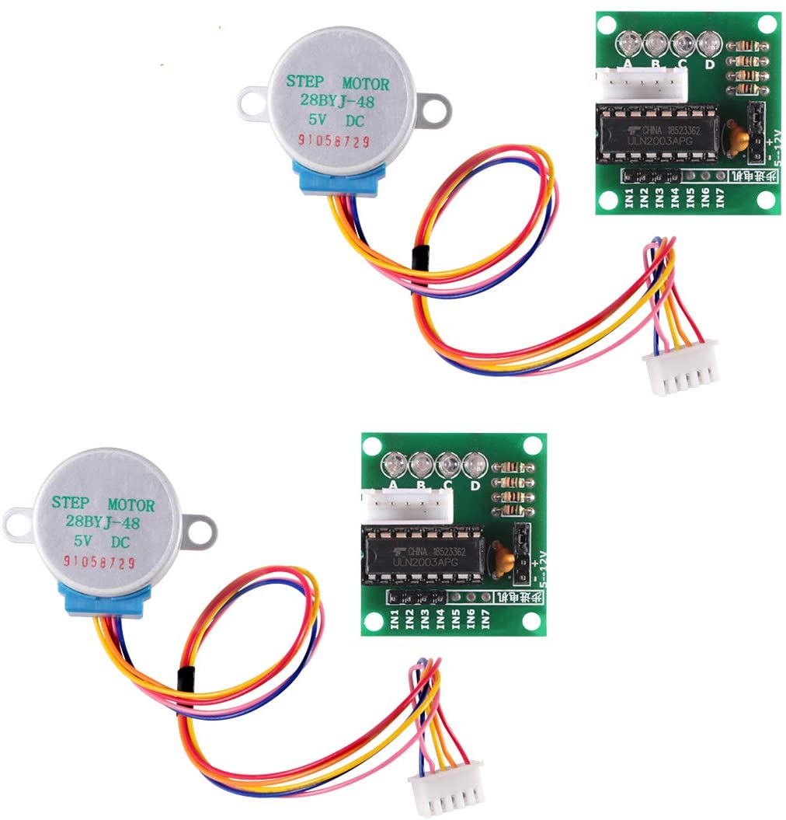
Figure 40: 5V Stepper Motor and ULN2003 Driver Test Module Board

- Has a four-phase LED which ensures that the stepper motor is working as expected.
- 4 phase 5 line, which can be utilized for chip driver ULN2003, can be able to connect with a 2 phase development board
- VDC: 5V
- Reduction Ratio: 0.015625
- Standard Interface Stepper Motor
- High step accuracy and resolution. low vibration and noise, Stable and reliable performance, high efficiency; Excellent quality and long service life.
- High resolution
- High Accuracy
- Low noise/vibration

ELEGOO 5 Sets 28BYJ-48 ULN2003 5V Stepper Motor + ULN2003 Driver Board for Arduino

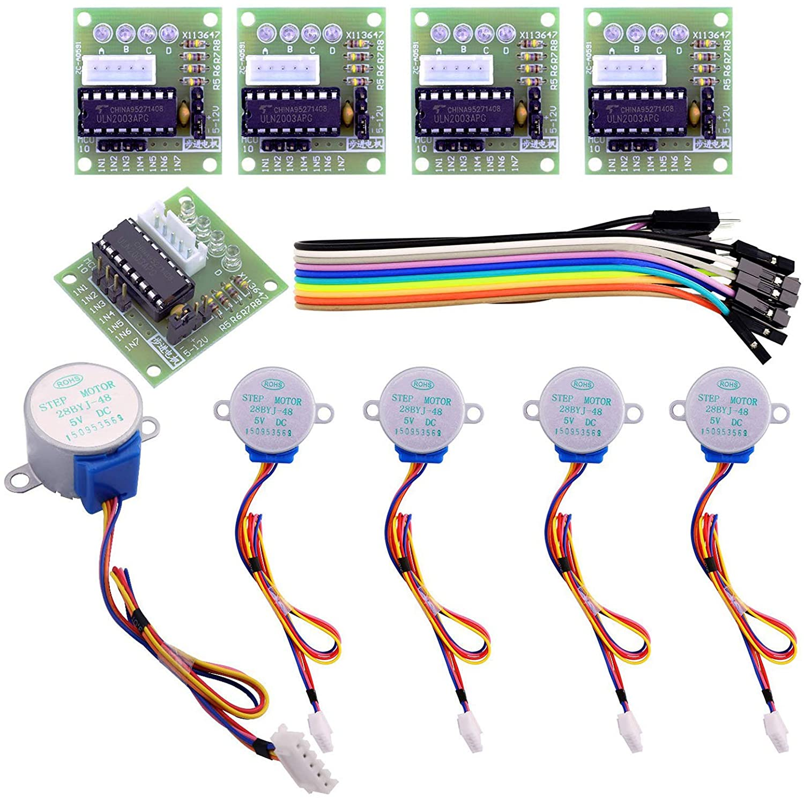
Figure 41: 5 Set 28BYJ-48 ULN2003 5V Stepper Motor

- Stepper motor with a standard interface, when used directly pluggable.
- A, B, C, D four-phase LED indicates the status of the stepper motor work.
- 5 line 4 phase can be used for ordinary ULN2003 chip driver, connect to the 2 phase , support the development board，With convenient use, direct docking
- Drive Module Board Size(in): 1.37*1.18*0.6 ; Stepper Motor diameter: 1.06(in) ; Stepper Motor lines: 9.45(in)
- Great packing in a box : 5 set Uln2003 Stepper Motor + Driver Board (with a little gift)

Speaker:

Speaker - 3" Diameter - 8 Ohm 1 Watt

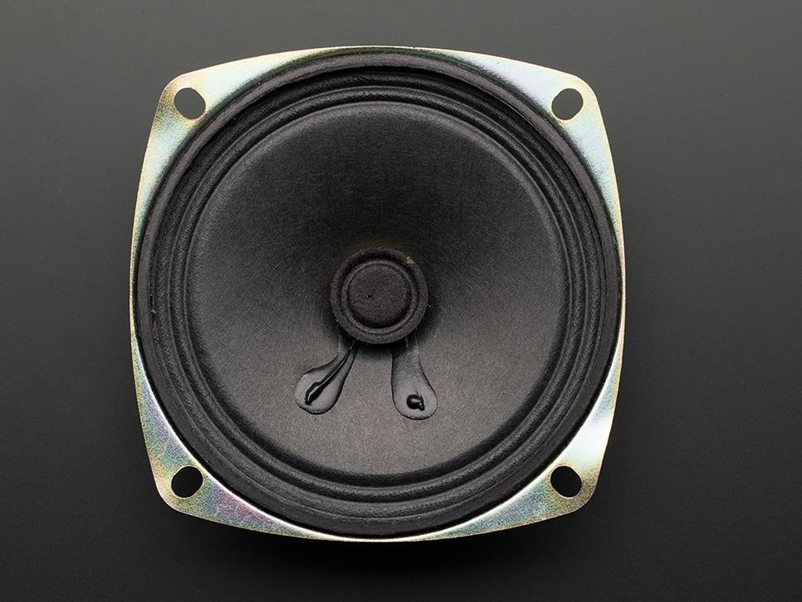
Figure 42: 3" Speaker

- The weight is 50.48g
- The dimensions are 77.8mm x 77.8mm x 25.49 / 3.06" x 3.06" x 1"
- 3” Diameter
- 8 ohm resistance
- Power: 1 Watt

Mono Enclosed Speaker - 3W 4 Ohm

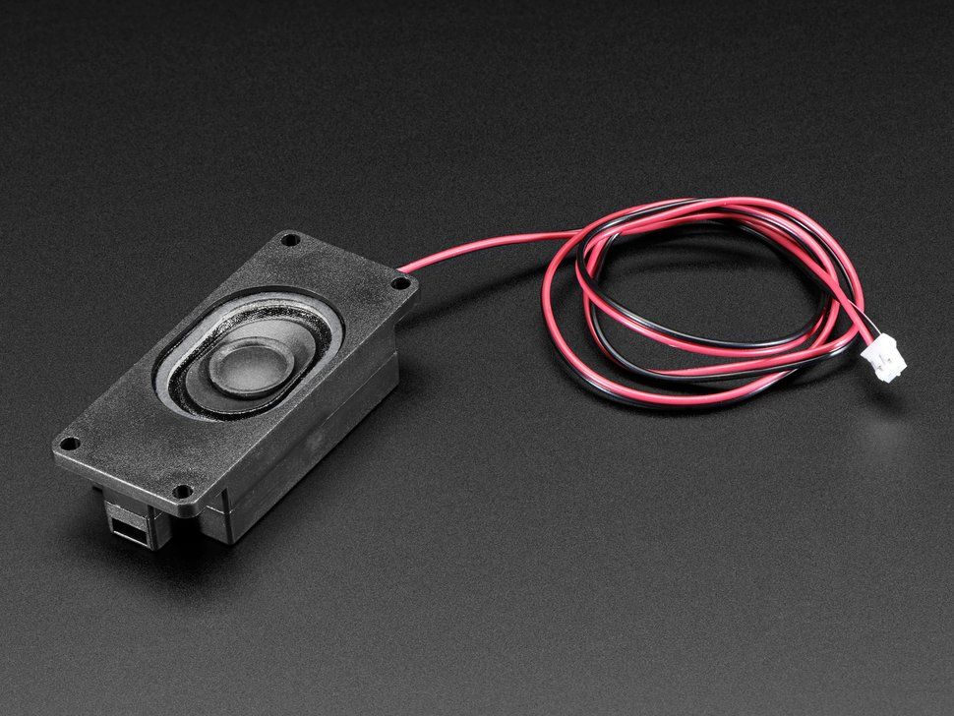
Figure 43: Mono Enclosed Speaker

- The weight is 26.4g
- The dimensions are 30mm x 70mm x 17mm / 1.2" x 2.8" x .7"
- Cable size is 22.5"
- The mounting holes are 3.4mm in diameter
- The mounting rectangle dimensions are 63mm x 24mm

Pill Dispenser/Container:

JUMBO Extra Large 7 Compartment Day Pill Tablet Medicine Storage Holder Dispense
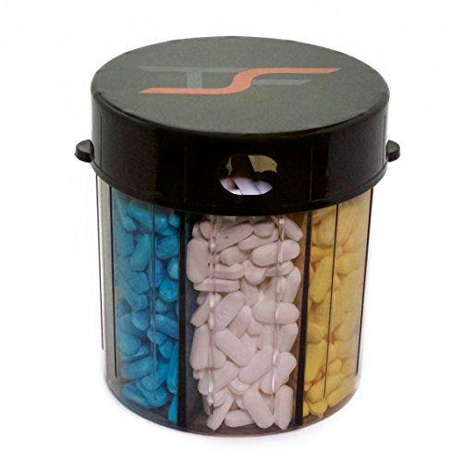
Figure 44: Pill Dispenser/Container

- 5” inches tall
- 4” in diameter
- 7 compartment slots

Breadboard:

Adafruit Perma-Proto Half-sized Breadboard PCB

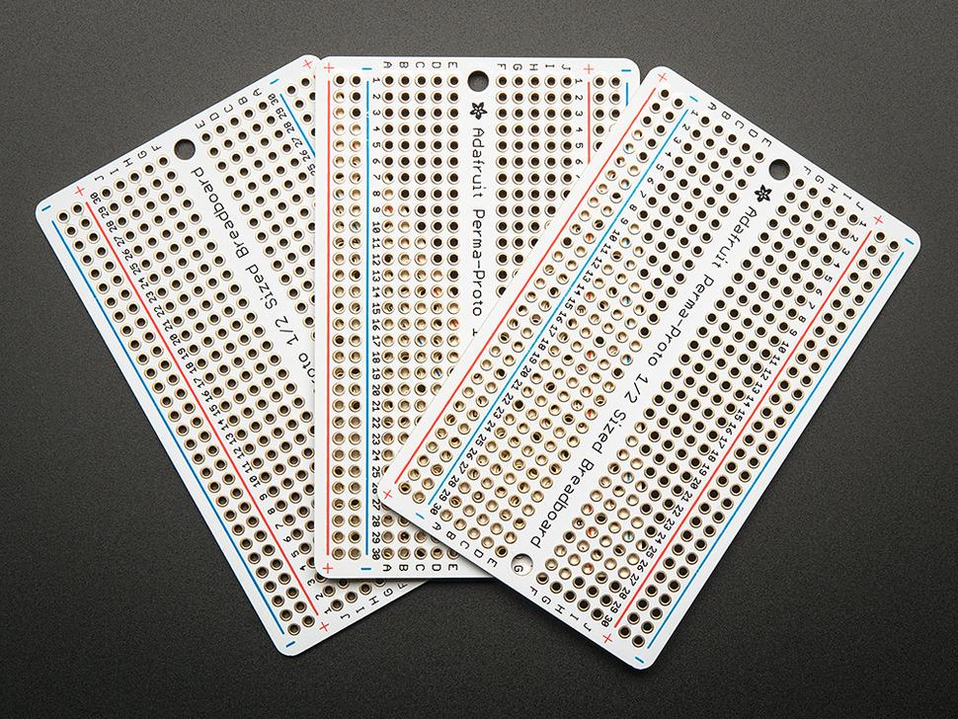
Figure 45: Adafruit Perma-proto Half-Sized Breadboard PCB

- Number of holes: 30 x ( 2 x 5)
- 4 x power rails
- Dimensions: 3.2 inches by 2 inches
- 0.063 inch width
- 1.2 millimeter drill holes
- 3.2 millimeter mounting holes separated 2.9 inches

Ultrasonic Sensor Sonar Distance

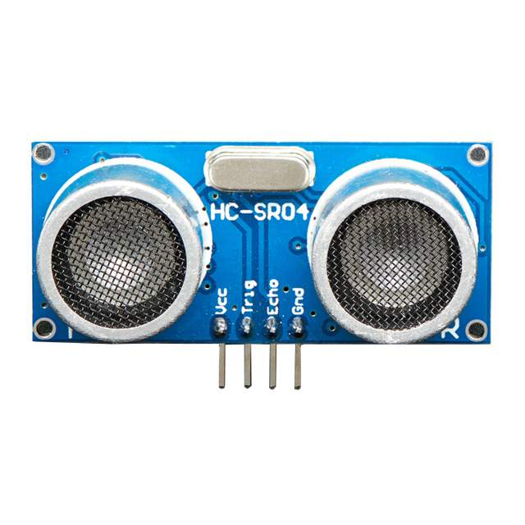
Figure 46: Ultrasonic Sensor Sonar Distance

- Frequency: 40 kHZ
- Voltage: 5V
- Beam Angle: 15 degrees

5.8 Software Design Choices

Microcontroller:

Arduino Uno REV3

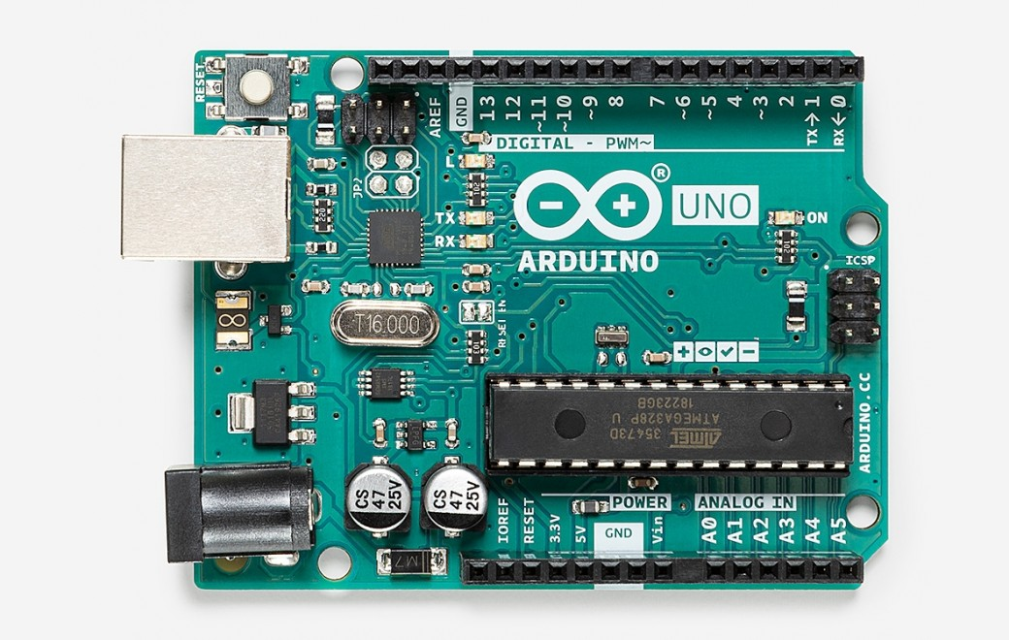
Figure 47: Arduino Uno REV3

- 14 digital I/O pins or PWM outputs
- 6 analog inputs
- 16 MHz ceramic resonator
- USB connection
- power jack
- ICSP header
- reset button.
- Programmable with Arduino Software

Arduino Mega 2560

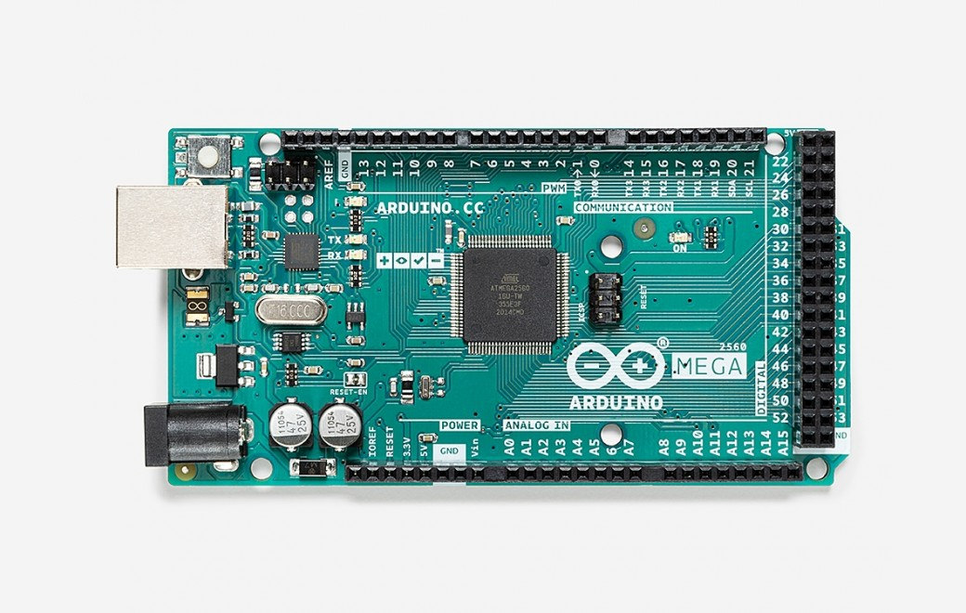
Figure 48: Arduino Mega 2560
- 54 digital I/O or PWM outputs
- 16 analog inputs
- 4 UARTs
- 16 MHz crystal oscillator
- USB connection
- power jack
- ICSP header
- Universally compatible with Arduino Uno motor shields

Alarm:

ARCELI 5pcs DC 3.3-5V Passive Low Level Trigger Buzzer Alarm Sound Module for Arduino
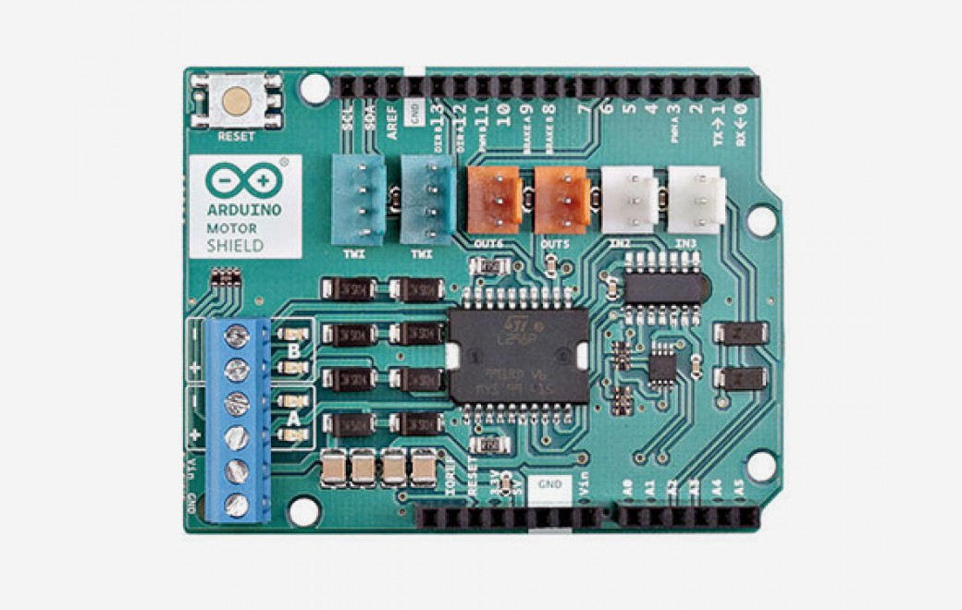
Figure 49: ARCELI 5pcs DC 3.3-5V

- Active piezo electronic buzzer module with low level trigger and continuous sound output.
- holes for fixing with bolt/ easy to install
- Single chip microcomputer high and low level
- active internal buzzer with shock source
- External connection: 3.3 V - 5 V
- can be directly connected to either 3.3 V or 5 V microcontroller.

Motor Controller:

Arduino Motor Shield REV3

Figure 50: Arduino Motor Shield REV3

- full-bridge driver designed to drive inductive loads
- lets you drive two DC motors with your Arduino board,
- You can also measure the motor current absorption of each motor, among other features.
- TinkerKit compatible

Qunqi 2Packs L298N Motor Drive Controller Board Module Dual H Bridge DC Stepper For Arduino
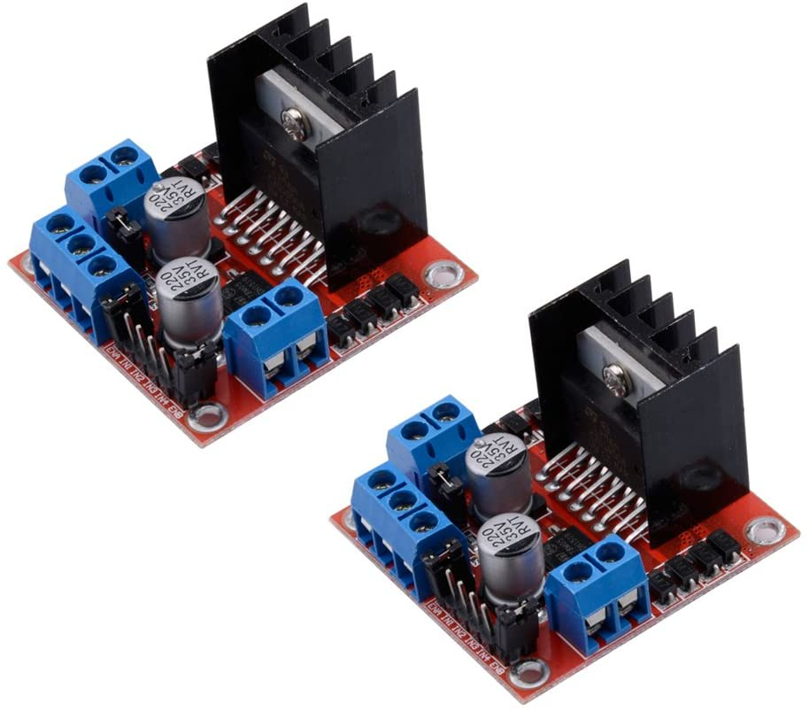
Figure 51: Qunqi 2Pack L298N Motor Drive Controller Board

- Dual-channel H-bridge driver
- Can drive one 2-phase stepper motor, one 4-phase stepper motor or two DC motors
- must use an external 5V logic supply when using more than 12V driving voltage
- Use large-capacity filter capacitors and diode with freewheeling protection function, increasing reliability
- High working power: 35V
- Imax = 3A MAX
- Standard power: 25 W
- Standard I = 2A
- Large capacity filter capacitance
- Large afterflow protection diode

5.9 Software Design

The Automatic Pill Dispenser relies heavily on software to operate effectively and efficiently. Reliable and optimized code is necessary in order to build a successful project. With medication being the focus of the project, it is important the software gets it right everytime. If it doesn’t, it could leave us open to liabilities. The software for the Med Master can be broken down into four different sections;
- The Mobile App - “Med Master Schedule”
- The Web Server receiving signals from the App
- The GUI being displayed on the screen from the decoder on through the Raspberry Pi.
- Sending the pill schedule from the Pi to the microcontroller.
- The code to control the motors through our microcontroller.
These five sections make up the entirety of the software written for the Med Master. It comprises multiple different languages and different supporting softwares, libraries, and frameworks. The main idea is the app will intake pill information and a pill schedule, send that data to the web server, and then the web server will send it to the Raspberry Pi. The Pi will then receive and parse that data through some Python code. From there it will output the schedule and pill information on the display of the Med Master. Not just this, but the Pi will then set the schedule in motion through some Python code that will handle the motor control.

5.9.1 The Mobile App

The mobile app is the main end point (or rather start point) for scheduling when pills are dropped from the machine. The mobile app will be called the “Med Master Schedule” and will be built on a MERN stack. The MERN stack is made up of ;
- MongoDB - Database storage.
- Express - Backend for building APIs.
- React Native - Front End for building a UI.
- Node - For JavaScript execution.
We decided to move forward with the MERN stack since we have some experience with developing mobile apps using it. The MERN stack also allows us to use only one language for the entire mobile app development, JavaScript. Using only one language means we don’t have to focus too much time learning multiple languages and following different syntaxes depending on front end or back end development. JavaScript is high-level and object-oriented, making it an easy language to pick up.

MongoDB is a NoSQL (non-relational) database that we will use to hold any data that needs to be saved and recalled in the app in JSON-like documents. In our case we will end up saving user accounts, device numbers associated with those accounts, and pill information for each account within a cluster. Our DB will be one cluster. Within each Cluster will be two collections;
- User Account - Id, First name, Last name, Email, Username, Pass, Device Number
- Pill Information - Id, UserId, Pill Taken, How Often Pill is Taken
Each one of these can hold multiple JSON like documents that will be used for calling and storing data. MongoDB was a no brainer as it is a popular Database Management System (DBMS) for developing mobile applications, especially the application is small scale and the devs are moving on a tight deadline. MongoDB allows us to move and develop quickly, it leaves a lot of the headache of a relational database like MYSQL behind. While a SQL based relational database might be more traditional and even more powerful, it is unnecessary and would take longer to set up. It’s just less flexible. MongoDB offers on the fly changes and easy edits. MongoDB also offers easy connectivity through JavaScript, allowing us to simply connect to our DB, grab the data we need, and send it back to the app or through the web server to the Pi all through a JSON response.

Node.js is the asynchronous event-driven runtime environment from which all the app code will be executed on. It essentially allows for JavaScript to execute outside of a web browser. Node is what allows the mobile app to be built on a “JavaScript everywhere” paradigm. Node processes incoming requests in a loop, called an event loop. Node is the basis of the mobile application, Express and React native sit on top of node to make a functioning app.

Express is a back end JavaScript framework for back end application development. We will use express to send JSON data and receive JSON data to and from the mobile application. Express makes it simple for us to create our API using JavaScript. This is how we will get our data to and from the database and how we will send the data through the web server to the Pi. Express offers web application features on top of Node.js.

React Native is a front end JavaScript framework created by Facebook for building native apps for both Android and iOS using one language. React Native is written in JavaScript and is then rendered in native code. We will use React Native to build out the front end of our mobile application. This keeps us in our “JavaScript everywhere” paradigm and allows us to build the mobile app for both Android and iOS simultaneously.
There’s no wasted development or code translation. This choice was also a no brainer. With a tight deadline, spending time writing the app in Kotlin for Android and then again in Swift for iOS would be a pain. We could just write the app for android, but then we’re not offering to a wide user base. Using React Native allows us to build the app quickly and gives us the flexibility to offer the app for both android and iOS users.

For writing code, especially with version control, there is no better IDE than Visual Studio. We will be using Visual Studio Community 2019 to write our mobile application code as it offers tons of features and support. One of the main reasons we will move forward with Visual Studio is that they offer built in GitHub support for easy version control. There’s no need to learn git in a terminal within Visual Studio as they offer a GUI for GitHub version control. This is a necessity when more than one person is working on the development of an application. Not only this, but Visual Studio offers quick access terminals, so we do not have to waste time changing directories everytime we reopen a terminal. It also offers a debugger, and support for many languages and frameworks and environments, like Node.
Visual Studio is an industry leader in the integrated development environment (IDE) world. They are a stable software and an obvious choice for anyone developing any sort of web or mobile application.

GitHub is one of the most popular development platforms for code management and version control that exists anywhere. It is massive with over 50 million developers using it. GitHub is the perfect fit for almost any project and we are no exception. The Med Master Schedulers code will be held in a GitHub repository and managed using Git. Git is the version control system GitHub uses for tracking changes in source code during application development. Pushes (commits) and pulls (fetch) to and from the repository will be done within Visual Studio using their built in source control for GitHub.

Expo is an open-source platform for making universal native apps for Android, iOS, and the web with JavaScript and React. We will be using expo to compile and run our mobile app on our phones for testing and development. We will also use expo to export our applications into APKs. From here the APKs can then be installed onto our mobile devices.

For the UI we wanted to go with a simplistic design where the user can sign up, login, enter the pills they are taking, and enter how often they are taking the pills. Before developing the UI, it is important to have an idea laid out of each page and how all of the form elements will be laid out. To do this, we used AdobeXd to create UI mockups of the mobile application. AdobeXd provides all the tools necessary to design the app layout before writing a single line of code. With this at our disposal, we created the mockups seen below of the main pages of the mobile application.

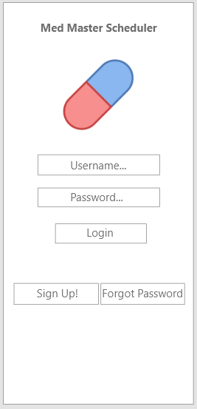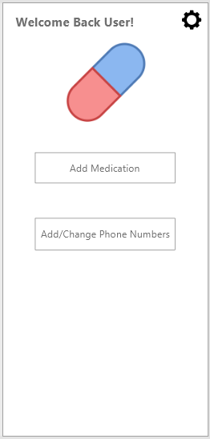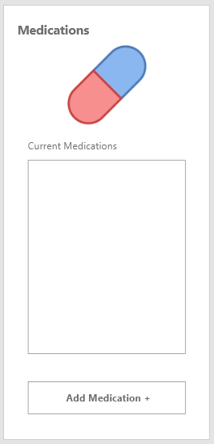
Figure 52: Mobile Application UI Layout

This layout seemed simple and intuitive. On the main page there is a login form with the options to login, sign up, or recover a forgotten password.
Breaking down these operations by action when clicked, we have;
- User clicks “Login”
  - Form checks if the username and password is filled out.
  - If yes, the data is packaged in a JSON format and sent to the database (the password is encrypted).
  - The database checks if the username and password exists.
  - If the user/password combination exists, an OK response is sent back to the user and they are authorized to enter the mobile application.
- User clicks “Sign Up!”
  - A modal appears where the user enters their first name, last name, password, email, and device number (located on the machine).
  - A JSON message containing that data is sent to the database.
  - The database checks if the user already exists and if the device number exists.
  - If both are yes, the sign up is successful.
- User clicks “Forgot Password”
  - A modal appears asking for the accounts associated email
  - User enters email address associated with account.
  - Email is sent to them containing a link.
  - User clicks the link in their email which takes them to a page where they can enter a new password.
  - User enters a new password.
  - The user's password is reset.
When the user logs in they are able to add medications, or add caretaker phone numbers.
When the user clicks to add a medication, they are taken to a page where they can add the medications they are taking and what day they are taking them. These medications and the schedule they are taking are sent and stored in the database and they are also sent to the Raspberry Pi. When the user clicks to add phone numbers, a model of contacts will appear where they can add a contact for the app to send a text message or notification to when the user takes the medication.This lets a caretaker know that the user has taken their medication. These three pages cover the main functionality of the application and touch all end points of the app.

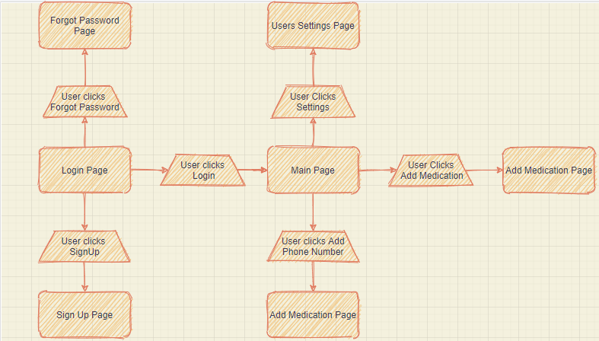
Figure 53: User Experience Flow

5.9.2 Sending Data to the Raspberry Pi

Data needs to somehow get from the Med Master Scheduler app to the Raspberry Pi. This data being the schedule the pills are being taken. Once the data gets there the Raspberry Pi can take that data and manipulate any way it needs to schedule when the pills will be dropped and display the schedule.
There are a couple ways of doing this.
- Send the data over Bluetooth from the phone to the Pi
- Connect the Pi to our DB via MongoDB and grab the user data
Connect via bluetooth has its benefits and downfalls. Main being this method is quick and does not require the user to have any internet access. However, anytime you want to update the schedule, you have to first connect to the pill machine. This means you’d have to be within range of the machine. This might not be ideal for forgetful users. Connecting the Pi to our database allows the Pi to easily grab the necessary data and schedule as needed. The user simply needs a connection to the internet to connect the app to the server it is hosted on. Then the API will take care of updating the database with the new schedule they enter. The Pi will connect to the database and use its “Device Number” as a way to find which users schedule it should take. The Pi will have an API to take care of this and bring back data for the Python program to use.

5.9.3 The LCD Display

When the Raspberry Pi powers up, it will immediately launch into a Python program that we will write the code for. This code will be split into two main functionalities, display the pill schedule on the LCD display and control the motors for the dropping of pills at the right time when scheduled.
Python is an interpreted, high-level programming language that is very flexible and carries a ton of utility, especially for programming with a Raspberry Pi.

Now, there are plenty of better options for building a GUI, however python offers tons of libraries for motor control. Wanting to keep things simple and not introduce too many programming languages, we are going to move forward with a Python only approach on the Raspberry Pi. There are tons of motor control libraries and Python also has lots of GUI frameworks we can use to build a smooth GUI to display on the LCD display. One of the frameworks we intend to use is Tkinter. Tkinter is built into the Python standard library. We will build out a simple GUI to display the pill schedule that has been entered through the app.

5.9.4 The Motor Control

The Raspberry Pi needs to be programmed to send data to a microcontroller which will control the servo motors and the stepper motor. We will do this with a Python program that will monitor the date and time. Every hour, or when the device is turned on, the Pi will reach out to the DB to grab the users Pill schedule. The Pi will send this schedule to the microcontroller on our PCB, the microcontroller will then monitor the time. When the time the microcontroller received matches the time the microcontroller has sampled, it will send signals to the motor drivers. These signals will tell the pill machines servo motor to open the hatch to drop the pills and will then tell the stepper motor to move the pill container to the next day. When the pills drop, the Python script will trigger an alarm to notify a nearby user that it is time to take the pills.

5.10 Software Summary and Schematic

All together this makes up the entirety of the software programming. We aim to use only two languages, JavaScript and Python for the programming. We may also have to use C for the microcontroller but we are aiming to use MicroPython instead as this is a subset of Python that can be used for MCU’s.
All together the logic process in schematic form looks like the following;

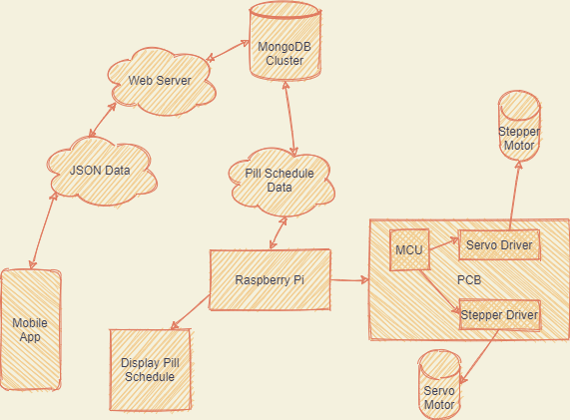
Figure 54: Software Summary

6. Project Prototype Construction and Coding

Constructing a prototype will be done through various methods including 3D printing for housing and PCB assembly. For coding we intend to flash the ATmega32 with C code.

6.1 Integrated Schematics

The schematic that we are looking to design will be created using Autodesk EAGLE in combination with Ultra Librarian and other useful CAD libraries to help find all the parts of our automatic pill dispenser. The desired parts will be searched through various CAD libraries until we can find the part, download the design for the part and integrate it with the rest of the schematic design.

Our schematic design will include the utilization of the following parts:

Microcontroller Unit (MCU) - The microcontroller unit is going to be the computer placed onto the PCB that permits the PCB to perform various tasks based off of computer programming. For our Automated Pill Dispenser, we will be designing our PCB to be able to perform the basic functionalities of Dispensing, Alarming, etc.

Servo Driver - The servo driver will obtain any signals from the MCU, begin to amplify the signal, and generate a current to the servo motor in order to allow the servo motor to perform the desired task according to the instruction(s) given. For the purpose of our automated pill dispenser, this will allow the dispenser to drop the medication into the cup when it needs to be dispensed.

Stepper Driver - The stepper driver enables the stepper motor to operate according to given commands. The stepper driver can pulsate signals in separate phases. In our case, we will be looking at a bipolar stepper motor capable of turning the pill container to the correct day where users can later choose to dispense their medication or rather insert medications.

Step-Down Voltage Regulator - step down voltage regulators essentially generate a lower output voltage given a high input voltage. The purpose for having one in our schematic for our automated pill dispenser board design is to be able to lower the output voltage from our stepper motor to our servo motor and MCU, to our servo motor driver and our stepper motor driver.

Through the process of discussion and lots of research we decided to implement the following components on our schematic.

Microcontroller Unit (MCU) -

ATmega328p
Features

- picoPower 8-bit AVR RISC-based microcontroller
- 32KB ISP flash memory
- read-while-write capabilities
- 1024B EEPROM
- 2KB SRAM
- 23 GPIO lines
- 32 general purpose working registers
- 3 flexible timer/counters that have compare modes
- Includes both external and internal interrupts
- serial programmable USART
- byte-oriented 2-wire serial interface
- SPI serial port
- 6-channel 10-bit A/D converter
- internal oscillator that has a programmable watchdog timer
- 5 power saving modes
- operates between 1.8 - 5.5 V

PWM Controller-

PCA9685
Features
- I2C controlled PWM driver with built in clock
- 5V compliant, can be controlled from a 3.3 V microcontroller which could operate up to 6V outputs
- 6 address select pins which can be wired on to a single I2C bus resulting in 992 total outputs
- 1.6 KHz adjustable frequency PWM
- 12-bit resolution
- Configurable push-pull or open-drain output
- Output enable that allows for one to disable all outputs

Stepper Driver -

TB6612FNG
Features

- Two input signals, IN1 and IN2
- four modes: CW, CCW, short brake, and stop mode
- Power supply voltage; VM = 15 V(Max)
- Iout = 1.2 A(average), 3.2 A (peak)
- Output low ON resistor
- Standby (Power save) system
- Built-in thermal shutdown circuit and low voltage detecting circuit
- Small faced package(SSOP24: 0.65 mm Lead pitch)
- Response to Pb free packaging

Step-Down Voltage Regulators -

LM2596T-12/NOPB
Features

- 3.3 V, 5 V, 12 V adjustable output versions
- Vout range (for adjustable versions): 1.2 - 37 V
- TO-220, TO-263 packages available
- 3A output load current
- Input voltage range: 40 V
- four external components required
- Excellent load regulation and line specifications
- Comes with an internal oscillator with fixed frequency of 150-kHz
- TTL shutdown capability
- Low-power standby mode, IQ, around 80 µA
- Comes with standard inductors that are ready to be used
- Includes current-limit protection as well as thunder shutdown
LM3940 (for 5 V to 3.3 V conversion)
Features
- Vin Range: 4.5 V - 5.5 V
- Vout Specified over Temperature
- Proficient Load Regulation
- Iout = 1A
- One external component required
- high temperature built-in protection
- Protected from any short circuits

The design process of the PCB can be broken into data/signal connections and power connections. We have ensured to design different voltage regulator circuits for delivering the proper power to each component on the board. The PCB will receive 12V DC input and will respectively step down that voltage anytime a component needs to be powered with a lower voltage. This is achieved using the LM3940 and LM2596 voltage regulators to step-down the voltage for the respective parts. For delivering 5V DC supply from the 12V DC input we have come up with the following eagle schematic:
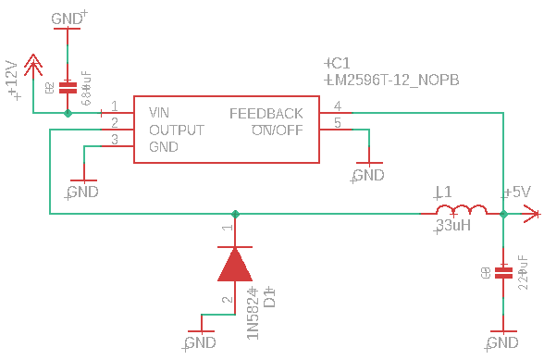
Figure 55: 12V DC to 5V DC Regulator

This supply will be used to deliver 5V DC to the Atmega32 and again to deliver 5V DC to the servo motors.

Along with this, we needed a way to step down the 5V DC to 3.3V DC to deliver steady voltage to the PCA9685 controller. To do this we used the LM3940 whose use is exactly for this scenario. The capacitors have been added to these voltage regulators to ensure stability and reduce impedance.
The following schematic will be used when we need to step down the voltage from 5V DC to 3.3V DC:
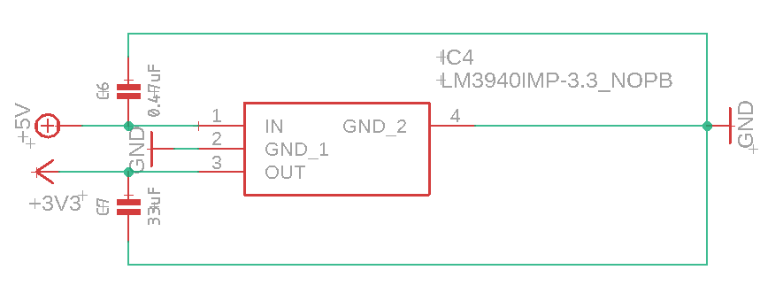
Figure 56: 5V DC to 3.3V DC Regulator

The PCB itself needs a schematic for how it is going to receive the 12V DC in the first place to power the board. For this we used an AOD417 MOSFET paired with a 3.5mm power terminal block. The schematic for this system looks as follows:
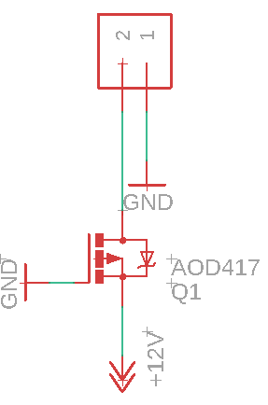
Figure 57: 12V DC input

Now onto the data/signal connections. Using Mouser electronics Library Loader, we were able to find the eCAD models for the parts we needed to build the connections. The Parts involved are the ATmega32 MCU, PCA9658 controller, and the TB6612FNG driver, along with the individual motor connections.
These connections looks as follows;
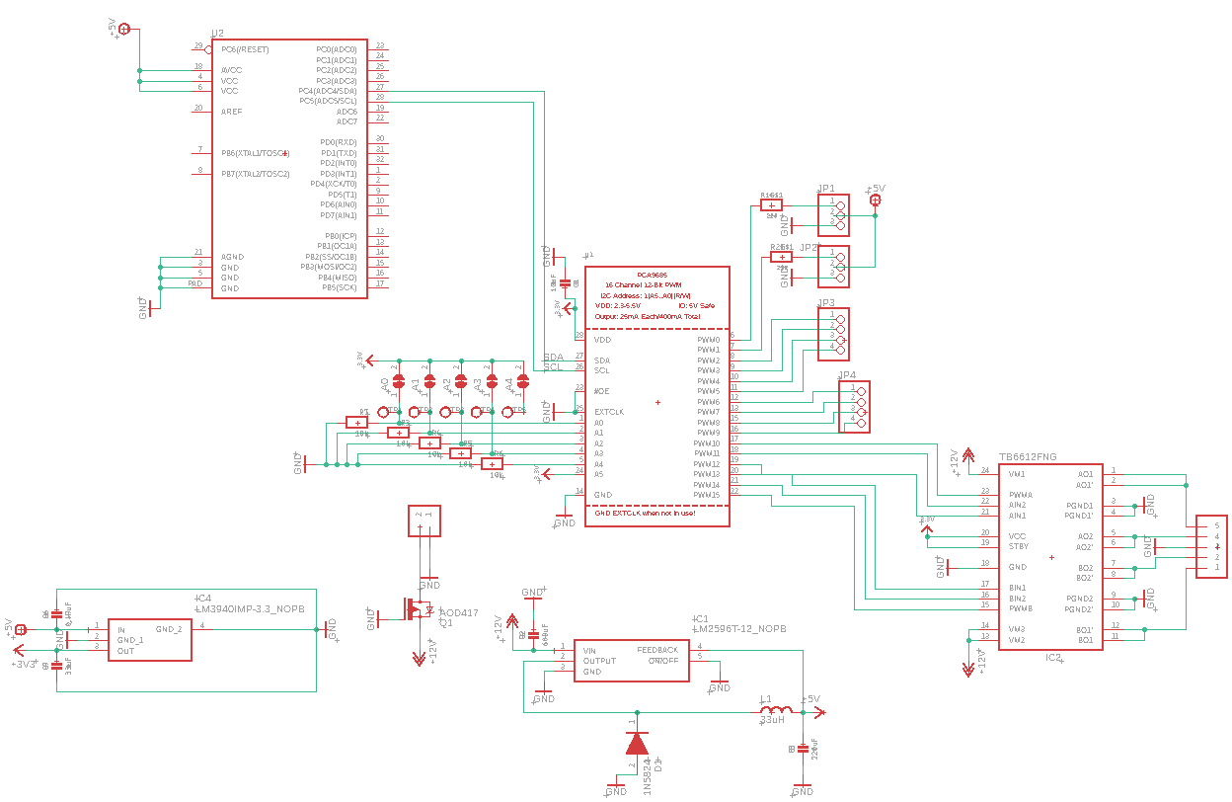
Figure 58: PCB Schematic

Breaking this down we have two servo connections, each receiving 5V DC, both connected to a PWM pin on the PCA9685 controller. Furthermore, we have six more PWM pins connected to the TB6612FNG driver to drive the stepper motors. This leaves us with eight extra PWM pins that have been routed to extra connectors in case we need the pins for testing or other functions. On the TB6612FNG we have the motor signal pins sent to their respective spot on the connector with a common ground being shared between the two H-bridges. This gives us the ability to have up to two stepper motors included. The TB6612FNG receives 12V DC to drive the motor(s). On the other side of the PCA9685, we have our ground and 3.3V DC to power the controller. We also have our A0-A4 pins which serve as solder pads for any external communications we may need, these are connected to the I2C control bus. The SDA and SCL are connected to the ATmega32 microcontroller. This is how they will communicate. The ATmega32 microcontroller is connected to a 5V DC supply and is obviously grounded.

Taking a closer look we can see the individual components that make up the connections;

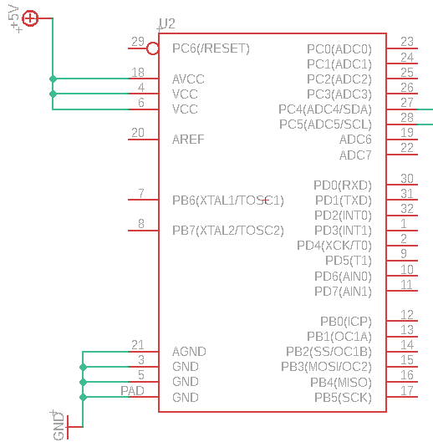
Figure 59: ATmega32 Schematic

This portion of the schematic is the ATmega32 microcontroller connected to a 5V DC power supply and connected to the PCA9685 by the SDA and SCL Pins.

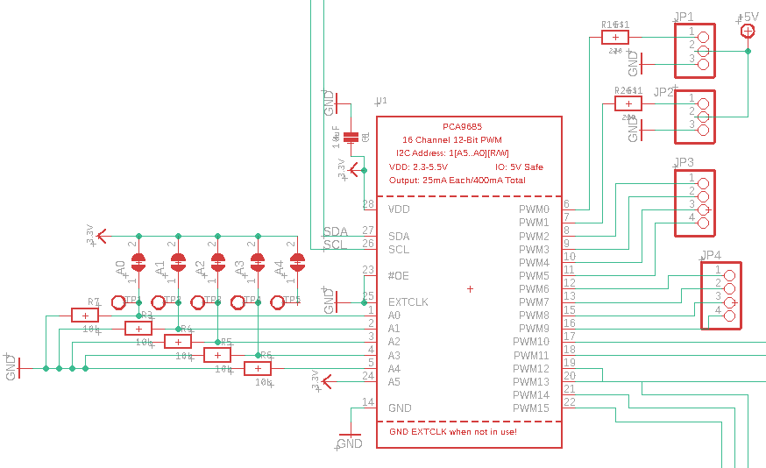
Figure 60: PCA9685 Schematic

This portion of the schematic shows the PCA9685 controller and all of it’s connections. The JP1 and JP2 connectors are where the servo motors would connect and JP3 and JP4 are excess PWM connections. Each servo connection is made up of three pins. Pin three is connected to ground, pin two is connected to the 5V DC supply, and pin one is connected to a PWM pin with a resistor in between for stability.

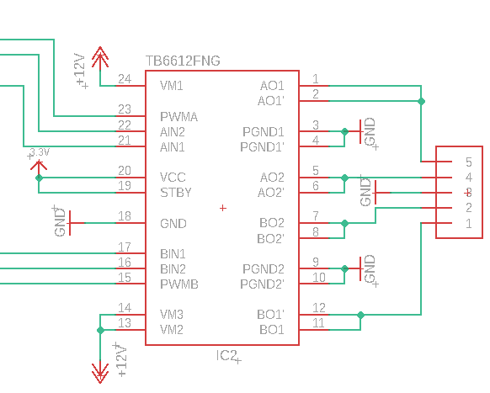
Figure 61: TB6612FNG Schematic

This is the schematic of the TB6612FNG driver used to drive the stepper motors. Up to two stepper motors would be connected to the one by five 3.5mm connector seen on the far right of the schematic. The driver is powered by the 12V DC supply and this drives the motors.

After generating the PCB board from our schematic, the PCB board looks as follows:

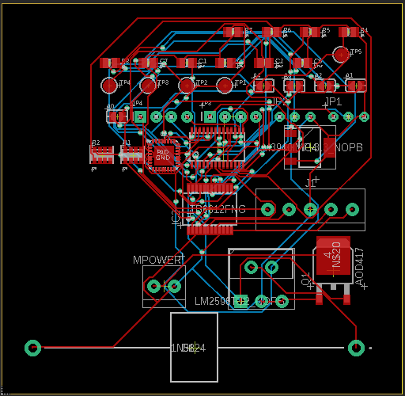
Figure 62: PCB Board

6.2 PCB Vendor and Assembly

PCB Vendor
There were various options when it comes to vendors that we were considering to use. Some manufacturers that we were looking at include: Imagineering Inc., ACME PCB Assembly, Accutrace Inc., and Cirexx International Inc. When it comes to considering a vendor, it is very important for us to consider which vendor can give us an affordable price and a well assembled PCB.

PCB Quality is important when choosing a good PCB manufacturer. However PCB quality ultimately signifies that the board is manufactured as specified and according to how it was designed to be made.

When the quality of a PCB is referred to, we usually consider the following things:
- Correct dimensions
- Holes drilled properly and in the right place
- Meets the minimum requirements of the board test
- The board is barely warped (if at all)
The quality of the PCB should meet high standards and should not deviate from the original order that was placed.
Due to the fact that there may be potential errors in production and such errors can threaten how well a PCB assembly company’s business may thrive, it is vital to consider the quality of the selected supplier. Something to consider would be attempting to speak to other clients who have worked with the PCB assembly company and ask them about their experience with the products that they’ve made.
It is worth taking a look at whether or not a PCB manufacturer can successfully meet all the requirements specifications for the PCB design. For instance, can they accept the designs in a specific file format, do they have the right PCB material in stock, overall what are the design constraints that are going to prevent the manufacturer from being able to deliver an accurate PCB board design.
A good thing to do will be to write on a list the desired characteristic one deems from a manufacturer in order for them to be able to successfully complete a job with little to no errors.
Cost is extremely important to consider because reducing the cost of a PCB board design ultimately enables PCB designers to be able to produce more of the same design if needed. It is important to note that one mustn't minimize costs too much.
Of course finding the optimal lowest price for production is fundamental, but keep in mind that as the price for the PCB continues to drop so does the quality of the PCB being produced.
Finding the right price to pay while minimizing the diminishing of quality is a must in order to obtain a great board at the best price.
Sometimes the time it takes to manufacture a PCB may not be a major concern. However most PCB assembly companies require boards by given deadlines. Ensuring these deadlines can be met is a major factor that should be considered when selecting a PCB manufacturer.
Time is also an important factor in determining the right PCB manufacturer to choose. Something to consider though is to check to see what deadlines there are to give a manufacturer the PCB board. After this, it must be ensured that as PCB designers, the specified deadline can be met. If all of these areas are being revised and the PCB manufacturer satisfies with what is being asked then the PCB manufacturer may be a good candidate for producing the PCB design.
It is important to mention that while it is critical that the PCB manufacturer receives all the necessary requirements to proceed with production, it is key to also be able to produce the PCB board in a short amount of time without producing any errors during production. Producing a PCB in a short amount of time results in a higher price and also results in a higher probability that errors may appear on the PCB board.

A good PCB manufacturer will look into testing boards given from PCB designs in order to see if they are able to comply with the design requirements that are being specified by the PCB designer. As the PCB designers, this is something that we must take into consideration.

In our case, the desired timeframe for receiving our PCB will essentially be fast enough to test the board and order a new PCB later on if the PCB design needs to be modified in order for it to perform all the functionality we need for our automated pill dispenser.

Another important factor to consider when choosing a PCB manufacturer is their ability to fulfill your order depending on the order size. There may be some instances where orders may come in small quantities and that specific components are needed. There may also be large orders in which the amount of PCBs needed may result in a limitation of material needed to fulfill that order.
It is important to consider what type of orders the PCB manufacturer is capable of fulfilling before the PCB designer chooses to go with the PCB manufacturer.
If a PCB manufacturer is accustomed to fulfilling large orders and they are given a small order, it may be hard for the PCB manufacturer to make the accommodations necessary to fill that order. Conversely, if a PCB manufacturer is accustomed to fulfilling small orders and they are given a rather large order, then that PCB manufacturer may be given too much to handle for them to be able to produce the order.
In our case, our order should be rather small so it is important to choose a PCB manufacturer that is able to align to the size of our order.

PCB Assembly Process
1. Stenciling Solder Paste

The first part in the assembly of the PCB is to apply some solder paste to the board. This method is like printing images on a shirt, except that a stencil that is stainless steel and rather thin is situated on top of the PCB instead of a mask. This enables assemblers only to apply solder paste to specific areas of the potential PCB design. These specific areas where components in the final PCB design will sit.

The solder paste itself, also known as solder, is a substance that has a grey color that consists of miniature metal balls. These miniature metal balls are typically composed of 96.5 percent tin, 3 percent silver and 0.5 percent copper. Solder and flux are jumbled together in solder paste, which helps the solder melt and bond to a surface, which is a chemical designed to help. The solder paste which looks like a rather grey paste has to be applied in exactly the right places and in exactly the right quantities to the board.

A mechanical adapter carries the PCB and the solder stencil in a competent PCBA line. An applicator then pastes the solder in precise quantities on the targeted areas. The device then extends the paste over the stencil, which is applied uniformly to all open areas. The solder paste stays in the appropriate places when the stencil has been removed.

2. Pick and Place

The PCBA process continues to the pick and place machine after the solder paste was applied to the PCB board, and a device puts surface mount components ,or SMD, on a pre-prepared PCB. Nearly all non-connectors on PCBs are nowadays accounted for by SMDs. In the next step of the PCBA process the SMDs are soldered to the board's surface.

It was traditionally a manual process that involved the use of some tweezers and where the assemblers were required to choose the components and place them manually. Fortunately, these days, an automated process for the development of a PCB exists between PCB producers. Due to the fact that modern day machines are more precisely and consistently accurate than people this change occurred. Also, due to the fact that machines can work longer hours than humans can, it is easier and more efficient for machines to construct PCBs instead of humans.

The device begins the process of pick and place by taking PCBs using vacuum grips and transporting it to the pick and place station. The robot then directs the PCB to the plant and starts to apply the SMTs to the surface of the plant. These components are placed at pre-programmed locations on top of the soldering paste.

3. Soldering reflow

Once the solder paste and components of the surface mount are all in place, they must remain. The solder paste must then be solidified and the components attached to the board. This is achieved by a process named "reflow" PCB assembly.

The PCB board shall be transferred to a conveyor belt once the pick and place process has been completed. A large fan, which is like a pizza oven, is moving in the conveyor belt. The oven consists of multiple heaters that gradually heat the table up to a temperature of approximately 250°C, or 480°F. It's sufficiently hot enough to melt solder in solder paste.

The PCB keeps moving in the oven when the solder melts. It goes through multiple cooler heaters to cool and solidify the solder in a regulated fashion. The SMDs are connected to the PCB by means of a permanent soldering joint.

Many PCBAs need special attention during reflow, in particular for a PCB assembly that is double-sided. Both faces need to be stencilled and reflowed separately on each side. The side that is stenciled first, placed and reflowed is the one with less parts and smaller parts. Afterwards, the other side is stenciled.

4. Quality monitoring and inspection

Once the surface mount components are soldered, they have to be tested for functionality after the reflow process, which does not involve the completion and installation of PCBA. Movement often leads to a connection with poor quality or no connection at all during the reflow process. Shorts are also a common secondary effect of this movement since components that were missing could at certain moments link circuit parts that should not be connected. Verification of these errors and misalignments may have many different approaches focusing on methods of inspection. The most frequent methods of inspection are:

- Manual inspections: Although automated manufacturacturing and smart manufacturing developments are progressing, manual controls still rely on PCB assembly. A visual inspection by a designer in person is an effective way to check on the quality of a PCB after the reflowing process completes for smaller batches. However as the numbers of inspected boards increase, this approach becomes more unworkable and inaccurate. If these miniscule components are looked at for more than one hour, optical fatigue could lead to less precise inspections.

- Automatic Optical Inspection (AOI): Automatic Optical Inspection is a more fitting method for inspecting the larger PCBA lots. High-powered cameras are being used to "see" PCBs by an Automated Optical Inspection machine (AOI). These cameras are set up in such a way to view solder connections at different angles. Various solder connections of varying quality reflect light in various forms so that the Automated Optical Inspection machine (AOI) can be capable of recognizing a lower quality solder. The Automated Optical Inspection machine (AOI) performs this very rapidly so that a high amount of PCBs can be processed in a short period of time.

- X-ray inspection: another inspection procedure includes the use of x-rays. This is a less frequently used method of inspection — it is most commonly used for complex and layered PCBs. X-rays permit viewers to see lower layers and identify probable hidden issues.

A board is considered a malfunctioning board depending on the standards of PCBA companies. The PCBs are usually sent back to the company for clearing, reworking or dismantling.

The next step is to test a part to ensure that it is working the way that it should be working, in spite of an inspection finding a mistake. The PCB connection quality will be tested. Boards that need any calibration or programming must be further examined to ensure optimal operating capabilities.

As soon as the reflow process is concluded, these inspections can be performed regularly to identify probable issues. These regular controls can ensure that errors are identified and remedied as soon as possible that can save time, effort and material both by the designer and manufacturer.

5. Inserting Through-Hole Components

Boards may include various components outside of the usual SMDs, depending on the type of board under the PCBA. These components are called plated through-hole components or PTH components.

A plated hole in the PCB is a hole plated throughout the board. These holes are used by PCB components to transmit the signal from one side of the board to the next. In this case, soldering paste will do nothing, since the paste will pass directly through the hole, without the possibility of it sticking.

PTH components require other soldering methods which won’t include the use of soldering paste later on in the process of PCB assembly:

- Manual soldering: Manual through-hole insertion is an easy process. In general, one person is required to insert one component in a designated PTH at a single station. Once completed, the board is moved to the next station where another person works on inserting another component. The cycle continues until every PTH is equipped. Depending on the amount of PTH parts being inserted over a one cycle of PCBA, this can be a long process. In particular, most companies try avoiding designing components using PTH to this way, but PCB designs still have PTH components.

- Wave Soldering: the automated version of manual soldering is wave soldering, and it usually takes on a different approach that the previous ones we’ve discussed. The board will be fitted with another conveyor belt once the PTH component has been put into place. In this scenario, the conveyor belt passes through a special oven, where the base of the board is washed by a molten solder wave. All the pins are soldered on the bottom of the board simultaneously. For double-sided PCBs this type of welding is almost impossible because soldering the whole PCB side would cause any sensitive electronic components to fail.

The PCB can now move on to the last inspection after this welding process is complete or it can proceed back towards previous steps if additional parts need to be added to the PCB or if the PCB needs to be assembled on another side.

6. Inspecting functionality of PCB

Following completion of the soldering step of the process of PCBA, a final inspection checks the functionality of the PCB. This test is called a “functional test”. The test enables the PCB to traverse its speed and simulates the normal operation of the PCB. In this test, simulated signals and power signals pass through the PCB while electrical characteristics are monitored by the testers.

In the event of inacceptable fluctuations or hit peaks outside the default range, including the current, voltage, or output signal, a test failure of the PCB will be concluded. Depending on company standards, the failed PCB can then be recycled or scrapped.

In PCB assembly, testing is the ultimate and most vital step that determines that the PCB is operating the way that it should be operating. This form of functionality testing is also why it is so critical to regularly test and inspect the PCB during the assembly.

6.3 Final Coding Plan

Problem Statement:

Create an automated pill dispenser that can successfully dispense the correct medication(s) at the right time as scheduled with little user effort.

Table 6: Requirements Analysis
# | Question | Answer
1 | Should the medication information be inputted via app or device? | Input information via app.
2 | Should time and dispensing status be displayed on device GUI? | Yes.
3 | Should the program store medication information in a database? | Yes.
4 | Must the program have good behavior when encountering input that is unexpected? | No.
5 | Should the program prompt the user to specify dosage? | Yes.
6 | Should the program specify all the different forms of input? | No.
7 | Should interrupts be set upon medication being dispensed? | Yes.
8 | Integer amounts or floating point amount? | Integer amounts
9 | Should the program allow for more medications to be added via app? | Yes.
10 | Should the program allow for more medications to be added via device? | No.
11 | Should we keep track of date and time? | Yes (EST.).
12 | Should sensors be able to detect whether there is a cup that pills can be dispensed in? | Yes.
13 | When should an alarm go off to notify users of a pill being dispensed via app? | At the time specified based off user-inputted information with the option of changing number of occurrences
14 | When should an alarm go off to notify users of a pill being dispensed via device? | At the time specified based off user-inputted information
15 | When should the program be executed completely? | The moment that the user takes the medicine cup from
16 | Should this project be developed using a single class and with the single method main? | No.
17 | Are there any other coding requirements that can be noted? | Use of coding fundamentals to optimize app and device performance.

Checklist:
- Comments can be placed on the header
- No multiline comments
- Ensure that indentation is proper
- Requirements influencing design: 1, 5, 6, 10, 11, 14, 16, 17
- Requirements influencing user interface: 2, 3, 4, 5, 9, 10, 11, 12, 13, 14, 15
- Requirements influencing coding: 1, 2, 3, 4, 5, 6, 7, 8, 9, 10, 11, 12, 13, 14, 15, 16, 17
- Ensure that all requirements are verified from the test plan (making sure that all the answers to the posed question are actually meeting the requirement)
- The test plan must succeed
- All source code, executable code, and any other forms of documentation must be submitted to whoever it is intended for.

User's Guide:
This guide is intended for the use of the mobile application. In order to use this app, you must have access to an android device. Upon obtaining an android device, go to the google play store and download our automated pill dispenser application. Once you have successfully downloaded the application, click open.
On your screen you should see a sign-in page. Please type in your credentials in order to access your account. If you do not have an account please press the create account button, complete the required fields and click submit. Upon logging in to your account, you will be redirected to a home menu. The home menu will display any upcoming medications reminders as well as medication dispensing history. There will be a navigation bar to the left that allows you to choose the following options: Pair with Bluetooth, Add Medication, Edit Medication, Remove Medication, Reminders, Medications, Find my Pills, Settings, and Sign out.
Pair with Bluetooth will prompt you to click a button to begin pairing your smartphone with the automated pill dispenser. It will notify you when it is connected when it successfully pairs with the device.
Add medication allows you to create a new reminder for a medication not previously dispensed by the automated pill dispenser. It will request for the name of the medication, the desired occurrences of the reminder, and the recommended dosage for the medication. Upon filling in all the required fields click create to add your reminder to the Reminders list.
The edit medication option allows you to look at a list of all previously created medications and choose one based on your preference of modifying its information. The form will include the name of the medication, the desired occurrences of the reminder, and the recommended dosage for the medication. Upon filling in all the required fields click create to update your newly saved reminder in the Reminders list.
The remove medication option will allow you to delete a medication that you no longer want from the medications list. Upon selecting the medication, you will be asked if you are sure that you want to delete the chosen medication. Upon clicking “Yes”, the medication along with any reminders associated with that medication will be deleted from the medications list and reminders list.
Upon selecting the reminders options, a list of all reminders scheduled to notify you of any upcoming medications that need to be taken will appear, with each one having the option of enabling and disabling that reminder.
Upon selecting the medications option, a list of all medications will show in the app with the options to click and view the information that is linked with the medication.
Upon clicking the Find my Pills option, you will be able to track using your smartphone the location of your automated pill dispenser via bluetooth. A map will pop up showing the location of your device or the last location the device was located from the moment it disconnected.
Upon clicking the Settings option, you will be sent to the settings menu where account settings can be modified and also any personalization settings can be changed to fit the preferences of your choosing using the application.
Upon clicking the sign out button, the user will be asked once again if they are sure that they want to sign out. Once you click “Yes”, you will then be signed out of your account.

Test Plan:
Different capabilities of this application need to be tested. We will be developing a series of different test cases to ensure that our program is functioning properly. Note that the result of these test cases may fluctuate in the final version later on. These test cases will be checking how well the whole application is working via its front-end graphical user interface because we can determine a functioning application when the expected front-end functionality of the application is working as it should. Please note, that this test plan may not have a very good runtime complexity but it will intend to take into consideration all the possibilities that can occur in the application.

Design:
The design process involves the use of a graphical user interface, a database, the use of a server to run the database, and an environment to test all expected output.

Coding Plan:
The left column shows each step of the coding development process with the intention of showing how the program is progressing over time as more changes are made. The intention of this is to be able to verify that each step is working properly by testing each stage individually. Comments will be made in the source code to indicate what was modified from the previous step in order to use good coding practices for more efficient coding development. All steps should be considered in order to achieve the desired end product for the user.

Table 7: Development Process
Step | Intended Accomplishment
Test IDE | Ensure that the IDE is functioning properly
Variable declaration | Ensure that variable declarations do not cause compilation errors at runtime.
Create login | Create login for user account information
Create login database | Location where user account information will be stored
Create medications list | To show users all the created medications along with their information
Create medications list database | To ensure that medications can be be created, updated, or deleted
Create reminders list | To show users all the upcoming reminders along with the option to enable and disable them
Create reminders list database | To ensure that reminders can be be created, updated, deleted, and saved for future use
Create settings page | To allow for user preferences to be changed and for account information to be modified
Create find my pills page | To track the geographical location of the automatic pill dispenser
Create an add medication page | To enable users to add new medications not already in the medications list
Create an edit medication page | To enable users to edit medications already in the medications list
Create a remove medication page | To enable users to remove medications already in the medications list that are no longer desired
Create API endpoint | To allow the front-end graphical user interface to connect with the backend database that stores all information
Functionality tests | Based off of the test plan, will ensure that all test cases pass.

7. Project Prototype Testing Plan

Prototyping enables us to test functionality while putting aside any other aspects of the project. The goal of prototyping is to create a physical real model of the system that can be tested for its functionality. For prototyping, both the hardware and software need to be in a functioning state in order to test.
The overarching plan is to achieve an MVP (minimal viable product) with no mobile app connectivity at first. The mobile app will be developed separately and the pill machines code will be edited when the app is finished to intake data arguments from the mobile app in order to run the proper scheduling. For the first iteration of testing, these arguments will be hard coded. Hard coding these values allows us to test different situations with different values and eliminates any debugging we need to do in regards to the app connectivity. Once the pieces of the software work with hardcoded values, we can begin testing the software system as a whole with values that are fetched and sent to and from the database. This will allow us to test for a complete and functioning software and work out any bugs we may encounter.

7.1 Hardware Testing

Our hardware testing can be split into two separate subsystems, the LCD display system and the motor/pill dropping system. These two systems together make up the main functionality of this project, dispense pills on a schedule with an informational panel. However for testing hardware, the first stop is the Raspberry Pi. One of the struggles with this process is powering each device involved.
We need to supply power to each of the following devices;
- Raspberry Pi 4
- HDMI decoder;
- The servo motor HAT
- The stepper motor HAT.
- The PCB (after we’ve done dev and testing with the HATs)
These all take external power, so we need to find a way to deliver the proper rated power to each component while maintaining a one plug power system. However, for testing we will deliver power separately to each component. This ensures each component powers up with it’s proper rated power and leaves out errors that could be our fault due to incorrect power splitting.

Testing the Raspberry Pi

Objective: The objective of testing the Raspberry Pi is to ensure that it runs properly on our power source and keeps a stable state with stable temperatures. This test will require that we supply the Raspberry Pi with the required 5V DC through the on board USB-C connector. With the connector we must ensure the Raspberry Pi stays on and stable for extended periods of time.
Environment: This test requires minimal hardware. Supplying the Pi with 5V DC through a usb-c connector will be a simple test that can be performed anywhere we have a 5V DC usb-C power supply. This is a pretty common power source, for testing, the official 5.1V/3A USB-C Power Supply will be used that is manufactured by Raspberry Pi. We will use a small digital infrared thermometer gun to ensure thermals on the Pi remain in the accepted range.
The steps of this test will be pretty straight forward;
- Plug in the Raspberry Pi to the power supply via the on board usb-c connector.
- Plug the power supply into the wall.
- Ensure the Pi boots up and the power LEDs do not flash any error codes.
- Allow the Pi to run for 2 hours.
- Check the thermals of the CPU every 30 minutes using the thermometer gun.
- Ensure the thermals are in the acceptable range of under 85 degrees celsius.
Once this process is done, we can ensure our Pi is in a proper functioning state.

Testing the LCD Screen

Objective: The objective of testing the LCD is to display the content from the Raspberry Pi onto the display for an extended period of time while power is being supplied. In this test, we will use a free Debian-based operating system for the Raspberry Pi to ensure the touch feature of the display works. The OS is called Raspbian and will be loaded to a micro-SD card and inserted into the Pi.
Environment: This test also requires minimum hardware outside of the parts we have already. The Raspberry Pi will run on the 5V/3A power supply via the usb-c connector. The HDMI decoder breakout board will run off of a standard 5V/1.2A micro-usb power supply. The testing process will proceed as follows;
- Connect the Pi to the 5V/3A power supply via the usb-c onboard connector.
- Connect the HDMI decoder to the 5V/1.2A power supply via the micro-usb onboard connector.
- Connect the TFT-LCD touch display to the HDMI decoder via the 40pin TTL onboard connector.
- Connect the Pi to the HDMI decoder via an HDMI cable.
- Insert a micro-SD card loaded with Raspbian.
- Plug in both power supplies to a power outlet.
The expected behavior is that both the Pi and the HDMI decoder power up with no issues. The boot process of the Raspberry Pi should display on the TFT-LCD screen and it should boot into the Raspbian OS desktop environment. From here we will test the touch screen functionality by traversing the OS using the touch functionality by opening and closing apps.

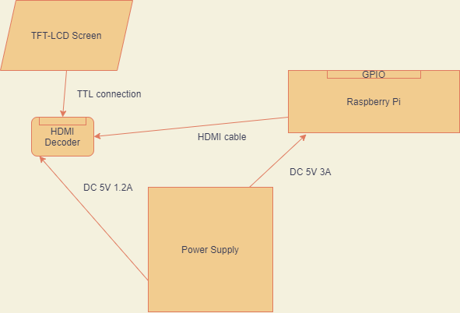
Figure 63: LCD System Test

Once this process is done, we can ensure the Pi works in conjunction with the HDMI decoder and TFT-LCD display.

Testing the Motors

Objective: The objective of testing the stepper and servo motors is to ensure the stepper motor runs properly and can be controlled through Python scripts. This process will also ensure our motor HATs on the Pi are functioning properly. The motors are driven by two motor HATs. The testing process for each will be the same, but 12V DC will be supplied for the stepper motor HAT, and only 5V DC will be supplied for the servo motor HAT.
Environment: This portion of the testing will require a fair amount of equipment for delivering proper power and measuring the voltage and amperage of certain parts with a multimeter. Therefore, this portion of testing will be done at UCF’s Senior Design Laboratory located in Engineering 1, Room 456. This will give us access to the necessary equipment for power measurements. For testing the motors we will need a 5V DC power supply for the Pi and a 12V DC power supply for the stepper motor driver.
The testing process will proceed as follows;
- Connect the Pi to the 5V/3A power supply via the usb-c onboard connector.
- Insert a micro-SD card loaded with Raspbian.
- Connect the Pi to an external computer monitor via the HDMI connector on the Pi.
- Connect the stepper motor HATto the Pi via the 40-pin GPIO.
- Connect the stepper motor to the driver HATvia the motor connectors onboard the stepper motor driver HAT.
- Power the stepper motor driver with a 12V DC power supply (5V if testing the servo motor HAT).
- Plug in the Pi’s power supply to a wall outlet.
- Ensure the Pi and the HAT both receive power and the Pi boots up.
- Once booted, use a Python library to try and control the stepper motors.
- Measure voltages and amperages to ensure a stable delivery of power to each motor.
Once successful, we can run this test again using the servo motor HAT to ensure that HAT runs fine. For the servo motor HAT, ensure you supply 5V DC and not 12V DC.
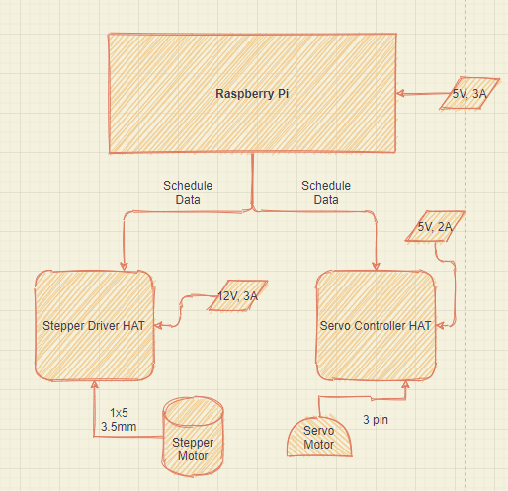
Figure 64: Motor System Test

Once both HATs have been tested and successfully drove the motors, we can begin adjusting the voltages to find a minimum voltage/amperage we need to supply to successfully drive the servo and stepper motors. Finding these values will help us to build a final power supply that will power the entire project while keeping the power used as efficient as possible.

Testing the Hardware System

Once we have confirmed that the Raspberry Pi, TFT-LCD display, HDMI decoder, motor HATs, and motors work, we can begin testing the hardware of the whole system as a single unit. To do this we must supply the proper power to each component. Then we must make all the proper wire connections. Once all connections are made, we can feed the TFT-LCD display a picture and then attempt to control the servo and stepper motors. We can also attach the stepper motor to the pill container to ensure the container will spin with the motor.
Objective: The objective of testing the whole system is to ensure that all connections are stable and that both subsystems can work simultaneously on the power supplied to the system. In this test, each part will be supplied a proper rated power and the functions of each hardware component will be tested.
Environment: Once completed we can move on to software testing, and then we can move on to testing the entire product. This portion of the testing will require a fair amount of equipment for delivering proper power to each component and measuring the voltage and amperage of certain parts with a multimeter. Therefore, this portion of testing will be done at UCF’s Senior Design Laboratory located in Engineering 1, Room 456. This will give us access to the necessary equipment for power measurements and power delivery. For testing the system we will need to deliver 5V DC to the Pi, 5V DCto the HDMI decoder, 5V DC to the servo motor HAT, and 12V DC to the stepper motor HAT.
The testing process will proceed as follows;
- Connect the servo motor HAT to the Raspberry Pi via the 40-pin GPIO header.
- Insert a micro-SD card loaded with Raspbian into the Raspberry Pi.
- Solder on the 40-pin GPIO extender to the servo motor HAT.
- Stack the stepper motor HAT on top of the servo motor HAT via the 40-pin GPIO extender.
- Connect the HDMI decoder to the Raspberry Pi via an HDMI cable.
- Connect the TFT-LCD display to the HDMI decoder via the 40-pin TTL connector on the decoder.
- Connect the servo motors and stepper motors to their respective hats.
- Connect 5V DC to the servo motor HAT.
- Connect 12V DC to the stepper motor HAT.
- Connect 5V DC to the HDMI decoder.
- Connect 5V DC to the Raspberry Pi.
- Attempt to control the motors with a Python script.
- Attempt to open an application on the Pi using the touchscreen display.
The expected behavior is that all the boards power on and don’t flash any error codes. The motors should be controllable via a python script and the touchscreen display should show the OS loaded on the microSD in the Raspberry Pi.

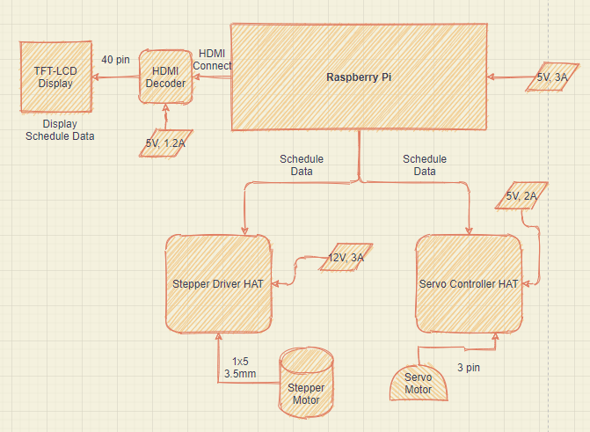
Figure 65: Hardware System Test without PCB (using HATs)

Once we have confirmed that it all runs on the proper rated power, we can begin taking voltage and amperage measurements and slowly adjust the power delivered to the motor HATs in order to find the most efficient power for the motors to run in a stable manner.

Testing the PCB
When we have successfully confirmed that our hardware system works using the HATs, we can remove the HATs and test our system using our own developed PCB. Our PCB will have combined the functionality of both the HATs onto one board.
Objective: Ensure our own developed PCB works in replacement of the motor HATs and ensure our extra functionality of having an MCU onboard our PCB is beneficial.
Environment: This portion of the testing will require a fair amount of equipment for delivering proper power and measuring the voltage and amperage of certain parts with a multimeter to ensure our PCB is functioning as designed. Therefore, this portion of testing will be done at UCF’s Senior Design Laboratory located in Engineering 1, Room 456. This will give us access to the necessary equipment for power measurements. For testing the motors we will need a 5V DC power supply for the Pi and a 12V DC power supply for the PCB.
The testing process will proceed as follows;
- Connect our PCB to the Raspberry Pi via the 40-pin GPIO header.
- Insert a micro-SD card loaded with Raspbian into the Raspberry Pi.
- Connect the HDMI decoder to the Raspberry Pi via an HDMI cable.
- Connect the TFT-LCD display to the HDMI decoder via the 40-pin TTL connector on the decoder.
- Connect the servo motors and stepper motors to their respective ports on the PCB.
- Connect 12V DC to the PCB.
- Connect 5V DC to the HDMI decoder.
- Connect 5V DC to the Raspberry Pi.
- Attempt to control the motors with a Python script.
- Attempt to open an application on the Pi using the touchscreen display.
The expected behavior is that all the boards power on and don’t flash any error codes. The motors should be controllable via a Python script that sends data to the ATmega32 which in turn sends signals to the motor drivers to turn the motors. Along with this the touchscreen display should show the OS loaded on the microSD in the Raspberry Pi.
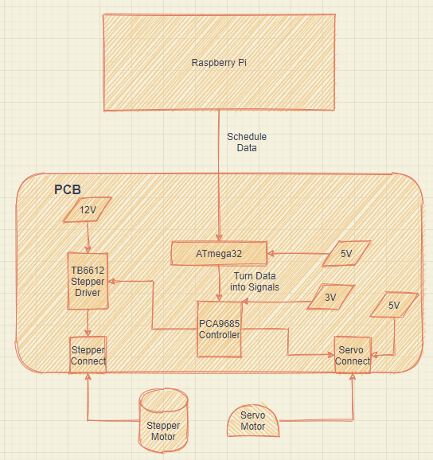
Figure 66: Hardware System Test with PCB

7.2 Software Testing

Software is a very heavy and important piece of this project. Our software can be broken into three different subsystems just as our hardware is, the mobile app, the Python scripts on the Raspberry Pi, and the code on the ATmega32 microcontroller. These three systems together make up the entire functionality of the software. The mobile app will send data to the DB that is hosted on a web server. The Raspberry Pi will then reach out to the DB to receive the data and send it to the MCU. To test this, we will test each subsystem independently and then we will test both systems together.

Testing the Mobile App

To test the mobile app we will use an API tester for making sure the GET/POST requests are working properly and we will use Expo to run the app on our mobile devices. This will allow us to test the app in a real time environment.
Objective: The objective of the mobile app is to ensure the mobile app functions smoothly, all API calls work properly, and all sent data makes it to the database along with all requested data makes it back to the application.
Environment: The environment for the software development of the mobile will be done through our own personal computers in our own dev environments. We have set up a shared GitHub repository so that each of us can make commits and push and pull code to and from the GitHub.
There will be two different testing processes for the mobile app, API testing, and UI testing.
The API testing will proceed as follows;
- Use an API tester, like ARC, to call certain API functions with a GET/POST HTTP request and pass through the proper example JSON arguments.
- If it is a request to get some data, ensure the data is received by the app in the proper JSON format.
- If the request is to send some data to the DB, ensure the database is updated properly.
- Repeat this process for all functions that make up the API.
The UI testing will proceed as follows;
- Attempt to use the app as a client and assess your experience.
- Ensure all form elements are properly fitted to the device.
- Ensure basic processes work like login, sign up, log out, add schedule, etc.
- Ensure form elements that can’t be left blank cause a warning when a HTTP request is submitted.
Once these tests are done, the mobile app is considered to be in a fully functioning and stable state.

Testing the Python Scripts

To test the Python code on the Raspberry Pi, we will start running the Python scripts after the boot up of the Raspberry Pi.
Objective: The objective of this test is to have the Raspberry Pi;
- Output the Pill Schedule to the TFT-LCD;
- Give the Pi arguments in the form of a schedule and have the motors move on that schedule.
This testing will be done in a way where we can adjust the arguments of the code to simulate different situations. The goal is to successfully display hard coded information on the display, and to successfully spin the motors based on the arguments given to the code.
Environment: As with the previous test the environment for the software development of the Python scripts will be done through our own personal computers in our own dev environments. We have set up a shared GitHub repository so that each of us can make commits and push and pull code to and from GitHub. The code will be pulled from the repository and uploaded to the Raspberry Pi.
The procedure for testing this is as follows;
- Boot up the Raspberry Pi.
- Run the control Python script with hardcoded arguments.
- Wait for the motors to move based on the schedule you hardcoded.
- Now run the Python GUI script.
- Ensure the GUI appears with the hardcoded information.
- Now test this with the scripts running automatically on boot up.
Once this is done, we can move forward with making sure the Raspberry Pi can grab the arguments for the display and motor schedule from the database.

Testing the Entire Software System

Testing the software system as a whole will allow us to confirm we can input data into the mobile app, then retrieve it to the Raspberry Pi and execute the necessary functions in accordance with the received data.
The Objective: The objective of this test is to enter a pill taken and schedule the pill is taken into the mobile application then have the motors move at that specified time and show the pill information on the TFT-LCD screen.
Environment: When running this test, we should have Expo running the mobile app on our mobile device and have ARC open in order to test the API and ensure the data is being sent properly via HTTP requests. We should also be connected to the MongoDB cluster to ensure the data is being properly inserted into the DB for the Pi to fetch. The Pi will be connected to a PC monitor for this testing.
The testing will proceed as follows;
- Check all hardware connections.
- Ensure the Pi is connected to the PC monitor and the motor HATs are connected.
- Ensure motors are connected.
- Enter into the mobile app and enter a pill you are taking and the schedule you are taking the pill.
- Check that the API function worked with ARC and ensure the database received this data.
- Now load the Python scripts onto the Pi via the micro-SD.
- Boot up the Pi and run the Python script to send data to the MCU.
- The Pi should get the data entered into the DB via the app and send the MCU data/signals pertaining to when and how the motors should move at the specified times.
- Once confirmed the motors moved, exit the script and start the Python GUI script.
- Ensure this script brings up a small window displaying the information entered into the mobile app.
Once this test is done we can confirm the software system is functioning properly.
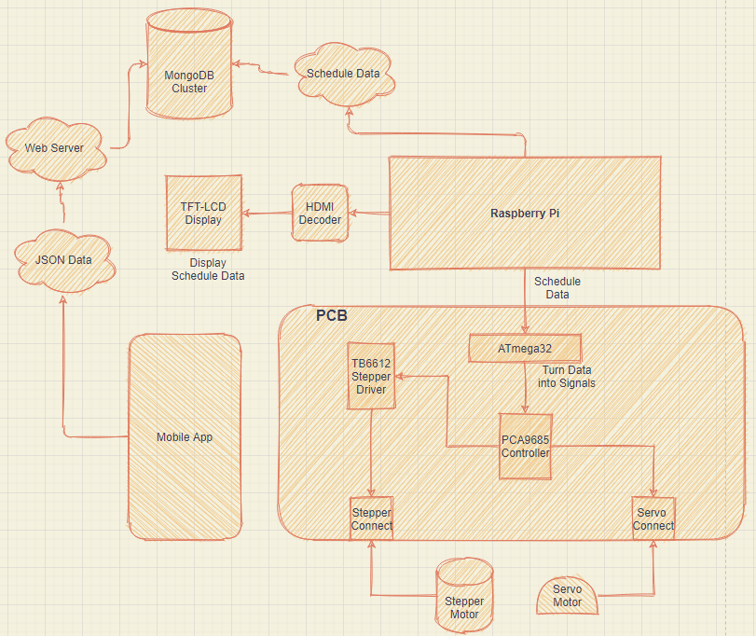
Figure 67: Software System Test

7.3 Prototype Testing

When both the hardware and the software have been testing, we can begin testing them in conjunction with each other, ensuring that everything works properly and all power measurements are in check.
The Objective: The objective of this test is to ensure the system works as a whole, software and hardware working together to produce a prototype as a minimum viable product. This prototype will not be enclosed in the finished casing but will use the pill container to ensure the mechanism that turns the pill holder works.
The Environment: Since this requires both testing the software and the hardware, this testing will be done at UCF’s Senior Design Laboratory located in Engineering 1, Room 456. This will give us access to the necessary equipment for power measurements and power delivery. We will also need all of the necessary software applications for testing, such as access to the MongoDB cluster, and an API tester for ensuring proper HTTP requests.
The testing will proceed as follows:

- Ensure all hardware connections are set up properly.
- Ensure the proper power is supplied to the components using the lab's power supply.
- Ensure you are connected to the MongoDB cluster and have an API tester open.
- Connect a wireless keyboard to the Pi via USB so you can type on the small display.
- Open the mobile app and enter a pill to take and the schedule it is taken.
- Check that the API function worked with ARC and ensure the database received this data.
- Now load the Python scripts onto the Pi via the micro-SD.
- Boot up the Pi and run the Python script to run the motor as scheduled.
- The Pi should get the data entered into the DB via the app and schedule the motors to move at the specified times.
- Once confirmed the motors moved, exit the script and start the Python GUI script.
- Ensure this script brings up a small window displaying the information entered into the mobile app onto the TFT-LCD display.

This confirms that the prototype functions properly and the hardware and software are all working together to bring the project together.

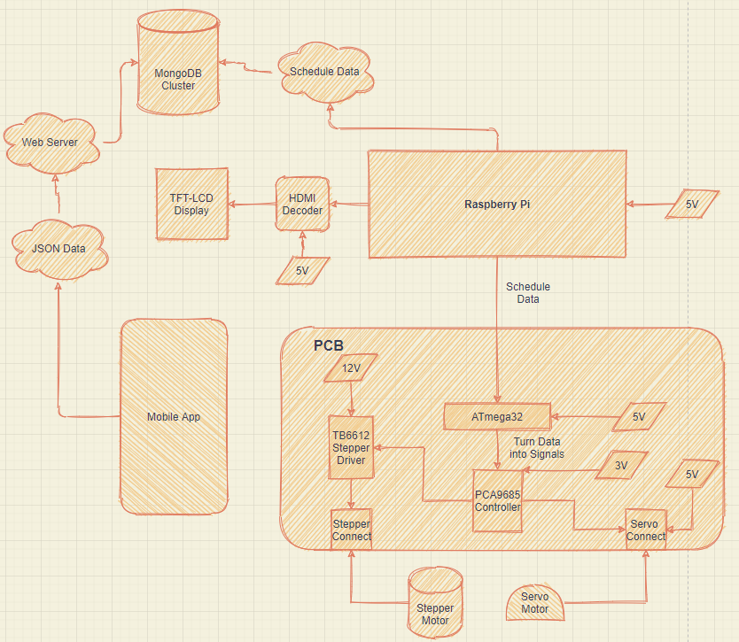
Figure 68: Prototype System

8. Administrative Content

This section of the document will discuss and show the time management and budget of the team. The timeline will show each milestone reached starting from the Senior Design Project Idea assignment until the Final Document due date. In this section we will also be discussing the expenses of all the equipment used to make up our automatic pill dispenser which is to be detailed and documented in a table.

8.1 Milestone Discussion

This section will have a breakdown on the milestones reached in regards to the completion of the project. It will start off from the beginning of the semester at Senior Design Project Idea of Senior Design I to the final presentation at the end of Senior Design II of the Spring 2021 semester.

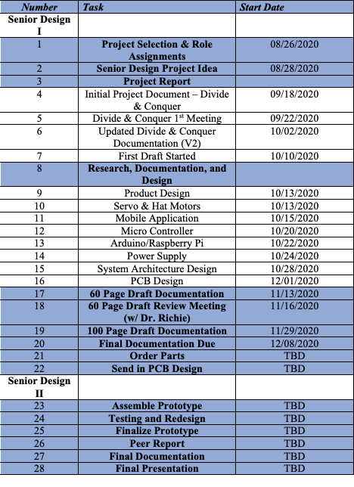
Table 8: Project Milestones

The table above has the milestones and dates that follow to show when they were accomplished.
Some of the project milestones were really early within the whole design; however, due to further research the milestones grew in both conception and implementation. For example, the overall product design at first only used a Raspberry Pi due to a lower footprint and easy use for implementation of our functionality of the product. With further research, we realized regardless of the decrease in the footprint of the overall design that we should implement some protection for the users by allowing there be a roadblock between the instructions being sent and the decoding of the instructions. So, we introduced the idea of including a PCB into our design and implemented it so that it provides security to the users knowing that the mechanical have a regulator and have a lower chance of operating without control. The PCB decodes and regulates the power to the components.

We took some time and thought into understanding the implementation of the PCB so that no matter the use, it would provide stability and reliability to both the design and the user. Overall after understanding how the PCB would benefit and increase the reliability of our design, the milestones for the project began to stack and become more complex, but more easily understood to complete them in a timely manner.The rest of the milestones are to be decided for now because we will either complete more milestones over the course of Senior Design II or will be completed and reworked over the break.

8.2 Budget and Finance Discussion

This project is not sponsored by anyone. The financing of this project will be done by each of the groupmates of this project. We will be splitting the cost of the project between each of us. With some research done we estimated a cost limit of under $500. After some more researching and picking out parts, our cost before developing a PCB had come to about $235.23. Leaving a lot of room for any unexpected expenses. You can see our initial projected costs below before PCB development.

Table 9: Projected Price List

Part Name | Price
Raspberry Pi 4 2GB Model Board | $35.00
5.0" 40-pin TFT Display - 800x480 with Touchscreen | $39.95
TFP401 HDMI/DVI Decoder to 40-Pin TTL Breakout - With Touch | $29.95
40-pin FPC Extension Board + 200mm Cable | $4.50
Adafruit DC & Stepper Motor HAT for Raspberry Pi | $22.50
Adafruit 16-Channel PWM / Servo HAT for Raspberry Pi | $17.50
Adafruit Perma-Proto Half-sized Breadboard PCB | $4.50
2x Micro servo | $11.90
1x Mini Stepper Motor - 200 Steps - 20x30mm NEMA-8 Size | $19.95
3D Printed Chassis Parts and Gears | Free
Grafco 3241 Graduated Medicine Cup, 2 oz | $9.48
Power Supply | $40 (approximation)
Total | $235.23

With PCB development came new parts that need to be added. Once we added those parts we came up with a Bill of Materials. This can be seen in the figure below.
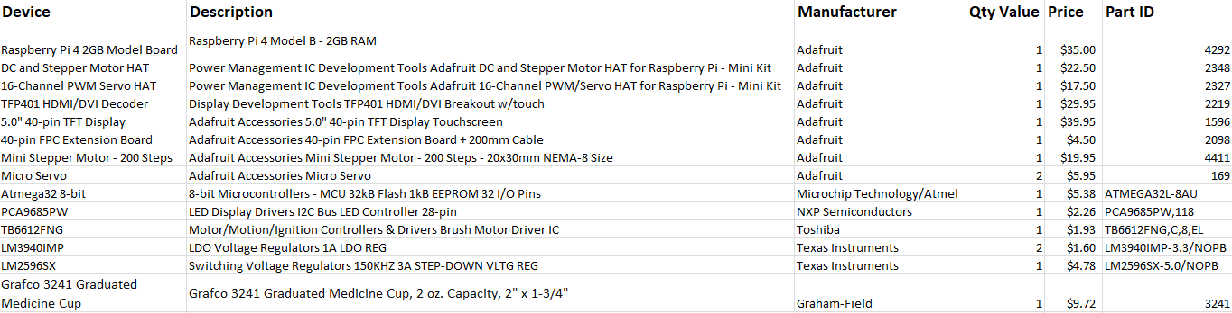
Figure 23: Bill of Materials (BOM)

This Bill of Materials takes into account all PCB parts and all external parts that are needed for the project. The only thing left out of the BOM is the housing which will be 3D printed. After adding the PCB parts to the mix our total comes to approximately $261.92 before a PCB vendor quote has been made.

The outline above shows all the parts that will be ordered and used in the project. At the time of writing, we currently do not have a finished power supply so we approximated $40 for a power supply. Along with this, there are some specific resistors and inductors we are still locating that I have allocated about $15 for.

With no one funding or sponsoring our project, the budget is extremely important to this project. We even went as far as to ask for some of the parts as Christmas gifts as a way to save money on the project. Keeping track of the component prices ensures we are able to fairly share the price of the project.
As we move forward we may experience some unexpected expenses. These will be handled on an as needed basis and we will each share these costs. On the fly expenses always come up and as we move forward with the build, we will continue to assess and calculate our total cost.

9. Appendices

This section will show the bibliography containing all the sources and materials used throughout this paper.

9.1 Bibliography

[1] “The Best Automatic Pill Dispensers.” Caring Village, 12 Nov. 2020, www.caringvillage.com/product-review/the-best-automatic-pill-dispensers/.
[2] “Cloud Computing Services: Microsoft Azure.” Cloud Computing Services | Microsoft Azure, azure.microsoft.com/en-us/.
[3] “cloud_server.” IBM, www.ibm.com/cloud/learn/cloud-server.
[4] “Google Cloud.” Google, Google, cloud.google.com/.
[5] III, Scott Fulton. “What Google Cloud Platform Is and Why You'd Use It.” ZDNet, ZDNet, 20 May 2019, www.zdnet.com/article/what-google-cloud-platform-is-and-why-youd-use-it/.
[6] “Medipense " Automated Pill Dispenser Medication Assistance for Seniors.” Medipense, 23 Nov. 2020, medipense.com/en/.
[7] “Prescription Drugs.” Health Policy Institute, 13 Feb. 2019, hpi.georgetown.edu/rxdrugs/.
[8] “TB6612FNG H-Bridge with Arduino – Better Than L298N?” Drone Bot Workshop 12 December 2019, https://dronebotworkshop.com/tb6612fng-h-bridge/
[9] "Types of AVR Microcontrollers" ElProCus, 10 Nov. 2018, www.elprocus.com/types-of-avr-microcontroller-atmega32-and-atmega8/.
[10] “Raspberry Pi.” Wikipedia, Wikimedia Foundation, 3 Dec. 2020, en.wikipedia.org/wiki/Raspberry_Pi.
[11] “LAMP (Software Bundle).” Wikipedia, Wikimedia Foundation, 27 Nov. 2020, en.wikipedia.org/wiki/LAMP_(software_bundle).
[12]

